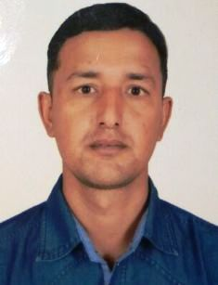**Sanjeep Thapa**

E: sanjeep.thapa1988@gmail.com

M: +971 0581837232

Visit Visa: Valid till 24 April 2018

Passport: 08037834

### OBJECTIVE:

A highly talented security Officer with huge Experience in providing personal, equipment and real properly security in assigned areas.

### Work Experience:

* Worked as an Armed Police force for 2 Years in Nepal, Katmandu
* Worked as PBD Security Officer for 3 Years in UAE, Abu Dhabi
* Worked as Salesman (Sagarmatha Supermarket) 2 Years in Nepal, Katmandu

# EDUCATIONAL QUALIFICATION:

* 12th Passed from SLC Board in 2003

### Professional SKILLS

* CCTV Operator/Security Officer-Knight bridge global security UAE, Al-Ain Mall.
* Driver in Pickup Van.

### Other SKILLS

* Good Skills in utilizing building security and access control systems and procedures.
* Excellent ability to detect problems and report information to appropriate personnel.
* Remarkable ability to understand and follow safety procedures.
* Strong ability to understand and follow specific instructions and procedures.

### PERSONAL DETAILS

Date of Birth : 27 Jan 1989  
Language : English, Hindi and Arabic (Average)

Marital Status : Married

Sex : Male

**Date: SANJEEP THAPA**

**Place:**