CURRICULUM VITAE

**Position Applying for:-**

**“(Draughtsman (Civil)”**

**MOHAMMAD NAUSHAD ALAM**

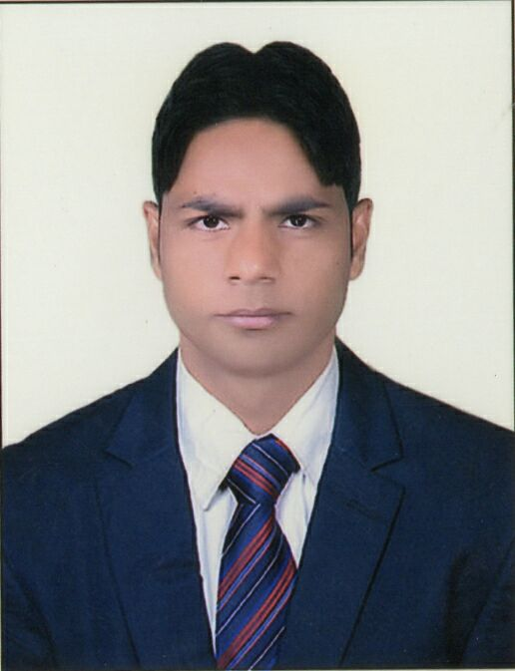

**Mobile:** +**91-9128160932/7021878748 (India Bihar)**

**Mobile:** **+91-7856818618 (India Home)**

**E-mail:** **alamnaushad7654321@gmail.com**

**Skype: naso786**

***To***

Dear Sir/ Madam,

It was with great interest that I came to know your recent posting for Your Job Vacancy in ------------------------------------ In response to this; here I am enclosing my resume for your consideration.

Review of my credentials will confirm that I am capable of serving as the catalyst for achieving revenue objectives and organic growth through effective contributions. Experience in **ARCHITECTURAL CAD, In Residential, Infrastructural and Civil Engineering works.**

I understand that working for your organization requires a candidate who is team oriented and is able to deal with people in various departments. I am confident that I possess these skills, which will help me to perform the job efficiently and effectively.

My goal is to transit my enthusiasm, creativity and experience into a position, where I continue to provide the strategic and tactical leadership critical to retaining valued customers of an organization. I am certain that my presence in your team will prove to be beneficial to your organization. As such, I would welcome an opportunity to speak with you to evaluate your needs and share my ideas.

Thanking you.

Sincerely, **MOHAMMAD NAUSHAD ALAM**

**KEY SKILL:-**

##### Preparing As Built Drawing…..

* In Perspectives in Auto cad. Preparing plan drawing for building works such as building design works, hall, kitchen, room, shop and layout set …etc.
* Very good knowledge and interested in interior fit tout installation work
* Expert in making 2D presentation drawings in photo Shop, and rendering
* Very good knowledge in computer and expert in using various computer and various

Computer packages such as Auto Cad (all various, dos/ windows platforms) Photoshop,

Adobe premium, V- ray mapping, Ms Excel & knowledge in computer hardware Assembling

**TOTAL WORK EXPERIENCE**

**1st WORKING EXPERIENCE**

* **COMPANY NAME : CHOUDHARY EARTH MOVERS. PVT**

**DESIGNATION : CIVIL DRAUGHTSMAN**

**PERIOD : 03/10/2011 to 28/01/2014**

**2nd WORKING EXPERIENCE**

* **COMPANY NAME : VMD CAD & GRAPHIC TECHNO. PVT**

**DESIGNATION : CIVIL DRAUGHTSMAN**

**PERIOD : 10/02/2014 to 07/05/2016**

**3rd WORKING EXPERIENCE**

* **COMPANY NAME : AGRANI HOMES PVT.LTD**

**DESIG NATION : CIVIL DRAUGHTSMAN**

**PERIOD : 20/05/2016 to 05/07/2017**

JOB DISCRIPTION:-

☞ **Produce drawing using computer assisted drafting system (CAD) or drafting machines,**

**Or by hand using compasses dividers protractor triangles and other drafting Devices.**

** Preparing detailed shop drawings for client's or consultant approval, developing**

**From architectural drawings.**

** Determine the order of work and method of presentation, such as orthographic or**

**Isometric drawing.**

** Review rough sketches, drawing, specification, and other engineering dada received**

**From civil engineers to ensure that conform to design concepts.**

**STRENGTH:-**

* Fast learner.
* Good communication skill.
* Passion for service and desire to grow in job.
* Ability to complete given work on time.
* Ability to convince other person easily.
* Confident, disciplined, punctual.

**CAREER VISION:-**

* **To obtain a challenging position as a Civil Draughtsman in an enterprise**

**TECHNICAL QULIFICATION:-**

* **Diploma in Civil Engineering From Jamshedpur (Jharkhand) In 2011**

**EDUCATION**

|  |  |  |
| --- | --- | --- |
| **Course** | **School / University** | **Year of passing** |
| Autocad And Photoshop | Cad Center |  |
| Diploma | Al-Kabir Polytechnic Jamshedpur Jharkd | 2011 |
| XIIth | Gandhi Inter College Nawada, Bihar | 2009 |
| Xth | S.M.S High School Nawada, Bihar | 2007 |

**TECHNICAL KNOWLEDGE:-**

* Plan - Layout Set
* Photoshop - Adobe Photoshop, Photoshop cs6
* CAD packages - Autocad-2004 from 2017.All packages.
* Working with windows - 98,200XP, windows7,8
* V- ray -
* Adobe premium -
* Adobe illustrator -

**PASSPORT DETAILS**

|  |  |  |  |
| --- | --- | --- | --- |
| Passport Number | Date of Issue | Date of Expiry | Place of Issue |
| **M-4879049** | 26 / 12/2014 | 25 / 12 /2024 | PATNA |

**PERSONAL DOSSIER:-**

**Date of Birth: -** 25/09/1992

**Permanent Address: -**  Mohammad Naushad Alam S/O Abdul Sattar

Mohalla Bhadauni Phulwari Sharif

Dist–Nawadah,State–Bihar Pin Code–805110

Mobile No: - 9128160932

**Languages Known: -**  English, Hindi, Urdu, Language Fluently

**Religion: -** Islam

**Nationality: -** Indian

**Marital Status: -** UN Married

**Hobbies: -** Surfing Net and playing Carom

**DECLARATION:-**

I hereby declare that the above information furnished by me is true to the best of my knowledge and given an opportunity, I shall definitely prove my worth.

Date/………… Sign……………..