**CURRICULAM VITAE**

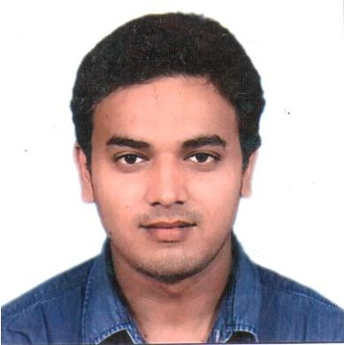

**ELECTRICAL ENGINEERING**

**SYED ALEEM RAZA**

**181/5 CHHURIYA MOHALLA,**

**TUGHLAKABAD,**

**NEW DELHI, 110044.**

**E-mail:** [**shobyraza@gmail.com**](mailto:shobyraza@gmail.com)

**DETAILS OF WORK EXPERIENCE:**

1. **Worked as an Electrical Electrician in ETA ENGINEERING Pvt Ltd. New Delhi, from 12/10/2006 to 28/08/2009 (3 Years).**
2. **Worked** **as an** **Electrical Electrician, UB ENGINEERING, New Delhi. from 04/11/2009 to 21/12/2011.**
3. **Worked as an Electrical Technician Cum Supervisor in ETA­- EMCO (QATAR), in Qatar From 09/10/2012 to 21/08/2015. ( Facility Management )**
4. **Self employed as an Electrical Maintenance contractor like House wiring , building wiring , repairing and replacement part of Electrical , DB, SMB, SMDB, CP, LCP, MV Panel , New Delhi Kalkaji, From 02/01/2016 to till Date**

**EDUCATIONAL QUALIFICATION:**

|  |  |  |  |  |
| --- | --- | --- | --- | --- |
| **Sr. No.** | **Qualification** | **University** | **Year of passing** | **Class** |
| 1 | S.S.C | UP Board | June 2004 | 2nd |
| 2 | H.S.C | UP Board | June 2007 | 2nd |

# **PROFESSIONAL QUALIFICATION:**

1. **ITI (Electrical Electrician) in 2006 (2 Year )**

**Industrial Training Institute Govt, of Delhi**

1. **DIPLOMA (Electrical Engineering) in 2010. (3 Year )**

**Empirial Institute of Management Science & Research New Delhi.**

**Job Profile**

**1) Maintenance of DG sets up to 750KVA.**

**2) Maintenance of UPS up to 120 KVA**

**3) Maintenance & Operation Of fire protection systems.**

**4) Maintenance & Operation of Hydro pneumatic pump.**

**5) Maintenance & Operation LT Breakers.**

**6) Carrying all electrical Preventive Maintenance.**

**7) Attending all electrical Complaints.**

**8) Material Store keeping.**

**9) Maintenance & Rewinding of AC Motors up to 50HP.**

**10) Maintenance & control wiring of star delta panels.**

**My responsibilities are**

**Ensure equipment health by daily Inspection as per checklists**

**Reviewing of all PM work orders and driving the Own team to rectify the observed abnormalities.**

**Maintaining history for Equipment breakdowns & component failure.**

**Trending of all energy like Electricity, Water& Diesel and exploring the possibility of cost savings.**

**Reliable operation and maintenance of all Engineering and Electrical equipment.**

**Operation and Maintenance of Air Conditioning plant, Diesel Generators,**

**Training**

**1) PTW (permit to work) by Emco Qatar.**

**2) VFD Training by Emco Qatar.**

**Witch as follows**

**1) Hand experience in cable lying, cable gladding cable dressing, cable rutting of power cables and Rewinding of AC motors.**

**2) Distribution board dressing and pipe setting.**

**3) Light fitting, wiring and DB fixing.**

**4) Maintenance defects rectification works of all kinds of circuit breakers mechanisms contactors and ACB**

**5) Installing of transformers and UPS systems**

**ADDITIONAL KNOWLEDGE:**

1. **I have knowledge about Computer Hard Ware and Soft Ware.**
2. **Computer Education with Basic & Fundamentals, MS Office XP, Window XP, Word, Excel, Power Point, Internet, Tally 7.1.**
3. **LMV Driving Expert**

**PERSONAL DETAILS:**

1. **Name : Syed Aleem Raza.**
2. **Father Name : Syed Tasleem Raza.**
3. **Date of Birth : 17th Oct 1988.**
4. **Nationality : Indian.**
5. **Gender : Male.**
6. **Marital Status : Married**
7. **Religion : Muslim**
8. **Mobile No. : +919555551487**
9. **Language Known : English, Hindi, Arabic, Urdu.**
10. **Hobbies : Interacting with people,**

**Music, Traveling, Driving**

**11. Strength : My Confidence & Self Motivation.**

**12. Passport : K0417980, 05/12/2011 to 04/12/2021**

**Place: New Delhi**

**Date: __________________ (Syed Aleem Raza)**