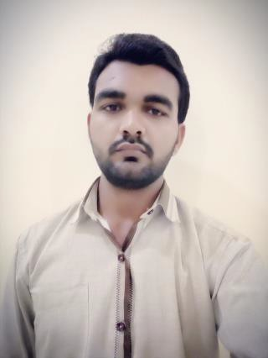**AMAR CHAND SONI**

D.O.B.: 03-Feb-1994

Nationality: India Location: Rajasthan, India Mobile: +91 9610700901

Ema[il: amarchandsoni01@gmail.com](mailto:amarchandsoni01@gmail.com) Indian Passport no: P9953358

# PROFILE

Amar Chand Soni has worked as a Sales Assistant Cum Computer Operator with 1 year of experience in Mahadev Motors,Harsor (Hero Motocorp Sub Dealer).

# EDUCATION

* Matric From Rajasthan Board (76.67%) Ajmer
* Intermediate From Rajasthan Board (79.80%) Ajmer
* C.P.T. From The Institute of Chartered Accountants of India (59.5%) New Delhi
* Diploma In Office Automation & Publishing with “A” Grade

# LANGUAGES

* English – Normal reading, writing and speaking
* Hindi – Excellent reading, writing and speaking

# COMPUTER SKILLS

* Operating System (WinXp,Win7,Win8,Win10)
* Microsoft Office (Word, Excel etc.)
* Tally
* Operating System And Software Installation

# STRENGTHS

* Team Work
* Discipline
* Management

# RESPONSIBILITIES AND ROLE DETAILS:

* Computer Operating.
* Stock Maintaining.
* Selling

**THANKS**

**AMAR CHAND SONI**

Page 1 of 1

MAHADEV MOTORS

Authorised Representative

of Dhamt Hero

- **Hero**

# Date - 05/03/2018

**EXPERIENCE CERTIFICATE**

# To whomsoev_er it may concern

This is to certify that Mr. Amar Chand Soni has been worked as a **Sales Assistant Cum Computer Operator** in our organization Crom **April.2017** to **March.20i8.** Dming the time of his tenure we

, fo und him extremely resourceful in all the technologies that he is competent.

w_e found him to be a ·good team player besides being a hard worker. We wish him all success in his future endeavo rs.

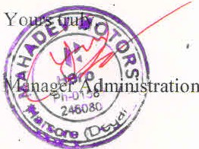

l

**Mahadev Motors, Authorised Representative of Dhamia Motors.**

Aimer Bypass, Near Mahesl:l Autom obiles, Harsor, Teh. Degana, D1stt. Nagaur (Raj ) Mob.: 9414603092