CURRICULUM VITAE

**Vivekananda Thakur**

**S/O**- Harindra Nath Thakur

Address: Manikpur, Ballia, U.P.

**Contact no:** +919458709436, +917905970598

**Email id**: vsthakur9dec88@gmail.com

|  |  |  |
| --- | --- | --- |
|  | |  |
|  |  | |

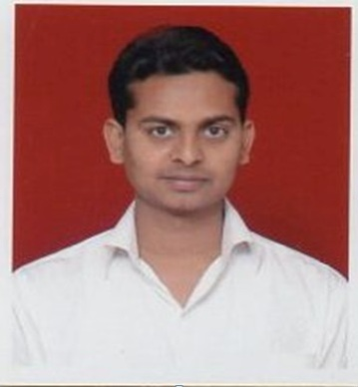

|  |
| --- |
| **OBJECTIVE:** |

To Achieve high career growth through a continuous process of learning for achieving goal & keeping myself dynamic in the changing scenario to become a successful professional and leading to best opportunity. And willing to work as A G M/DGM (Civil) and in the reputed construction industry.

|  |
| --- |
| **PROFESSIONAL EDUCATION:** |

|  |  |  |  |  |
| --- | --- | --- | --- | --- |
| **DEGREE** | **UNIVERSITY** | **COLLEGE** | **BATCH** | **AGGREGATE** |
| B.Tech.(Civil) | UPTU | Rajshree Institute Of Management & Technology, Bareilly | 2010-2014 | 69% |

|  |  |  |  |  |
| --- | --- | --- | --- | --- |
| 12th | UP Board | Maniar Inter College Maniar Ballia | 2006 | 65% |
| 10th | UP Board | Maniar Inter College Maniar Ballia | 2004 | 56% |

|  |
| --- |
| **Work Experience:** |

**Organization :** Samrat Infra Estate Pvt. Ltd.

**Description :** Road Construction

**Duration :** 18 JUN 2014 to 5 NOV 2016

**Designation :** Site Engineer

**Organization : S.S. Infrazone Pvt. Ltd.**

**Description : Road Construction**

**Duration : 11 NOV 2016 to till now**

**Designation : Site Engineer**

|  |
| --- |
| **Summer Training:** |

**Organization :** PWD Pilibhit

**Description :** **Village Road**

**Duration : 30 days**

|  |
| --- |
| **Technical Skills:** |

* Experience in basic use of computer
* MS office
* AutoCAD
* Internet Savvy.

|  |
| --- |
| **Personal Qualities:** |

* + - Positive attitude towards work and great ability towards result oriented output
* Excellent Communication/inter personal skills to interact individuals at all level

|  |
| --- |
| **Project:** |

* HPC (High Performance Concrete)

|  |
| --- |
| **Hobbies:** |

* Net surfinges, listening songs.

|  |
| --- |
| **Personal Details:** |

**Father’s Name**: Mr. Harindra Nath Thakur

**Date of Birth**: 09-12-1988

**Gender**: Male

**Languages Known:** Hindi, English

**Address**: Manikpur, Ballia, U.P.

|  |
| --- |
| **Declaration** |

I hereby declare that the information mentioned above is correct to my knowledge and I bear the responsibility for any sort of inconvenience over the mentioned particulars.

**DATE: ...................................**

**PLACE: Ballia**

**SIGNATURE……………………**