**CURRICULUM VITAE**

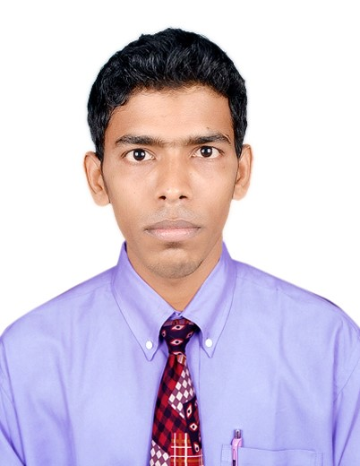

**MOHAMMAD DANISH WAKIL**

**Email :** [**danishwakil66@gmail.com**](mailto:danishwakil66@gmail.com)

**Mobile : +91-7070999718**

**Applied For: - LAND SURVEYOR**

**Objective: -**

Seeking an opportunity, that commensurate with my qualification and experience as a **LAND SURVEYOR** where I will be able to enhance my technical skill and an asset to the organization as well.

**Experience: -**

I have knowledge as **LAND SURVEYOR** on various construction projects like road & infrastructure work, multi-story building, collage & school building, commercial building, highway construction, bridgework, earthwork, hydropower project, cutting & filling work with total station (resection method and stakeout method). have knowledge about Chain, Compass, plane table, Auto level, Dumpy level hand GPS (Garmin etrex 20) also use a DGPS (Trimble R8 GNSS 5800 tr4), land survey and boundary survey, topographic survey.

**Key skill: -**

* Ability to operate total station at site to co-ordinate assistance as per instruction from the management and check before submission to client or consultants. Data transfer also.
* Following the instruction of project management team in order to get approval of work to achieve the target to timely completion of projects.
* Presentation and updating progress reports weekly & monthly.
* Maintaining all records for the revision of drawings.
* Day-to day progress of work and personal.

**Instrument knowledge: -**

* DGPS Trimble R8 GNSS 5800 Model-version (R3, R4).
* Total STATION Geomax ZT20. [Geomax zoom 30 pro](https://www.google.co.in/search?es_sm=93&q=geomax+zoom+30+pro&revid=1523540748&sa=X&ved=0CHAQ1QIoAGoVChMIps7-s-f9xgIVhVc-Ch2zcALo)
* Total Station Sokkia CX105.
* Total Station Nikon NPL 352.
* Total Station Trimble M3 DR

**Computer proficiency: -**

* **Auto Land Desk, (Multi section etc.)**
* **Auto-cad (2D-3D).**
* **Assembling of Computers.MS-Office Package, Photoshop.**

**Experience in each organization with Description of works: -**

|  |  |  |  |  |
| --- | --- | --- | --- | --- |
| SLNo. | Duration | | Name of Organization | Description of works |
| 1. | Sep-2012 | Jan-2014 | Working in Sahara Construction Group Of Engineers. | * Club Commercial Building, Mehsana, Gujarat. Building Layout Marking with Ts 3mm error. |

**Experience in Abroad each organization with Description of works: -**

|  |  |  |  |  |
| --- | --- | --- | --- | --- |
| SLNo. | Duration | | Name of Organization | Description of works |
| 1. | Mar-2014 | Aug-2018 | Working in Al Mohanna Trading and Contracting Company (QATAR). Following Client :-Ashghal | * Riw Outof Grater Doha Roads to Farms and Villages Phase-III. * Road and Infrastructure in the North Part of New Salata (Zone 40) Ds008. * Riw in Rayyan Phase-IV. * Riw in South of Grater Doha (Zone 92, 95) Phase-IV. |

**Qualification: -**

|  |  |  |  |
| --- | --- | --- | --- |
| **Course** | **Board/Institute** | **Year Passed** | **Position** |
| Matriculation (10th) | Jharkhand Academic Council, Ranchi | 2010 | 2nd |

**Technical Qualification: -**

|  |  |  |  |
| --- | --- | --- | --- |
| **Course** | **Board/Institute** | **Year Passed** | **Grade** |
| Diploma in Land Surveying With Total Station | Aims technical management institute-Jamshedpur, Jharkhand, India. | July-2010 To June-2012 | A |
| Auto-cad Drafting | Aims technical management institute-Jamshedpur, Jharkhand, India. | July-2010 To Jan-2011 | A+ |

**Personal Information**

* Father’s Name : Mohammad Wakil
* Place of Birth : Jamshedpur
* Date of Birth : 05/04/1993
* Permanent Address : H No-118 Rd. No.13,Jawahar Nagar,

Azad Nagar Ps-Mango, Jamshedpur- 832110 Jharkhand, India

* Nationality : Indian
* Religion : Muslim
* Marital Status : Unmarried
* Languages Known : English, Hindi and Urdu
* Physical Status : Possess a good and sound health

Height: 5’ – 9” Weights - 52 kg.

**Passport Details-**

* Passport No : L-1948993
* Date of Issue : 24/05/2013
* Date of Expiry : 23/05/2023
* Place : Ranchi

**Declaration: -**

I hereby declare that above particulars are true & complete to the best of my knowledge.

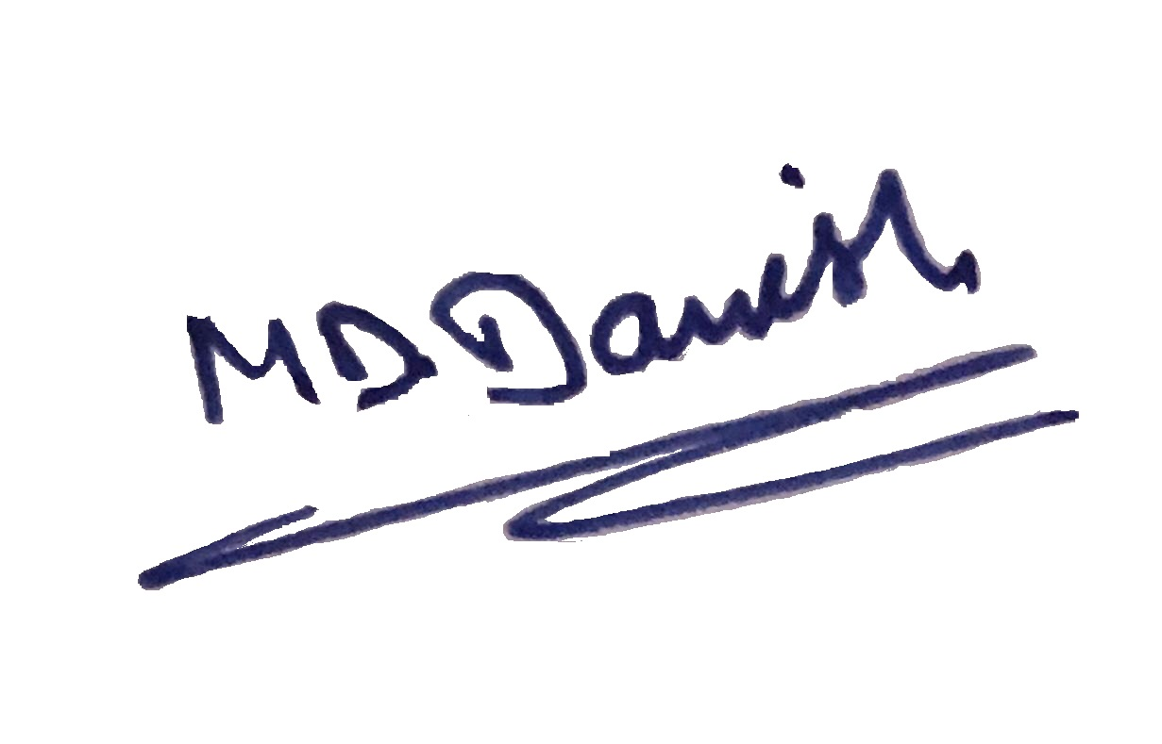

Date………………….. Yours faithfully

*(MOHAMMAD DANISH)*