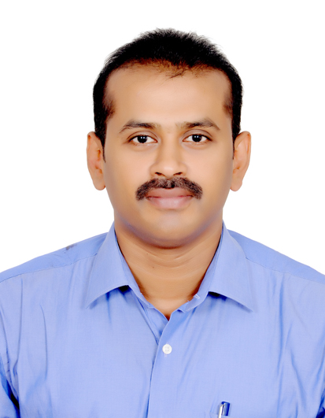**ASHOK KUMAR. D**

4/9, SBI Officers Colony, Seevagasinthamani Street, Ganesh Nagar,

Selaiyur, Chennai, Tamil Nadu 600 073, India.

Mobile: +91-9884264632

[dashokkumar83@yahoo.com](mailto:dashokkumar83@yahoo.com)

**PROFESSIONAL SUMMARY:**

* Resourceful and seasoned **Mechanical Project Engineer** with strong industry reputation for accuracy and efficiency
* Having **10 years of work experience**
* A registered member of **Saudi Engineering Council (SEC)**
* Having Saudi Arabian **driving license** valid till 08/07/2019

**CORE QUALIFICATIONS:**

* Exceptional industrial project management experience
* Strong expertise in mechanical equipment and complex machinery
* Extensive expertise with mechanical systems in Water Transmission Projects and in power plant projects
* Thorough knowledge of Process Safety Management and standard work practice
* Outstanding skills in machinery and equipment design
* Excellent ability to conceptualize and fully implement projects
* High skills in production process support

**CAREER GRAPH:**

|  |  |  |  |
| --- | --- | --- | --- |
| Company | Location | Role | period |
| MA. Automation | India | Project Engineer | Nov 2012- Present |
| ILF Consulting Engineers | Saudi Arabia | Sr. Mechanical Engineer | Jan 2011- Aug 2012 |
| Hamad Al Muhana Group | Saudi Arabia | QA/QC | Jun 2009- Dec 2010 |
| Esquire Engineering Solutions Ltd | India | Design Engineer | July 2007- May 2009 |

**EDUCATION:**

* **Bachelor's Degree - Mechanical Engineering in 2007**

Bharath institute of science and technology, Bharath University.

* Diploma - Mechanical Engineering in 2003

SRM Polytechnic College, Directorate of Technical Education.

**PROFESSIONAL EXPERIENCE:**

**Project Engineer Nov 2012 to Present**

**M.A. Automation Chennai, India**

* Responsible for project and process planning.
* Work closely with customers to develop prototypes.
* Responsible for launching and implementing new systems based on customer special needs.
* Assisting senior level engineers in developing mechanical design and in solving implementation issues
* Overseeing the complete work procedures of Plant Projects
* Developing work safety guidelines and scheduling goals of various projects simultaneously
* Playing a lead role in the project initiation stage to the actual execution stage
* Developing the overall scope and execution strategy of the project
* Assembling and testing electro-mechanical equipment and machinery

**Sr.Mechanical Engineer Jan 2011 to Aug 2012**

**ILF Consulting Engineers Riyadh, Saudi Arabia**

* Consultant for SWCC water transmission projects.
* Provide client support in following-up the quality related procedures in the site
* Inspect the various water pump stations and pipelines to ensure activity at the site are as per approved method of statement and inspection test plan.
* Prepare reports on project execution and completion. Thereby update the project manager on the project progress.
* Monitor activities of the reporting mechanical and welding inspectors located at various sites.

**QA/QC Engineer Jun 2009 to Dec2010**

**Hamad Al Muhana group Dammam, Saudi Arabia**

* Perform all daily inspection and test of the scope and character necessary to achieve the quality of construction on site.
* Cary out inspection and checking for all quality related procedures in the site
* Coordinate with the consultant’s representative and Site in charge for inspection and meeting about quality problems including the closure of Non-Compliance Report.
* Taking care of Quality assurance and control documents of the entire project
* Develop method of statement for the activity based on specifications of the project.
* Carry out Internal Audit at the site as scheduled in the Project Quality Plan.
* Liaison the Technical Engineer for submission of material submittals to Consultant.

**Design Engineer July 2007 to May 2009**

**Esquire Engineering Solutions Ltd Chennai, India**

* 2D to 3D Part and assembly Modeling using Pro/ENGINEER
* Preparation & Quality checking of engineering drawings
* Expert in cabling, sheet metal and in casting modeling
* Lead Reverse engineering execution team

**COMPUTER PROFICIENCY:**

* Pro-Engineer (Wildfire 5.0/Creo2.0)
* Solid works
* AutoCAD
* MS office – Word, Excel, Power point

**PERSONAL DETAILS:**

Name : ASHOK KUMAR.D

Father’s Name : DURAIVEL MANIMOZHI.A

Date of Birth : 30/07/1982

Gender : Male

Marital Status : Married

**Passport No : N5793720 valid till 12/01/2026**

**KSA driving license : 2273794863 valid till 08/07/2019**

Notice Period : Immediate  
Current Location : Chennai, India

**DECLARATION:**

I hereby declare that above mentioned details are true to the best of my knowledge and belief.

Yours truly,

**ASHOK.D**

**Mobile: +91 9884264632**

**Thank you for your attention!!!**