Md. Anis

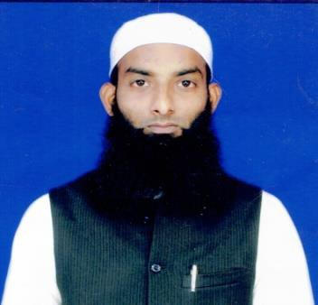

E-mail: [ani.elc@gmail.com](mailto:ani.elc@gmail.com) Mob No. +919883143787

23/H/1 Palm Avenue, Kolkata =700019

West Bengal, India

# Objective

Seeking a challenging position where my skill and potential for career advancement will contribute to the efficiency and profitability of the organization ensuring personal and professional growth simultaneously.

# Personal Particulars

Father’s Name : Md. Idris

Nationality : Indian

Marital Status : Married

Religion : Islam

Date of Birth : 28.09.1982

Sex : Male

Language : Hindi, Bengali, Urdu & English.

# Education

|  |  |  |  |  |
| --- | --- | --- | --- | --- |
| Sl. No | Name Of Examination | School/University | Division | Year of passing |
| 1. | 9th | Park Circus High school | pass | 2000 |
| 2. | Electrician Diploma | Don Bocso  Technical Institute | Pass | 2002 |

Note : Government Electrician License Holder Part I & Part II in 2004 & 2006

# Work Experiance

* **2009 *–* till date**

10 years Expreiance for all kind of ecletrical work

# Computer Experiance

* Working Experience in MS Office,

# Interest

* Take knowledge from Internet, Making good new friend,

Date : Signature of Md. Anis