**CURRUCULUM VITAE**

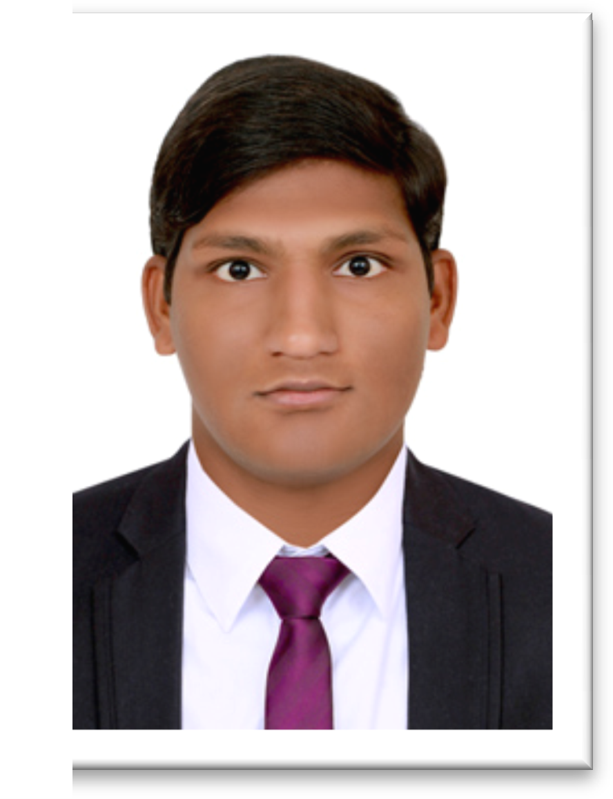

# SYED AMEAR,

**MEP Design Engineer,**

**E-Mail:** [**amearsyed2@gmail.com**](mailto:amearsyed2@gmail.com)

**Phone: +91 8919331989**

**JOB APPLICATION**

## To

The HR Manager

**Sub:** Application for the post of **“MEP Design Engineer”**.

## Dear Sir,

With reference to the above subject, I avail this opportunity to introduce myself Syed Amear. I am in a field where creative and logical thinking is must and I am confident that I can do justices to the work with my talent and skills.

Being actively involved in the field of **MEP** for **1 year,** I have gained wide experience, which has benefited me professionally and broadened my creative and logical thinking in the **MEP** field.

I am confident to Design & Draft the Mechanical works for commercial, Residential, Hospitalized & industrial projects.

I’m enclosing here my **Curriculum Vitae** for your kind consideration of my candidature and hope that I may get an opportunity to prove my worthiness.

Keeping in view of my qualification, knowledge and experience, I am confident that I can fulfill the above-mentioned assignment perfectly and live up to your expectations.

Looking forward for a favorable response. With best regards,

**Syed Amear**

**Enclosure: Resume**

**BRIEF OVERVIEW:**

Looking for a challenging and demanding position in a growth oriented MEP consulting organizations, where there is ample scope for individual and organizational growth.

**SUMMARY:**

Around **1 YEAR OF EXPERIENCE IN MEP** Industry with, good analysis and design capability, good communication and interpersonal skills, proven individually in project management and worked with team of professionals.

**WORK EXPERIENCE:**

* Presently Working as **MEP DESIGN ENGINEER** IN TAIBA ENGINEERING CONSULTANTS**,** Hyderabad, India from May 2016 – May 2017.

**EDUCATIONAL QUALIFICATION:**

* B.Tech [Mechanical] from VIVEKANANDA College Of Engineering

**COMPUTER KNOWLEDGE:**

### Hvac Design :

* Hourly Analysis Program (HAP) For Heat Load Calculation.
* TOSHIBA Software for VRV pipe sizing.
* ZAMIL Software for Equipment selection (Package AC, AHU, FCU, Chillers)
* GENERAL FORM
* E-20 FORM
* Chilled Water Pipe Sizing by McQUAY Pipe Sizer
* Duct Sizing By McQUAY Duct Sizer
* CAREER PSYCHOMETRIC CHART ANALYSER
* BETA TERMINAL DEVICE SELECTOR (Diffusers, Grills, Louvers)
* EXPANSION TANK SIZER
* Hydraulic Calculations for Chilled Water Pump Selection.
* Cooling Tower Selection
* Duct Designing by Equal Friction Method, Velocity Reduction Method, Static Regain Method.
* Ventilation Calculations for Kitchen, Toilets and Car Parking Areas.
* External Static Pressure (ESP) Calculation for Blower Selection.
* CONVERTERS

### Plumbing Design:

* Water pipe Sizing in Buildings
* Hydraulic Calculations for Pump Selection
* Septic Tank sizing
* Soak Away Pits Calculations
* Designing Strom Water Drainage In Building
* Manhole Design
* Estimating Hot water Demand and Heater Capacity Selection.

### Fire Fighting Design:

* Fire Water Sump sizing, Over Head Tank sizing
* Sprinklers Selection, Designing, Pipe Sizing.
* Fire Fighting Pump Selection by Hydraulic Calculation.

### Revit MEP 2018:

* Creating an MEP Project, Linking Projects, Creating and applying a view to Template,
* **Planning Mechanical System**:**-** Preparing Spaces, Creating Zones in different levels, Analyzing Heat and Cooling Load, creating a Air Flow Schedule.
* **Designing Mechanical Air System:-** Placing Hosted and Non Hosted Air Terminals, Creating supply Air Systems, Creating Duct Work manually and Automatically.
* **Designing a Mechanical Piping System:-** Adding Mechanical Equipment , Creating a Piping System, Adding Pipe using Auto Or Manual Layout, Sizing Pipe, Adding Valves, Inspecting a System.
* **Planning Electrical System:-** Specifying Electrical Settings, Defining Required Lighting, Creating Color Fills and Schedule
* **Designing an Electrical System:-** Adding Lighting Fixtures, Placing Switches, Junction Boxes, Creating Lighting Circuits with Wires, Creating Switch System, Creating Power Loads, Balancing Wire Sizes and Breaking Services.
* **Designing a plumbing System:-** Adding Sanitary Fixtures, Creating a Sanitary System, Refining the Sanitary Stack, Creating Cold Water System, Creating the Hot Water System.
* **Planning** **a** **Fire** **Protection** **System:** Specifying Pipe Setting, Determining Zone Requirement, Creating a Sprinkler Design Schedule.
* **Designing a fire Protection System:-** Adding Sprinklers, Creating a piping System, Modifying Pipe Diameters.
* **Creating Documentation Views:-** Duplicating plan Views, Creating A plumbing Isometric Riser.
* **Working With Annotations and Dimensions:-** Creating Annotations, Creating Dimensions, Creating a Legend.

### Drafting Software:

* AutoCAD 2017, REVIT MEP 2018

**TECHNICAL EXPERTISE:**

# HVAC JOB RESPONSIBILITIES:

* Heat Load calculations, Heat Loss calculations following **ASHRAE Standards**.
* Air Distribution System by Velocity Reduction Method, Equal Friction Method and Static Regain Method following **SMACNA Standards**.
* ESP Calculations for Fans & Blowers.
* Toilet & Kitchen Ventilation system Designing.
* Car Parking ventilation and fresh air system Designing.
* Head Loss calculation for Primary & Secondary Pump system.
* Chilled water pumps, condenser water Pumps Selection and power calculation.
* Selection of Chillers, AHU’S, FCU’S, Exhaust Fan, Blower, Window Ac,Cooling Tower, Desert Cooler and other Equipment’s.

# PLUMBING JOB RESPONSIBILITIES:

* Underground reservoir, Elevated Roof Tank Sizing.
* Water Supply System and Foul Water Drainage System Calculation.
* Vertical Stack, Branch Drain pipe, Horizontal sewer Sizing.
* Manhole, Septic Tank, Soak away pit Calculation.
* Storm water drainage & External water supply Calculation.
* Head loss Calculation for Water Pipe System..

# FIRE FIGHTING JOB RESPONSIBILITIES:

* Fire water Demand & Fire water tank Calculation following **NFPA Standards**.
* Head Loss calculation for Fire water pumps system.
* Jockey pump, Main Pump, Diesel Operated Pump, and Booster Pumps Selection.
* Sprinkler system, Fire Hose Cabinet, Water Hydrant system, Smoke detector, Heat detector Selection.

**RESPONSIBILITIES AS A MEP Designer Engineer**

## Worked as a MEP Designer Engineer.

* Preliminary planning based on Architectural drawings.
* Concept/Design discussions with the clients and Architects.
* Co-ordination with architectural and structural & all MEP work.
* Checking the weekly and monthly progress, dealing with consultant, reporting the project manager and to the project management team.
* Monitoring the sub contractor work progress, checking the quality of work as per specification and approved drawings.
* Going for the inspection on the site.
* Checking of all HVAC, ELECTRICAL & Plumbing Service Drawings.

**PROJECTS HANDLED:**

* Aishwarya Silks is six Flory building with two basements contains a huge area of 1000 square feet. Design of a building and site requirements were handled by our firm
* Maruti car showroom at Hyderabad , HVAC Designing & Drafting is done by our firm.
* Commercial Centre is a high rise building based in Hyderabad. Designing and Execution were major aspects done by our firm. This project went on for one year and executed successfully
* Hill Residency, Hyderabad is a high rise building. A complete MEP Designing was under taken by our firm
* Shadan engg college building , HYDERABAD, HVAC Designing and drafting.

**PERSONAL DETAILS:**

Name : SYED AMEAR

Father’s Name : SYED MEER

Sex : Male

D.O.B : 25-02-1994

Marital Status : UNMARRIED

Nationality : Indian Passport Number : P3776951

Language Known : English, Urdu, Hindi.

Permanent Address : 2-2-10/1, THILAK ROAD, KORUTLA-505326, TELANGANA, INDIA

**DECLARATION**

## I hereby declare that the above furnished details are true to the best of my knowledge and belief.

**Date** **: 02-07-2018**

**Place** **:** Hyderabad

## Yours Sincerely

**(SYED AMEAR )**