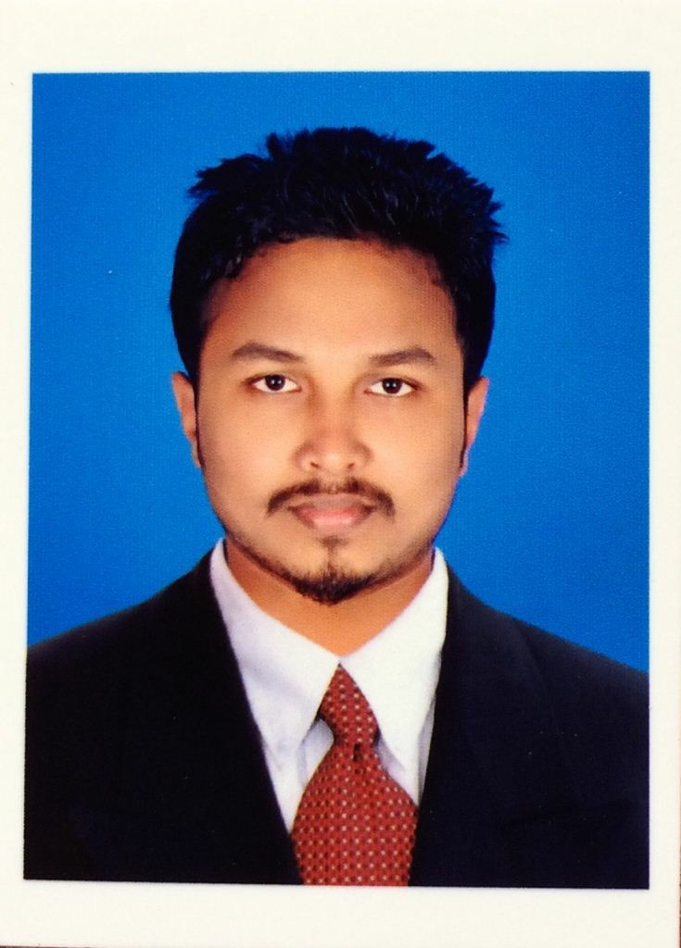

*MOHAMED SANOOJ S*

*Email id :* [***mohamedsanooj07@gmail.com***](mailto:mohamedsanooj07@gmail.com)

*Mobile No : +971-588213769*

***To obtain a full time position in a company that offers a professional working environment and enables me as a graduate to grow while meeting the corporation’s goals***

***PRESENT EMPLOYMENT***

## *Working as QA/QC Engineer in Al Shafar Steel Engineering LLC(ASSENT), Dubai UAE from May 2017* to till date*.*

***WORK EXPERIENCE***

***Area of Proficiency:***

* + *Inspection of incoming raw materials, electrode inspection as per ASME Sec II Part-C.*
  + *Fit up inspection, alignment, dimensions, bevel angel, bevel face, root face, root gap, surface cleanliness, and tack weld.*
  + *Pre-weld inspection, welding equipment, preheating requirements, electrode baking, oven, quivers.*
  + *In process weld inspection, setting of current manipulation of electrode, inter-pass cleaning, inter- pass temp, root run inspection.*
  + *Visual inspection of weld and NDT requirements as per AWS D1.1 structural steel welding.*
  + *Dimension inspection, length, breadth, thickness, hole dia, pitch distance, diagonal QA/QC documentation such as verification of mill test certificate, electrode test certificate, preparation of dimensional report, preparation of weld visual report. Review the approved drawings & scope of work.*
  + *Review of WPS, PQR and welder qualification certificates.*
  + *Verification of material test reports as per client requirements.*
  + *Witnessing Welder Performance Qualification Testing (WPQT).*
  + *Monitoring the welding Activities as per WPS.*
  + *Witnessing of Mechanical tests tensile test, Hardness test, Impact Toughness test for procedure qualification as per standard EN 10025-2:2004, ASME Sec II Part A&B.*
  + *Witnessing non-destructive testing for welds which involves MT, PT,RT &UT*
  + *Suggestion of methods / procedures to improve the quality of working.*
  + *Preparation of daily welding inspection reports as per agreed formats to the projects.*
* *Controlling and monitoring all QC&NDT activities as per approved procedures and inspection*

***PREVIOUS EMPLOYMENT***

## *Worked as QA/QC Engineer under Larsen & Toubro Ltd in Reliance J3 SEZ Project from May 2015 to* April 2016.

***Job Responsibilities:***

* *Ensure welding defects and welding symbols at all levels.*
* *As per the construction drawing ( P&ID,GAD,ISOMETRIC ) the pipe should be erected.*
* *Check the fitup by the leveling scale and pendulum.*
* *Inspect and follow the welding process ( ARC,MIG,TIG,FCAW ) the pipe should be welded.*
* *Inspect the weld before,during and after.*
* *Identify the welding defects (Cracks, Undercut, Porosity, Overlap, Spatter, Excessive Conversity&Concavity, Excessive weld reinforcement )*
* *After welding, check the quality of welding by Liquid Penetrant Test*
* *Conduct weekly / monthly quality meetings.*

***ACADEMIC QUALIFICATIONS***

# *B.E (MECHANICAL ENGINEERING) 6.7 CGPA – 2015*

*Mar Ephraem College of Engineering and Technology, India.*

# *with 63.9%-2011*

*ABC Matriculation Higher Secondary School, India.*

***PROFESSIONAL QUALIFICATIONS***

## *DIPLOMA IN WELDING ENGINEERNIG AND TECHNOLOGY*

*Annamalai University, India.*

## *QA/QC, PIPING AND PIPELINE ENGINEERING, NDT (ASNT LEVEL 11)*

*TechShore Inspection Services, Kochi, India.*

***ACADEMIC TRAINING***

## *PROJECT WORK:*

***Main Project:*** *Mechanical Property of Coconut Husk Fibre Reinforced Polyester Composite* ***Mini Project :*** *Design and Fabrication of Solar Powered Grass Cutter.*

## *WORKSHOP PARTICIPATED:*

* + - * *ROBO-ZEST’15 International level Robotics Championship.*

***DESIGNING/DRAFTING SOFTWARES***

* + - * *AUTOCAD*
      * *Ansys*
      * *Solid Edge*

***LANGUAGES KNOWN***

*English -Speaking, Reading & Writing* Arabic -Reading & Writing Malayalam -Speaking, Reading & Writing Tamil -Speaking, Reading & Writing

*Hindi -Speaking*

***PERSONAL DETAILS***

*D.O.B :26th September, 1993*

*Gender :Male*

*Father’s Name :Saleem M*

*Nationality :Indian*

*Religion :Islam*

*Passport No :N0068596*

***DECLARATION***

*I hereby declare that all the information stated above is true to the best of my knowledge.*

*(MOHAMED SANOOJ S)*