# WORK EXPERIENCE

## Enrich Hair and Skin Solutions Pvt.

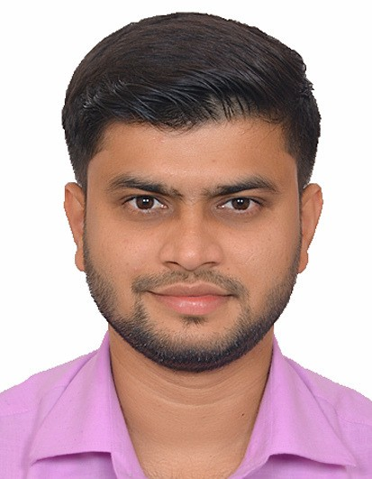

Ltd. – Senior Executive (January 2017

– Till Date)

Handling daily operations in the Salon.

Organize shifts for the employees according to the peak hours and seasons.

Promotions of products and services delivered by the Salon.

Overlook discounts and schemes made available to the clients.

Maintaining tracker for the payments received from the clients and preparing daily MIS.

Tracking the inventory/stocks required in the branch.

Maintain records of the staff inclusive of their salary and working schedule.

# PRASHANT MORE

9987427687

[pmore2985@gmail.com](mailto:pmore2985@gmail.com)

PROFILE

BMS graduate with almost 3.5 years of experience in the field of Sales & Marketing with a reputed organization.

Good interpersonal and organisational skills.

Critical thinker with decision making skills

# WORK EXPERIENCE

## HDFC Developers Ltd (HDFC Red) – Associate (July 2014 – October 2016)



Content Addition.

Worked on a high end product called ‘Brandstore’.

Handled online property exhibitions – Collecting and entering data, working on creatives.

Communicating with the support team and other departments for solving, implementing client’s and organization’s needs.

# PRASHANT MORE

9987427687

[pmore2985@gmail.com](mailto:pmore2985@gmail.com)

SKILLS

Basic knowledge of Microsoft Office, Excel, Internet.

Communication Skills, Negotiations Skills, Analytical Skills.