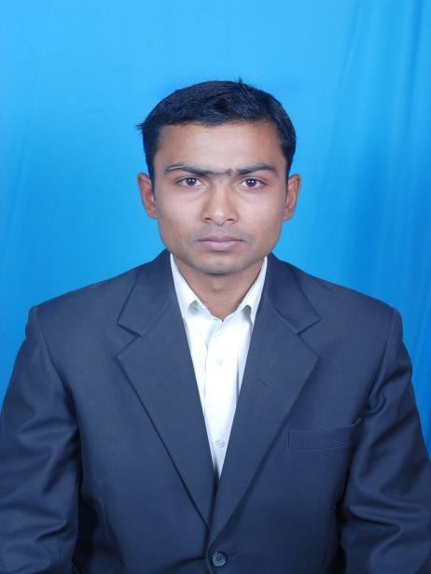

**ELECT R IC AL ENGINE ER**

**REHAN REZA**

**PERSONAL DATA**

Date of Birth 02.02.1992 Sex Male

Nationality Indian

Religion Islam Marital status Unmarried PASSPORT NO-L2379826

PASSPORT VALIDITY-14/05/2023

**E-MAIL**

[**rehan.reza5@gmail.com**](mailto:reza5@gmail.com)

**PRESENT ADDRESS**

S/O-REYAZ AHMAD, VILL-CHAPARA FARID, GANJ MISRAULIA,

PO-CHANDANPATTI, DIST-MUZAFFARPUR BIHAR,INDIA

**OBJECTIVE**

Seeking to be a professional in a dynamic work culture where I can utilize my skills, which I have been learning through my education and experience.

**EDUCATION**

**Diploma** in **Electrical and Electronics Engineering** from **MES Polytechnic ,** Madhugiri, Tumkur,

Karnataka, India.

Year of Passing:2011

**B.Tech.** in **Electrical Engineering** from KARNATAKA STATE OPEN UNIVERSITY,MAYSORE,INDIA

Year of Passing: 2016

**CURRENT INDUSTRY**

EPC ELECTRICAL, PROJECTS, EXECUTION, BILLING, AS BUILT DRAWING ETC**.**

**COMPUTER KNOWLEDGE**

MS Office Application. AutoCAD

**AREA OF INTEREST**

**Electrical(L.V.,INDUSTRIAL,INTERNAL & EXTERNAL**

**ELECTRICAL WORK)**

**LANGUAGES KNOWN**

ENGLISH-READ,WRITE,SPEAK HINDI-READ,WRITE,SPEAK URDU-READ,WRITE,SPEAK ARABIC-READ,WRITE KANNADA-SPEAK

**OTHER DETAILS**

NOTICE PERIOD-30 DAYS CURRENT LOCATION-NEW DELHI AGE-24 YEARS

SKYPE ID-REHAN.REZA3 PASSPORT NO-L2379826 PASSPORT VALIDITY-14/05/2023

CONTACT N0-+919738049168,+917503697949

**EMPLOYMENT HISTORY**

A.P. ENGINEERS & INTERIORS

PVT. LTD.,NEW DELHI APRIL 2014 to TILL DATE CLEINT: MADE EASY GROUP

NAVYUG ENERGY SOLUTIONS JUNE 2011 TO MARCH 2014 PVT. LTD. ,BANGALORE

CLIENT:BIAL,BANGALORE

B L KASHYAP & SONS LIMITED DEC 2009 TO JUNE 2010

**JOB RESPONSIBILITIES**

Electrical Low Tension Installation of LT Transformer, LT Panels etc.

Installation & operation maintenance of 11Kv/440V Transformer with OLTC, Diesel Generating Sets.

Excellent working knowledge in UPS, Fire Alarm System, CCTV Camera.

Electrical Hose/Commercial Wiring In house, Hotels, Commercial Buildings, Rising Main etc.

Better co-ordination with other Depts. To work in a unison for smooth operation and maintenance of Industrial Appliances, plant.

Keeping all round vigilance of men, material and machinery. Maintain relevant plant records and maintenance of other documents.

Strict adherence of safety measure and usage of safety appliances by all concerned.

**DECLARATION**

I hereby declare that the information furnished above is true to the best of my Knowledge.

Yours’ truly,

Place : NEW DELHI

Date : **(REHAN REZA)**