**ANOOP.M. R**

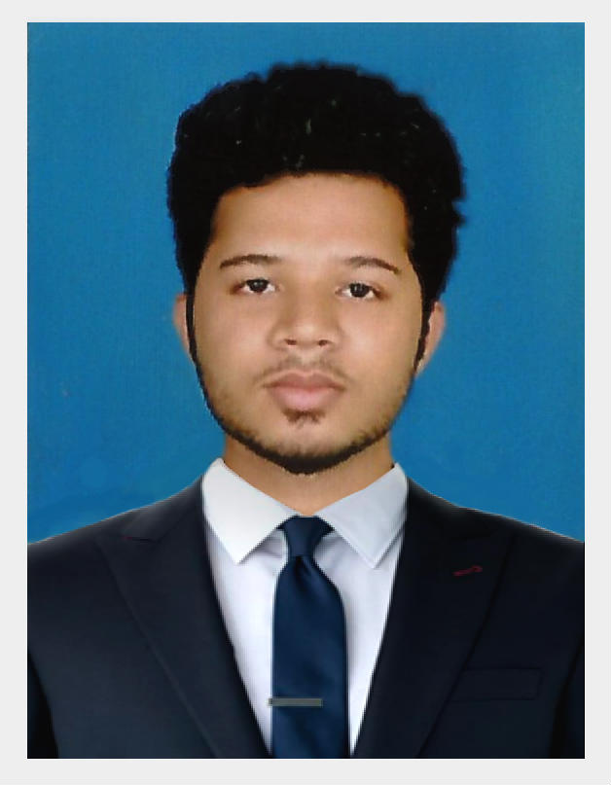

[anoopmr030@gmail.com](mailto:anoopmr030@gmail.com)

 +91 7550020084

+971 501419645

***Professional Summary***

Extremely seasoned and reliable **HVAC Project Engineer** with proven ability to handle short- and long-term projects successfully. Able to bring the majority of projects to completion under customer budget at or ahead of customer deadlines. Effective at managing both small and large technical project teams.

**Core Qualifications**

* Significant HVAC project management experience
* Good grasp of HVAC engineering design programs
* Sound knowledge of sizing layout and calculation of plumbing and HVAC projects
* Exceptional expertise in commissioning and installing HVAC equipment
* Outstanding budget and project management skills
* Superior organizational and communication skills
* High skills in water and air balancing procedures
* Profound skill in construction and investigation services

**Career objectives**

To have a growth oriented and challenging career, where I can contribute my knowledge and skills to the organization and enhance my experience through continuous learning and teamwork.

**Professional objectives**

Seeking an internship to contribute significantly to the organization by making use of my personal skill and knowledge and to enhance the same through continuous learning and to achieve new heights in my career, while being innovative, sincere and hard working.

**Experience**

* ***SA ENTERPRISES***

Designation …………………….……………..Design Engineer-Sheet Metal

Duration ……………………………………… December 2014 to November 2014

Clients …………………………………………Blue Star, S&W, Ashok Leyland

***Job Descriptions***

* Designing sheet metal parts of HT LT Electrical panel boars.
* Tooling program for AMADA A1 punching Machine.
* Monitored and ensured proper project execution.
* Conducted monthly audits to ensure timely project completion.
* Performed post-project job performance evaluations.
* ***SOFT AIR ENGINEERING PVT LTD.***

Designation ………………………………… HVAC Project Engineer

Duration ……………………………………. December 2014 to till now

Current Project …………………………….. VR Mall Chennai

Client ……………………………………….. BLUE STAR Ltd.

***Job Descriptions***

* Monitored and ensured proper project execution.
* Adhered to customer specifications in submitting material requests.
* Obtained major project items such as exhaust fans and pumps.
* Conducted monthly audits to ensure timely project completion.
* Performed post-project job performance evaluations.

**Academic & Professional Qualification**

**B.E Mechanical Engineering with 7.1 CGPA (2014)**

E.G.S.P College of Engineering-Nagapattinam, Under Anna University, Chennai

**H.S.C with 68% Aggregate (2010)**

Govt. HSS Balanthode, Kerala, India

**Key Skills**

* Experienced in Piping related drawings like isometric/3D designing in Auto CAD,
* Solid Works and Pro-E/Creo
* Microsoft office
* Adobe Photoshop
* Windows 10

**Area of Interest**

* Mechanical designing and analysis.
* Maintenance Engineering.

**Project Done**

Project Area ……………………Design and Development

Project Title…………………… Bottom pouring magnesium stir casting furnace

Role ……...……………………. Leads the team in designing and analyzing.

Software used for Designing …... Solid Works-2010, Auto CAD

Software used for Analyzing …… Ansys V5

**Industrial Visit & Trainings in**

* Royal Enfield Factory, Chennai
* Tamil Nadu transport corporation Kumbakonam division
* ONGC Karaikal.
* Non-Distractive Testing (NDT GRADE-II).
* NIOS industrial safety.

**Certifications**

* Certification in Auto CAD, Creo/Pro E and GD&T.
* Certification in Non-Distractive Testing (NDT GRADE-II).
* Certification in CNC programming and automation.
* Certification in NIOS industrial safety.

**Personal Profile**

Date of Birth : 31.12.1991

Gender : Male

Nationality : Indian

Father’s Name : Raveendran

Religion : Hindu

Marital status : Single

Languages Known : English ,Malayalam ,Tamil & Hindi.

***Present Address*  Permanent Address**

Padmam, Kavaraparambu Thekkethaniyottu House

House No 70/1 Ellukochi, Karake Village

L.P.S. Road – Palarivattom Post Coorge Post, Karnataka State

Kochi – India, Pin 682025 India

Phone: +914842335891 Pin:571247

**Passport Details**

Passport Number : N6960942

Place of Issue : Bangalore, Karnataka.

Date of Issue : 03/02/2016

Date of Expiry : 02/02/2026

**Reference**

Available upon request.

Date: 14/01/2017

Place: Chennai

ANOOP.M. R