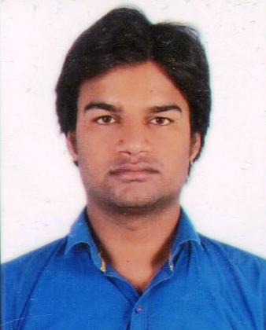

**AKHLAKUR RAHMAN**

Electrical Engineer

**Corresponding Address: Contact**

F-100/2f Shaheen Bagh Cell :+91-7827830774,+91-7070669464

Jamia Nagar Okhla New Delhi-25  **Email:-akhlak07827@gmail.com**

**Objective:**

Position in the Electrical Engineering Field, to be an accomplished professional and use effectively all my technical skills to the best of my ability & intelligence to contribute the growth of organization.

**Professional Qualification:**

* + **Bachelor of Technology (Electrical & Electronics)** from **MAHARISHI DAYANAND UNIVERSITY, HARYANA-** in 2012.

**Academic Qualification:**

* + Senior Secondary education from **BIHAR BOARD.**
  + Higher Secondary education from **BIHAR BOARD**.

**Work Experience:**

**Current Employer**

* + **Asian Construction Company.** from 10/06/2016 to Present

**Previous Employee**

* + **Vijay Electricals Ltd.** from **03**/09/2014 to 30/05/2016**.**
  + **Surya Construction Company** from 13/07/20012 to 03/08/2014

**Project Handle**

* NISD building at Dwarika Sector 10 New Delhi **(ASIAN CONSTRUCTION COMPANY)**
* **33/11/0.44kV** Rural Electrification at Bihar **(** **VIJAY ELECTRICALS LTD)**
* **Tera Elegance** Building at Bhiwadi **(SURYA CONSTRUCTION COMPANY )**

**Designation:** **Electrical Site Engineer.**

**(MEP DEPARTMENT)**

**Job Description :**

* + Work accordance with **CPWD** (Central Public Work Department) with **BOQ** (Bill Of Quantities.
  + Handling all the electrical works considering the safety and quality requirements, Work accordance with Auto Cad Drawing, Work accordance with electrical calculation like (**LUX**) (**VOLTAGE**) (**CURRENT**) (**POWER)** etc.,Preparation of daily progress report (**DPR**). Supervision of work to ensure progress as per schedule & execution as per approved drawing and specification., Sound Knowledge about Installation of Circuit breakers , relays, Conduit and duct banks.
  + Understanding of Single line diagram (**SLD** Managing & Execution of Electrical Project, Co-ordinating with clients, consultant, contractors & vendors, installation of transformer and D.G. set. Erection of H.T. and main L.T. panels including cabling with termination. Conducting lighting with wiring. Erection of cable trays support for laying of L.T. cables. And understanding **Fire Fighting** and **HVAC** like (**M.E.P)**

certification of measurement book from concern authorities. Preparing overall project scheduled and billing schedule. Preparing schedule of recourses,

**Summary of Skills:**

• monitoring all site activities on real time basis to ensure completion of project with in time and cost parameters for effective resources deployment to maximize the out put.

· Ensuring timely availability of man power and equipment/material for completion of project

• liaising with clients, consultant, contractors and external agencies for determining technical specification, approval and obtaining statutory clearances.

• Reconciliation of materials received at site/stores. Implementing quality and safety standards at site.

**Computer skills:**

· MS Word, Power Point, MS Excel.

· Language HTML, Basic of C.

· **Matlab** **Simulation**.

· **AUTO-CAD** from **HR INTERNATIONAL GROUP.**

**Interpersonal:**

· A Highly motivated team player with the ability to quickly & integrate new idea.

• Communicating & performing in a dynamic & cross-functional environment.

• Leading, supervising and taking ownership of projects and their deliverables.

· Meeting deadlines & working under pressure.

**Achievement:**

**•**  **3rd** rank in **5th** & **6th** semester in B.TECH

**•** **1st** rank in **7th** & **8th** semester in B.TECH

**Personal Details:**

**• Father’s Name : Motiur Rahman**

**• Date of Birth : 4th** **JAN 1990**

**• Marital Status : Single**

**• Nationality : Indian**

**• Religion : Islam**

* **Hobbies : watching News, Listening music.**
* **Strengths : Hardworking, Honest & Self Confident**
* **Permanent Address : Village-Sareyan, P.S-Basantpur,**

**Distt-Siwan,Pin:-(841406),Bihar,India**

·  **Passport no. : M8780042**

·  **Date of issue : 24-04-2015**

·  **Date of expiry : 23-04-2025**

**I clearly declared that all above information are true on my behalf.**

**Date**: (**AKHLAKUR RAHMAN**)

**Place: New Delhi**