## 

## Resume

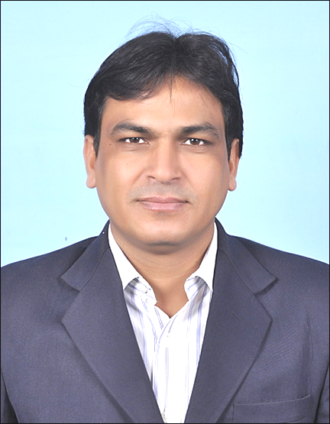

**Gayyur Alam**

Mob: + 91 9818232612

E-mail: gayyur_alam@yahoo.co.in

Residence : Bharat City, Ghaziabad.

An Electrical Engineer with **18 Years’ Experience** in Facilities Management for Shopping Malls, IT, Corporate and Residential Building etc.

**_________________________________________________________________________**

**Career Objective:**

To work with a reputed organization where my knowledge & creative potential can be put to use for rapid growth and contribute towards company goals by undertaking challenging assignments.

**Professional Qualification:**

* 3 Years Electrical Engineering Diploma (Regular) from M G Polytechnic Hathras (U.P.) in 1996 with 72% marks.

**(2)**

**Organizational Experience:**

**Apprenticeship:**  **M/s Indfos Industries.Ltd. Ghaziabad.**

**Period:**  May 97 to April 1998. (1 Year)

**Designation: Trainee**

**Previous Job:**  M/s Utec Corporation Pvt. Ltd. Ghaziabad.

**Period:**  May 98 to Sep 2004. (6 Year)

**Designation:**  Facility Engineer

**Site:**  **CPWD, UPPCL & Mother Dairy Delhi.**

**Previous Job:**  M/s A2Z Facilities Management Pvt. Ltd. Gurgaon.

**Period: Oct** 2004 to Sep 2008. (4 Year)

**Designation:** Facility Engineer

**Site: 1) M/s Crown Interiors Mall Faridabad.**

**2) M/s DLF City Centre Mall Gurgaon.**

**Present :** M/s Nimbus Harbor Facilities Management Pvt. Ltd. Gurgaon (Haryana).

**Period :** Oct 2008 to till date.

**Designation:**  Facility Manager

**Site: A) M/s NIIT Technologies (Software Company) Sec-63, Noida (2 L sq. ft.)**

From Oct 2008 to Nov 2013 (5 Years)

**B) Amarpali Sapphire -Residential site, Sec-45, Noida. (15 Towers,)**

Jan 2014 to Dec 2014 (1 Year)

**C) ETT2, Sector 132, Noida (Commercial 10 Lakhs sq. ft in 4 towers-80 tenants,) Since** Jan 2015 to till date .

**(3)**

**Job Profile**

**Electrical**

* **Operation and Maintenance of 33 KV Electric Substation.( VCB –Crompton make,4x200 Amp , Transformer- 33/.415 KV, 4X 2500 KVA Crompton make with RTCC,**
* **Operation and Maintenance of LT Pane includes Capacitor Panel, , ACB up to 4000 Amps, PLC & Woodward Synchronizing Panel**
* **Operation and Maintenance of D.G Set (2000 KVA, 1250KVA, 750KVA and 500 KVA).**
* **Operation & Maintenance of Lift/Escalator.**
* **Operation & Maintenance of UPS (3x120 Kva, 2x60Kva).**
* **Energy Management.**

**HVAC**

* **Operation and Maintenance of Air Conditioning Center Plants (3x360 TR).**
* **Operation of BMS (Honeywell EBI R430) for Air Conditioning.**
* **Operation and Maintenance of Split, window & Package AC.**
* **Operation & Maintenance of VRF, VRV, LG Make up to 20 HP (100 Units).**

**Fire & Plumbing System**

* **Fixed Fire Fighting System (Water Pumps & Extinguishers).**
* **Operation & Maintenance of Fire Alarm, CCTV and Access Control.**
* **Softener, Filtration & RO System.**
* **STP Plant-180 KL , MBBR , Hydratech Make**
* **Wash Rooms plumbing System.**

**Site Transition:**

* **Site Handover from Project Team to O& M Team.**
* **Making Snag list.**
* **Checking All Manuals, Drawings & Testing report and warranty latter.**

**Soft Services**

* **Handling Housekeeping.**
* **Client Visit & Events.**

**(4)**

**Administrative**

* **Follow up with AMC Vendors.**
* **Handling Corresponding with branch offices and external Agencies**
* **Arranging Staff Meeting, Assigning of Jobs, Follow ups Complaints analysis to Improve the efficiency of the Department**
* **Preparation of Various Report like Weekly/Monthly& Yearly Electrical, Daily MIS Report, Recommended Spare Parts and Maintenance Budget**.
* **Laisioning with Govt. Body/Auth.**

**Computer Proficiency**

**MS office and MS Outlook-E. Mails**

**Personal Details:**

**Marital Status : Married**

**Nationality : Indian**

**Religion : Islam**

**Language Known : Hindi, English, Urdu.**

**Gender : Male**

**Age : 40 years**

**Pass Port No : J 3772202**

**Pass Port Issue date : 29/9/2010**

**Pass Port Expiry date : 28/9/2020**

**Salary Expectation : Negotiable**

**Notice period : 30 days**

**Place : Noida**

**(Gayyur Alam)**