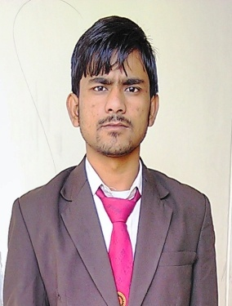 **MD TAJAMMIL HAQUE**

MOBAIL NO +918847026322

Email:- Mdtajammilhaque0786@gmail.com

***OBJECTIVE:****To be a part of result oriented professionalsof an organization that provide a challenging innovative work environment and opportunities where I can learn and enhance my professional knowledge.*

***EDUCATIONAL QUALIFICATIONS:***

* Diploma in Mechanical Engineering: From HSBTE Haryana Education in 2015(6th semester68% marks )
* HSC:From BSEB Patna in 2011 (57% marks)
* SSC:From BSEB Patna in 2013 (58% marks)

***TECHNICAL SKILLS****:*

Software known: - Solid works 2013, Microsoftoffice.Autodesk Inventor

Language known: - English, Hindi& Urdu.

***DIPLOMA PROJECT DETAILS****:*

Project Name : Pedal powered Eco friendly hacksaw machine

Role : Team leader

Team Member : 08 persons

Duration :01 month.

***SUMMER TRAINING*:** One month training in Industrial automation in M/s Maruti Suzuki India Ltd on behalf of M/s Vertex Power Controls Private Limited (GURGOAN)

PREVIOUS PROFESSIONAL EXPERIENCE:-

Organization: HINDUSTAN AERO SYSTEM. PVT, LTD,( j-26 sec,63 Noida)

Company profile: Housing, Bezel, Front panel, Body Recepticale and piston pin Manufacturing Company

Designation: GET ENGINEER

Department: Quality Control

Duration: 3 Year

***PROFESSIONAL STRENGTHS:-***

* Diploma in MECH Engg. from SRM College of Technical Education (H.S.B.T.E).
* Systematic approach towards work.
* Self-belief and positive Attitude.
* Quick Learner in emerging technologies.

***PERSONAL DETAIL:-***

DOB : 17/05/1995

Sex : Male

Hobbies : Reading books and magazines, helping needy people.

Languages Known : English, Hindi and Urdu,

Nationality : Indian

Marital Status : Unmarried

Religion : Islam

*DECLARATION****:*** I hereby declare that all the information mentioned above is true in best of knowledge and belief.

Date: - …………………

Place ( NOIDA).

(MD TAJAMMIL HAQUE)