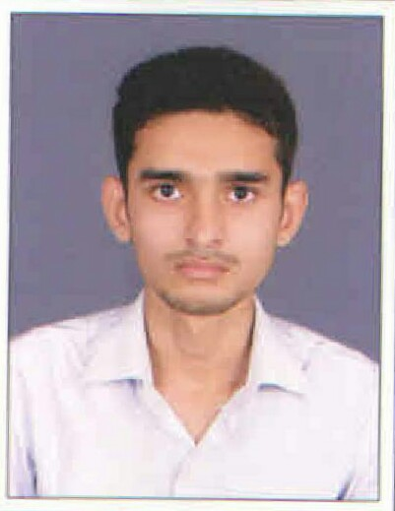

**Curriculum Vitae**

##### Kalsariya Haresh H.

195, Nandanvan Society,

Bapa Sitaram Chowk,

Katargam, Surat,Gujarat.-395004.

Mob. : +91 7383499072

+91 7984202595

Email : kalsariyagigs@gmail.com

**Objective**

Seeking a challenging position according to my organizational skills and knowledge to the best of my ability where I can utilize my Knowledge and skills as well as which allows me to learn New Work while utilizing my experience.

**Computer Skills**

CCC, Basic, Internet,Excel

**Personal Skills**

* Team Leader
* Management
* Supervising / Petzl Level-3 Training Certificate By Allied

**Academic Records**

|  |  |  |  |
| --- | --- | --- | --- |
| ***Examination*** | ***Board*** | ***Passing Year*** | ***Percentages*** |
| S.S.C. | G.S.E.B. | March 2011 | 80.00% |
| Mechanical Engg. | Diploma | March 2014 | 6.5 SPI% |

**Job Experience**

|  |  |  |
| --- | --- | --- |
| ***Name of Organisation*** | ***Designation*** | ***Duration*** |
| Trucept Solution Pvt. Ltd. | CCE (Customer care Executive) | 6 Months (Part Time) |
| Laser Sos India Pvt. Ltd. | Service Engineer | 1 Year |
| Gujarat Gas Ltd. | Site Supervisor | Since 17th March 2016 |

**Personal Details**

|  |  |
| --- | --- |
| Full Name | Kalsariya Haresh Himmatbhai |
| Date of Birth | 9th January, 1996 |
| Nationality | Indian |
| Caste | Hindu- Prajapati |
| Marital Status | Unmarried |
| Gender | Male |
| Language Known | Gujarati, Hindi & English |
| Hobbies | Reading, Travelling, Learning New Things |

**Declaration**

I assure you that above stated information are true to best my knowledge and work in your organisation with sincerity and honestly.

Thanking you.

Date : ------------------------------------

Place :  ***(Kalsariya Haresh H..)***