**CURRICULUM VITAE**

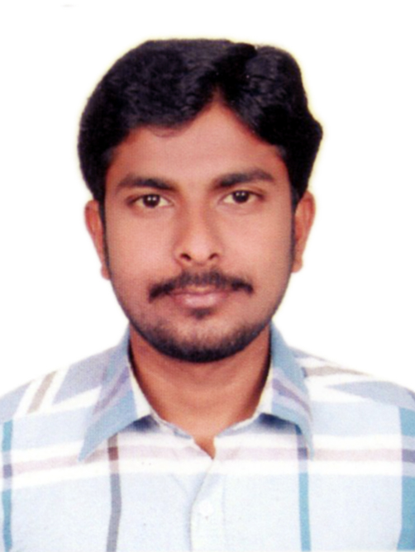

**MOHAMED FAIZAL .K.M.**

**B.E.EEE ­**

E-mail: [mohamedfaizal13@yahoo](mailto:mohamedfaizal13@yahoo).com

Mobile-No: +91 9750342113

**OBJECTIVE:**

To become a successful professional in the field of Electrical & Electronics and to work in an innovative and competitive world.

EDUCATIONAL QUALIFICATIONS:

|  |  |  |  |
| --- | --- | --- | --- |
| **EXAMINATION** | **INSTITUTION** | **BOARD\**  **UNIVERSITY** | **YEAR OF**  **PASSING** |
| SSLC | Hithayathul Islam Hr Sec School, Kadayanallur. | State Board | 2007 |
| DEEE | Scad Polytechnic College ,  Cheranmahadevi | DOTE | 2010 |
| BE(EEE) | Sarthar Raja College Of Engineering, Alangulam | UNIVERSITY | 2014 |

**Passport Details**

Name : MOHAMED FAIZAL

Passport Number : N1987005

Place of Issue : MADURAI

Date of Issue : 11/08/2015

Date of Expiry : 10/08/2025

Driving License : Having Indian License

**PROJECTS DETAILS:**

DiplomaProject : Multi System Multi Technician Fault Intimation System Using RF

Communication

Engineering Project : Intelligent fuzzy using MPPT Controller

**COMPUTER SKILL SET:**

Computer Hardware Assembling and software installation

Operating System : Windows XP, Vista, Win 7, Win8 & 8.1

Package : MS Office

Software : Auto Cad, Orcad, Hardware &Networking

Service : Mobile Phone

**SPECIAL INTEREST:**

* Electrical Work
* Systematic
* Auto CAD

**EXPERIENCE:**

**INTEL COMPUTER TRAINING CENTRE**

Working as Auto CAD faculty from June 2010 to July 2011, and

Hardware& Networking faculty from June 2010 to July 2011

**GENN CONTRLS INDIA PVT LMT IN COIMBATORE**

Production Engineer in Machining Process (2012- 2017)

**PERSONAL PROFILE:**

Father’s Name : K.M. Mohamed Hanifa

Date of Birth : 30.03.1992

Sex : Male

Nationality : Indian

Marital Status : Single

Permanent Address : 99/26, Allimoopan Street

Kadayanallur – 627751,

Tirunelveli District,

Tamil Nadu.

Interests and activities : Reading historical books, Sports

Languages : Tamil, English

**OTHER ACTIVITIES:**

* + Social Activities
  + Positive Thinking, Being flexible
  + Motivating Team player

**DECLARATION**

`I hereby declare that the information and facts stated above are true and correct to the best of my knowledge and belief.

Place: Yours Faithfully

Date:  **K.M.MOHAMED FAIZAL**