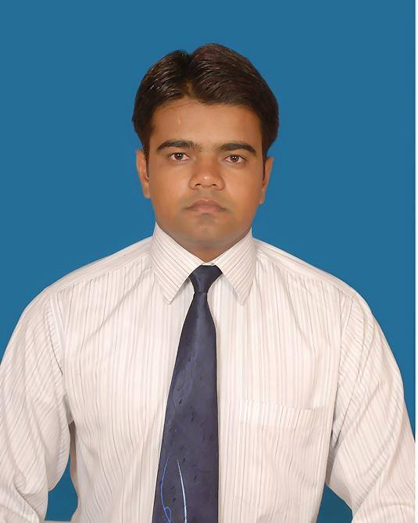**ASHRAF ALI**

**Address –**

**4/917, “MEER QADA”,**

**Behind Faiz -E- Aam Masjid, Gulzar Gali,**

**Jamalpur, Aligarh 202002. (U.P.)**

**+91-9259112225, 9015156857**

[**ashrafalimeer@gmail.com**](mailto:ashrafalimeer@gmail.com)

**Objective**

To join an organization that respects the individuality of professionally committed person with aim of mutual cooperation, promotion of skill enhancement, utilization of skills to achieve the organization’s objective.

**Current Experience**

* **19 May, 2015 - Till Date...** Presently I am working as a **Jr. Site Engineer in P.M.C Built Well Solutions Delhi.**
* **19 Feb, 2013. To 11 May, 2015. (Civil)**  **Supervisor** in **Shreenath Group** in **Aligarh Muslim University Aligarh.**

**Job Responsibilities**

* Supervision f activity, like Excavationbackfilling.
* Blok work finishing.
* Plaster and finishing work according to the approved Drawing**.**
* Layout & Construction Work of Boys & Girls Hostel.
* Daily workload and activity monitoring.

**Professional Qualification**

**Diploma in Engineering** **(Civil)** 73.42% from **Board of Technical Education** Uttar Pradesh. **(2013)**

**Project**

* I have done my one month Summer Training Project in **Utter Pradesh State Bridge Corporation Ltd.** Aligarh. Under the Supervision Assistant Engineer Mr. Jangveer Singh. **(20/06/2012 to 18/07/2012)**

**Professional Profile**

Positive attitude, excellent communication and self correspondence skills & ability to learn more whilst working on the job.

**Extra knowledge**

* MS Office 2007
* Auto CAD-2D

**Experience before Diploma**

**March, 2006 – Dec, 2009, (Civil)** Supervisorin **Pragati Construction Jhansi.**

**Job Responsibilities**

* Timely arrangements of the materials, manpower, & equipments needed for the work.
* Verify the quantity of required Constructions materials, its availability and request immediately to the procurement.
* Site supervision.
* Coordination with Consultant and architecture.
* Supervising the work progress.
* Daily workload and activity monitoring.

**Feb, 2003 – Jan, 2006,** **Supervisor (Civil)...** In **A. M. G. Infrastructure Noida**.

**Job Responsibilities**

* Site supervision.
* Coordination with Consultant and architecture.
* Supervising the work progress.
* Daily workload and activity monitoring

**Academic Qualification**

* Intermediate, UP Board. **(1999)**
* High School, UP Board. **(1997)**

**Personal Details**

Father’s Name **: (Late)** Mr. Shadab Ali

Nationality  **:** Indian

Marital Status **:** Single

Date of Birth **:** Jan 5th, 1982

Languages **:** English & Hindi.

Passport No. : M6041991

**Reference- ­­**

*On your demand.*

Date:

Place:

**(ASHRAF ALI)**