Curriculum Vitae

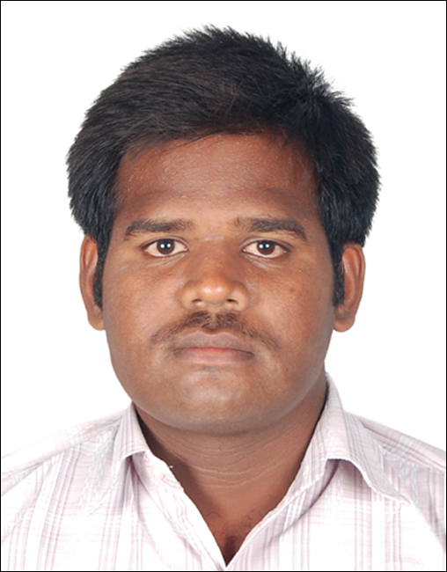

NARESH KUMAR.R E-MAIL ID: nareshtech4@gmail.com

POST APPLIED: SITE ENGINEER

MOBILE: +919944911372

**ASSETS**

* Great Communication Skill.
* Adapted and challenged to work in a team.
* Self-Motivated, Self-Confidence and Quick Learner.
* Strong analytical and problem solving skill.

**TECHNICAL TRAINING**

* **In plant Training:**

Attended one month In-plant Training at Tondiarpet to get real life experience on Multistorey

Building.

**PROFESSIONAL EXPERIENCE (4 YEARS)**

**NAME OF WORK : (765/400KV) SUB STATION, CONSTRUCTION OF**

**RESIDENTIAL BUILDING (G+2) at THIRUVALAM.**

**CLIENT : POWER GRID CORPORATION OF INDIA.**

**FIRM : KUMAR BUILDERS**

**DESIGNATION : JUNIOR SITE ENGINEER**

**PERIOD : JULY 2014 to JUNE 2016**

**JOB DESCRIPTION:**

**1. Ensure that field construction activities are maintained in accordance with project drawings,**

**Specification, Schedules, Construction Budjet, Procedures, Quality Requirements and Safety**

**Standards.**

**2. Site supervision/execution, checking and assuring that the construction work is as per the**

**Project Technical Specification and Drawing’s.**

**3. Conversant with architect and structural drawings.**

**4. Broaded Knowledge in YARD P.C.C and METAL SPREADING (765kv/400kv) at**

**Thiruvalam Substation.**

**5. Taking Sewerage line from Buildings with well-connecting chambers to Septic Tank.**

**6. Co-ordinate with sub-contractors for smooth flow of work.**

**7. Inspecting and Checking the Materials prior to their use at site as per sample approved by**

**Consultant.**

**8. Monitoring daily progress of site.**

**9. Preparing running account bills.**

**10. Preparing Weekly and Monthly Progress report to be submitted to the project director and**

**Consultants.**

**11. Ensuring that all work is done without wastage of Materials.**

**NAME OF WORK : DEVELOPMENT OF HUBALI AIRPORT (CONSTRUCTION OF**

**NEW TERMINAL BUILDING ATC TOWER cum TECHNICAL**

**BLOCK cum FIRE STATION, SUB-STATION AND OTHER**

**ANCILLARY BUILDINGS AND SERVICES at HUBALI.**

**CLIENT : AIRPORT AUTHORITY OF INDIA.**

**FIRM : LOGOS CONSTRUCTION PRIVATE LIMITED**

**DESIGNATION : SITE ENGINEER**

**PERIOD : JUNE 2016 to SEPTEMBER 2017**

**Job Responsibilities:**

# Setting out the work in accordance with the drawing and specification.

# Checking materials and work in progress for compliance with the specified requirements.

# Observance of safety requirements, persuade all labors to wear the safety gadgets

# Quality control in accordance with method statements, quality plans and inspection and test plans

1. Preparing of measurement books

# Maintaining of rain records, Hindrance register, site instruction report

# Prepare and maintaining of checklist for all work procedures at site

# Preparation of bar bending scheduled as per GFC.

# Evaluate and monitor all subcontractors’ performance.

# Keep a trace of subcontractors, equipments productivities.

# Schedule the work plan for projected week.

# Monitor the subcontractor’s performance daily and record it.

# Supervising and ensuring the sufficient labor deployment to achieve the day to day target.

# Work done measurement updating for labor payments.

# Providing data in respect of variation, orders, and site instructions.

# Preparing and record drawings, technical reports, site diary.

**NAME OF WORK : (400/220KV) SUB STATION, TOWER**

**FOUNDATIONS, STANDARD PREFABRICATED**

**R.C.C BOUNDARY WALL, R.C.C ROAD and OFFICE**

**BUILDING in PAVAGADA, TUMKUR DISTRICT.**

**KARNATAKA.**

**CLIENT : POWER GRID CORPORATION OF INDIA.**

**FIRM : AAKAR GROUPS**

**DESIGNATION : SITE ENGINEER**

**PERIOD : FROM SEPTEMBER 2017 (CURRENTLY WORKING).**

**JOB DESCRIPTION:**

**1. Ensure that field construction activities are maintained in accordance with project drawings,**

**Specification, Schedules, Construction Budget, Procedures, Quality Requirements and Safety**

**Standards.**

**2. Taking land Survey by Rise and fall method to get Average F.G.L for Excavation work of**

**Boundary wall.**

**3. Preparing B.B.S for column and panel slabs.**

**4. Inspecting and Checking the Materials prior to their use at site as per sample approved by**

**Consultant.**

**5. Monitoring daily progress of site.**

**6. Preparing running account bills.**

**7. Preparing Weekly and Monthly Progress report to be submitted to the project director and**

**Consultants.**

**SOFTWARES KNOWN**

* **AUTO CAD**
* **DCA (Diploma in Computer Application)**
* **MS-OFFICE**

**TECHNICAL SKILL ACHEIVEMENTS**

* **Work Shops**

**1. One day Workshop of CREATIVITY and INNOVATION Conducted by International Techno-**

**Management Fest-gra VITas’13 held at Vellore Institute of Technology (VIT University).**

**2. Have attended a two-day workshop on “REAL TIME ANALYSIS and DESIGN OF TALL**

**BUILDINGS” in ARUNAI COLLEGE of ENGINEERING.**

* **TECHNICAL PRESENTATIONS**

**1. Presented a Paper on MIVAN SHUTTERING in Eshwari engineering College and Won**

**Second Prize.**

**2. Participated a AD ZAP, Quiz, Model Making Event at ACE Tech Fest’13 in Eshwari engineering**

**College.**

**PROJECTS**

* **MINI-PROJECT**

**1. Planning, Designing and Estimating of RECTANGULAR AND CIRCULAR OVERHEAD**

**TANK.**

* **MAIN PROJECT**

**1. Planning, Designing, Estimating and Scheduling of MULTISTOREY BUILDING.**

**ACADEMIC PROFILE**

* **B.E Civil Engineering**

**6.3** CGPA (2014)

(Arunai College of Engineering)

(Under ANNA UNIVERSITY CHENNAI),

Tiruvannamalai.

* **Pre –University**

**80.16 %(** Sri Ramakrishna BHEL Hr Sec School**)**

Ranipet.

* **S.S.L.C**

**80.4%** (Sri Ramakrishna Higher Secondary School, Arcot.)

Walajapet

**EXTRACURRICULAR ACTIVITIES**

* **Sports**

1. Successfully attained the rank of **BLACK BELT** in “**GOJU-KAI” KARATE-DO TRAINING**

**SCHOOL, VELLORE.**

2. Participated in the Annual Sports in InterCollege CRICKET & Won Silver Medal.

**PERSONAL DETAILS**

Father’s Name : Mr.G.Rangan

Date of Birth : 22/12/1992

Age : 25

Sex : Male

Passport Number : M4782643

Nationality : Indian

Religion : Hindu

Languages Known : Tamil, English and Hindi.

Hobbies : Reading Books, Surfing net, and Playing Cricket.

Marital Status : Single

Permanent Address : 3/260, Shanthi Nagar, Melpudupet, Ammoor

Road, Walaja, Vellore Dist.Pin Code: 632513

Tamilnadu.

**DECLARATION:**

I hereby declare that all the information furnished above is true to the best of my knowledge.

**PLACE: WALAJA NARESH KUMAR.R**