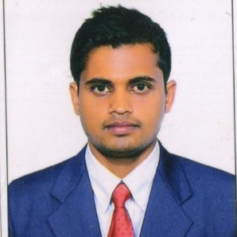

**MOHAMMED KHURSHED ALAM**

Village- Kharsahwan, Post-Shikarpur, Police station- Balthar , West Champaran Bihar 845307

9588257584

[khurshidg.gk@gmail.com](mailto:khurshidg.gk@gmail.com)

# CAREER OBJECTIVE

Hard-working student (3.5/4.0 GPA) with proven leadership and organizational skills, and minute attention to detail. Seeking to apply my abilities to ﬁll the internship role in your company. I am a dedicated team player who can be relied upon to help your company achieve its goals.

# EDUCATION

**SBTET TELANGANA STATE**

Electrical and Electronic Engineering 69.68

2016

# BSEB

Matriculation 76.8

2013

# EXPERIENCE

**Tecnimont ICB eng& congratulations**

Electrician Technician

*07/12/2016 - 27/06/2018*

# TECHNICAL SKILLS

Communication Skills

Ability to work under pressure Decision making

Time management Self motivated Conﬂict resolution Adaptability

# PERSONAL STRENGTHS

A Resourceful, result oriented professional with demonstrated ability in identifying potential strategic opportunities and implementing comprehensive section plans to achieve objective strong work ethics as well as excellent inter perusal and organization skills.

# PERSONAL PROFILE

Date of Birth : 29/08/1997 Marital Status : Single Nationality : Indian

Known Languages : English, Hindi and Urdu

Hobby : Playing cricket, internet surﬁng, reading motivational stories Passport : S3553232

Date of issue : 07/09/2018 Issue place : Patna

Date of expiry : 06/09/2028

# DECLARATION

I hereby declare that the above information is true and correct to the best of my knowledge and belief, I hope you will consider my C.V favorable and call me for interview with the delegate and prove my worthiness and capabilities i shall be ever grateful to you at all time. Thank you

Date : ........................

Place : ..........................