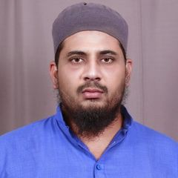

### CONTACT

**Saleem Ahmad**

**SALES/ACCOUNTANT**

at City Sanitary Store

Location: Delhi, India

Education : Master's degree, Laws

Location: Delhi, India

Name: Saleem Ahmad

Mobile Phone: +91.9917655470

Country: Delhi, India

Email Address: [saleemahmad007@gmail.com](mailto:saleemahmad007@gmail.com)

LAST ACTIVITY: 2018-11-29

REF.: CV46394009

### TARGET JOB

Target Job Title: Accountant,Salesman Career Level: Mid Career

Target Job Location: UAE; Saudi Arabia; Qatar

Employment Type: Full Time Employee; Internship; Contractor; Part Time Employee Target Monthly Salary: AED 5,000 (≈ USD 1,361)

Notice Period: 1 month or less

### PERSONAL INFORMATION

Birth Date 18 August 1987 (Age: 31) Gender Male

Nationality India

Residence Country Delhi, India Name in Arabic أﺣﻤﺪ ﺳﻠﻴﻢ

Marital Status Married Number of Dependents 5

Driving License Issued From India

### EXPERIENCE (11 YEARS, 7 MONTHS)

May 2015 - Present

# SALES/ACCOUNTANT

at City Sanitary Store

**Location:** Delhi, India **Company Industry:** Sales **Job Role:** Administration

I'm retailer/wholesaler of this ﬁrm, Selling pluming materials, bathﬁttings, sanitary items and tiles.

July 2011 - November 2018

# Architectural Drafting and Visualization

at City Home Construction Group

**Location:** Delhi, India

**Company Industry:** Construction

**Job Role:** Construction and Building

Its my own created group my position as 2D/3D draftsman/Contractor/Material Contractor. I have constructed a large number of houses, schools, marriage halls and hospital too.

Its my part time job till now

March 2008 - June 2010

# Accountant/Salesman

at Cotton County

**Location:** India

**Company Industry:** Sales

**Job Role:** Sales

In this company my role as Accountant/Saleman.(Full Time)

February 2007 - March 2010

# Medical Representative

at Sinomed Pharme

**Location:** Ghaziabad, India **Company Industry:** Pharmaceutical **Job Role:** Sales

July 2006 - January 2007

# Medical Representative

at Elder Health Care Limited

**Location:** Delhi, India

**Company Industry:** Pharmaceutical

**Job Role:** Sales Medical Representative

**Extra years of experience not listed above:** 0 Years, 2 Months

### EDUCATION

**Master's degree, Laws**

at M.J.P.Rohilkhand

**Location:** Ghaziabad, India May 2015

**Grade :** 54 out of 100

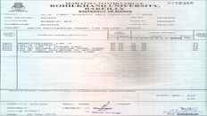Due to ﬁnancial crisis I have completed only ﬁrst semester.

# High school or equivalent, Urdu

at Jamia Urdu Aligarh

**Location:** Lucknow, India December 2011

**Grade :** 68 out of 100

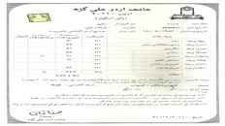

# Diploma, AutoCAD, 3DMax&Vray

at Planet-C

**Location:** Ghaziabad, India August 2011

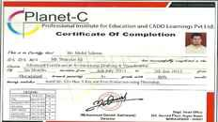**Grade :** 80 out of 100 Draftsman

# Bachelor's degree, Zoology

at M.J.P.Rohilkhand University

**Location:** Ghaziabad, India June 2009

**Grade :** 51 out of 100

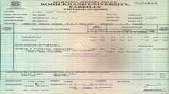

### SPECIALTIES

#### Human Behavior

Questions: 0

Answers: 0

#### Determination

Questions: 0

Answers: 0

#### Honesty

Questions: 0

Answers: 0

#### Communications

Questions: 0

Answers: 0

#### Leadership

Questions: 0

Answers: 0

### SKILLS

**COMMUNICATION**

**Level:** (Expert)

### Leadership

**Level:** (Expert)

### Adaptability

**Level:** (Expert)

### LANGUAGES

**Arabic**

**Level:** (Native)

### Hindi

**Level:** (Expert) | **Experience:** More than 10 years

### English

**Level:** (Expert)

### Urdu

**Level:** (Expert)

### TRAINING AND CERTIFICATIONS

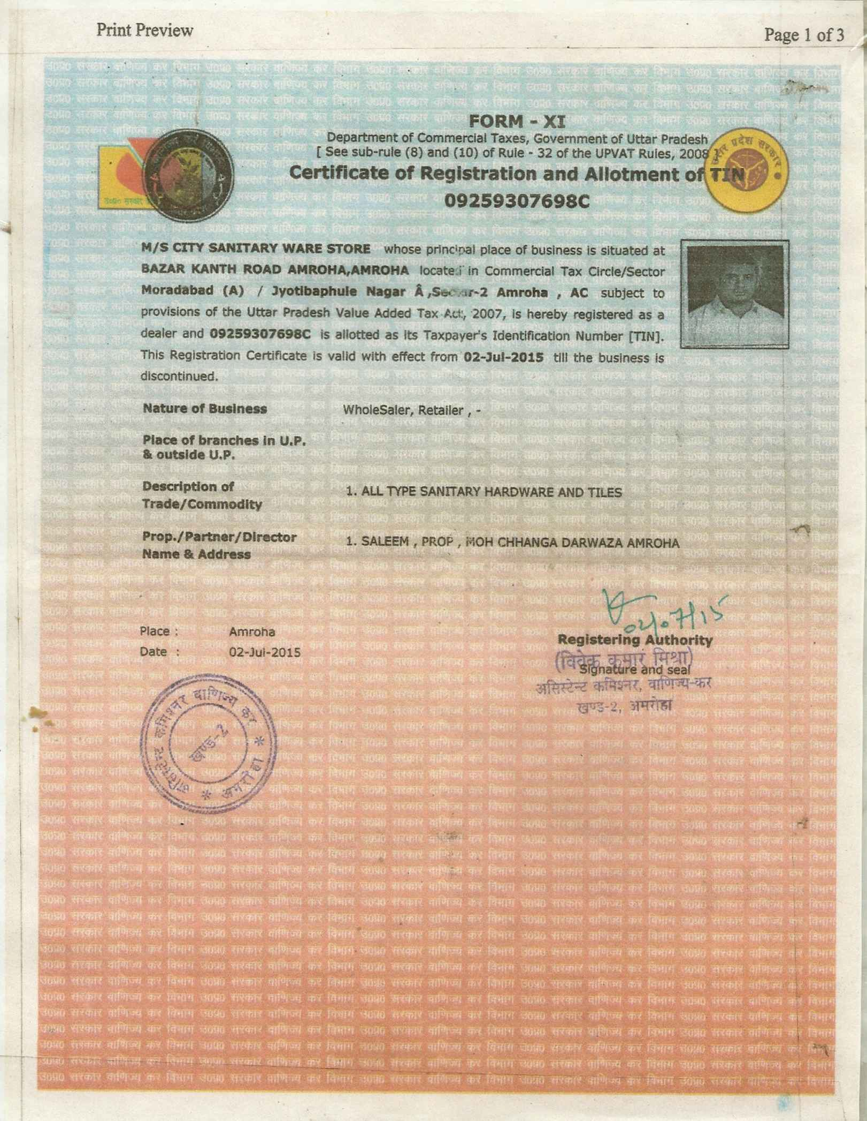**City Sanitaryware Store (Certiﬁcate)**

**Issued in:** July 2015

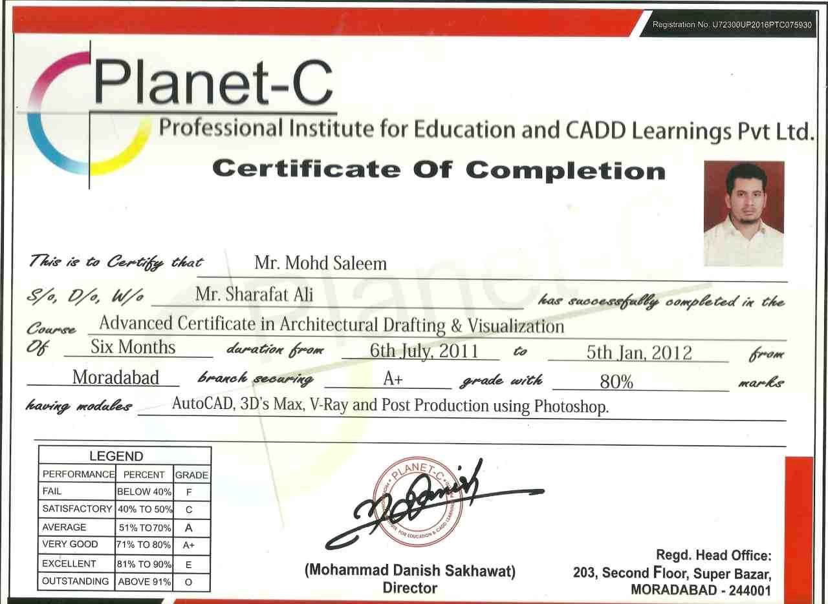**Architectural Drafting and Visualization (Certiﬁcate)**

**Issued in:** July 2011

## Medical Representative (Certiﬁcate)

**Issued in:** June 2006

## College activity (Certiﬁcate)

**Issued in:** May 2005

### HOBBIES AND INTERESTS

**Coocking**

Diﬀrent types of dishes

### Reading

Quran,Hadith & prophetic stories

