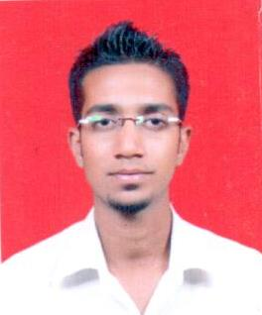CURRICULUM VITAE

MUBASHEER AHMED KHAN

**Address:**

**10-5-385/1/1/D2A,**

**Syed Nagar, First Lancer**

**Hyderabad – 500028 Contact Number: +919182834870**

**Telangana state. Email Id:mubasheerkhan@gmail.com**

OBJECTIVE

**Seeking a position of mid career level where my technical and analytical skills could be utilized for the benefit of the organization.**

EDUCATIONAL QUALIFICATION:

|  |  |  |
| --- | --- | --- |
| **DEGREE/CERTIFICATE** | **BOARD/COLLEGE** | **YEAR OF PASSING** |
| **B.com** | **ANWAR-ULOOM DEGREE COLLEGE** | **2013** |
| **INTERMEDIATE** | **ALIYA JUNIOR COLLEGE** | **2011** |
| **S.S.C.** | **PRIYADARSHINI HIGH SCHOOL** | **2006** |

VALUE ADDITION

* **Flexible in team as well as individual**
* **Quick Learner.**
* **Capable of Handling Critical Conditions**

**Demonstrated abilities to learn and apply the new technologies and capabilities to seamless integrate myself in team environment. I would be the invaluable asset to work in organization to achieve the goal**

EXPERIENCE:

* **worked as a salesman cum cashier in alhokair fashion retail from May 2015 to May 2017 in Saudi Arabia (Riyadh).**
* **Worked as a Associate with Vertex Solutions as customer Care Executive From August 2014 to April 2015.**
* **Worked as a Customer Care Associate in Shopper Stop Begumpet for 1 year.**

**From March 2013 to April 2014.**

* **Worked as a office IN charge in Cool Berg Enterprises January 2012 to November 2013.**

ACTIVITIES

* **Playing cricket & Watching Movies**.

PERSONAL DETAILS

**Name : Mubasheer Ahmed Khan**

**Father Name : Basheer Ahmed Khan**

**Date of Birth : 12thDEC 1989**

**Languages : English,Hindi,Arabic**

**Nationality : Indian**

**Gender : Male**

**Marital Status : Single**

Declaration:

**I hereby declare that the above furnished information about me is true to the best of my knowledge and belief.**

**Date :**

**Place :**

(Mubasheer Ahmed Khan)