RESUME

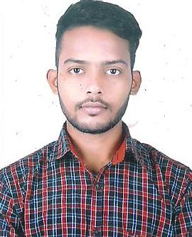

Name: Rama krushna dash

Post applied for: Mechanical engineer

Contact No: 9078684961, 7735608686

E-MAIL ID: rama.mech@rediffmail.com

* OBJECTIVE :

Obtain a position where I can apply my acknowledge and skills, working with a dynamic and laborious staff environments by continuously growing and contribution to the main objective of the organization.

* WORKING EXPERIENCE:
* Recently working at UNITED SPIRITS (A DIAGEO Group of company). As a trainee.( From 01 October 2015 to31 May 2017).
* Working with Amazon. In ( Delhi NCR) as a packing issuer. ( From 02 May 2015 to 10 September 2015).
* **Working with A.T.S Infrastructure (Greater Noida, New Delhi) As a P&M Supervisor. 01 September 2014 to 31 March 2015.**
* Total Experience 2 years +
* Name of organization UNITED SPIRITS. Ltd
* Designation Trainee (mechanical)
* Role Trainee engineer (preventive & maintenance)

 Responsibilities

(i)preventive maintenance & trouble shooting of construction equipment’slike, engine,earthmoving machine, vehicle repairing Batching Plants, Transit Mixers, concrete pump ,DG sets , vibrator,niddle,pneumatic equipment , bar cutting machine, bar bending machine etc. Located centrally and at project site (ii) Preventive maintenance schedule for construction equipment’s.

(iii) Keep track of service requirements and records of the Equipment’s and machinery as per the manufacturing standard &Maintenance requirements.

(iv) Keep track on preventive maintenance schedule, repair notification, history card, Calibration records Etc.

(v) Responsible for attending the breakdown maintenance.

(vi) Responsible for upgrading Repair & Maintenance facilities and

Build spares stock.

(vii) Comprehensive MIS of Vehicles/equipment’s and machinery with regards to uses, maintenance costs etc.

(Viii) Preventive maintenance an 260 Bpm Labelling machines, vacuum filling machines, Domino printing machines, tapping machines Etc.

(ix) Advance preparation of upcoming audits.

QUALIFICATIONS

* 10th passed from board of secondary education Odisha.
* Diplomain mechanical engineering from Gandhi polytechnic. Berhampur Odisha.( With 71%)
* Recently completed B.TECH at Roland institute of technology Berhampur Odisha. ( With 7.02 C.G.PA)

Computer knowledge- m.s office-(word, exel), internet.& AUTO CAD.

**PERSONAL DETAILS:**

Date of birth : 22 APRIL 1996

Father’s Name : Late. Sibaram dash

Marital Status : Unmarried

Language known : Hindi, Oriya, English,

Nationality : Indian

Religion : Hindu

**ADDRESS** : s/o-Sibaram dash

medical bank colony,5th lane

p/s-berhampur

Dist: - ganjam (Orissa)

Pin: - 760004.

Contact Number:9078684961, 7735608686 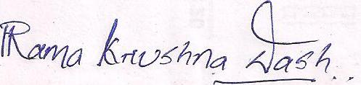

Authorized signatory

(Note: Hereby declare that above mention details are correct and complete to the Best of my knowledge.)