**MOHAMMED IQUBAL A**

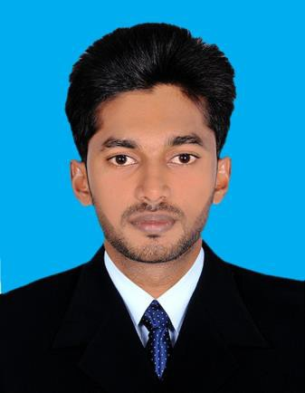

**SAFETY OFFICER**

**UAE mobile :(+971)0561961996**

## Email id: [iqubalpmna1@gmail.com](mailto:iqubalpmna1@gmail.com) Passport No: L6570524

Visa Status: Visit visa

## Present Address: block 214/8, shake colony, Al Karama, Dubai

**OBJECTIVE**

Looking forward for **safety officer** with a reputed organization that give me an opportunity where I can improve my abilities and which provides an environment to share my skills with others so that I will be a part of success in that organization.

# PROFESSSIONAL SYNOPSIS

Competent professional with over 3 years of experience as a safety officer in construction industry

# EDUCATION (certificates attested by UAE Embassy)

**BE Automobile Engineering** from paavai group of institution namakkal, tamilnadu, India during the year 2010-2014**.**

# TOTAL WORK EXPERIENCE (3YEARS)

From June 2014 – July2017 **safety officer** with **EKK INFRASTRUCTURE pvt, Ltd, Kerala, India**

# DUTIES AND RESPONSIBILITIES

* Preparation of job safety analysis and risk assessment
* Work permit verification for hot and cold jobs.
* Pre-job briefing for safety task assignment
* Safety at excavation, installation of batching plant hot mix plant. form work for construction, erection, concreting, work at height
* Heavy lift for safe operation
* Safe and standard erection of scaffolds and traffic safety controls
* Monitor PPE and ensure quality and availability of adequate stock inventory
* Workplace monitoring and regular inspection of ongoing construction activities. mechanical job
* Safety audits, inspection hazard identification and corrective and preventive action
* Preparation of safety performance report, safety statistics report
* Putting observation in action tracking system, communication with line management
* Promote safety culture by safety promotion activities
* To comply the legal requirement for health and safety
* Imparting general and job specific training to workers

# EDUCATIONAL PROFILE

|  |  |  |  |  |  |
| --- | --- | --- | --- | --- | --- |
| **COURSE** | **STREAM** | **INSTITUTION** | **BOARD/UNIVERSITY** | **YEAR** | **MARKS** |
| **BE** | Automobile  Engineering | Paavai group of  institution | Anna University  Chennai | 2014 | 7.90  CGPA |
| 12th  Standard | Biology science | Government higher secondary school  vettathur | Kerala State Board | 2010 | 69.16% |

**ADDICTIONAL QUALIFIACTION**

* **(NEBOSH) international general certificate**
* **(IOSH) managing safely**
* **SCAFFOLDING INSPECTOR**
* **MEDIC FIRST AID**

**SKILLS &ABILITIE**

* Mental and physical willingness to hard work.
* To be an active part of the team and to motivate the team work.
* Reliable, quick learner.
* Willing to shoulder challenges and responsibilities.

# COMPUTER SKILL

* + Expertise in **word, excel** and basic application

# PERSONAL DETAILS

Date of Birth 27-07-1992

Fathers name MOHAMMED A

Nationality INDIAN

Languages known ENGLISH, HINDI, TAMIL, MALAYALAM Marital status SINGLE

# DECLARATION

I hereby solemnly declare that all the above-furnished details are true to the best of my knowledge.

Yours faithfully,

DUBAI Mohammed iqubal A