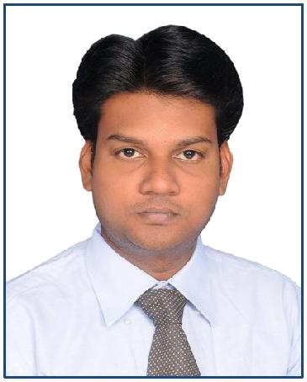**A.MOHAMED NAJMUDEEN**

**Mail Id : mohamednajmu87@gmail.com**

**Mobile No: 052 4972244**



**CAREER OBJECTIVE**

To obtain a challenging position with opportunities for professional growth based on merit and performance, utilizing proven abilities developed through my education and experience

**Working Status and Communicational Address**

Designation : Accountant

Employer : Moss Edifice Private Limited.

Period : Sep 2014 to Oct 2016.

Designation : Accountant

Employer : Manimohan & Co, T.Nagar, Chennai.

Period : Apr 2012 to Mar 2013.

**Responsibilities**

* Prepare TDS workings to submit e-filing.
* Preparation of Trial Balance and Balance Sheet and monthly closing entries.
* Petty Cash, Suspense & Maintaining The Daily Cash Book
* Preparation of Physical Stock verification for Auditing reports.
* Accounting Payable & Receivable and general ledger maintenance...etc.
* Prepare Sales Tax workings to submit e-filing.
* Prepare Service Tax workings to submit e-filing.

|  |  |  |
| --- | --- | --- |
| **EDUCATIONAL QUALIFICATION** |  |  |
| **Master of Commerce** | (2006-2008) | 60% |
| E.G.S.Pillay Arts & Science College |  |  |
| Nagapattinam |  |  |
| **Bachelor of commerce** | (2003-2006) | 55% |
| E.G.S.Pillay Arts &Science College |  |  |
| Nagapattinam |  |  |

**PC KNOWLEDGE**

Office Tools : Ms-word, Ms-Office.

Accounting Software: Tally ERP 9.

**PROJECT IN UNDER GRADUATE**

|  |  |  |
| --- | --- | --- |
| Title | : | Environmental of sipcot |
| Members | : | 6 |
| Duration | : | 2 Months |
| **PROJECT IN POST IN GRADUATE** | | |
| Title | : | A SALE OF SOFT DRINKS IN NAGAI. |
| **CERTIFICATE** |  |  |
| Accounting Software | : | Tally, Share Business |
| **PERSONAL DETAILS** | |  |
| Date of Birth | : | 31-03-1986 |
| Father name | : | A.MOHAMED ARIFF |
| Sex | : | Male |
| Marital Status | : | Single |
| Nationality | : | Indian |
| Languages Known | : | English Tamil. |
| Passport No | : | H 1319760 |
| Visa Status | : | Visit Visa |
| Present Address | : | Naif Road Deira. |

Dubai.

**DECLARATION**

I here by declare that the above information is true is to the best of my Knowledge.

**Yours Truly,**

**(A.MOHAMED NAJMUDEEN)**

**Date :**

**Place :**