**\*CURRICULUME VITAE\***

-(RIZWANUL HAQUE)-

**RIZWANUL HAQUE**

**Postal Address :-**

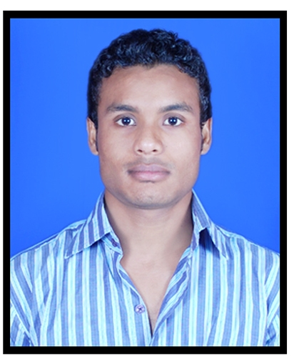

House No-5119 , Street No-3

Surya Colony Sehatpur,

Faridabad Haryana,

Pin - 121013

**E-mail:-** [rizwanulhaq.1993@gmail.com](mailto:rizwanulhaq.1993@gmail.com)

[rizwanulhaq.93@rediffmail.com](mailto:rizwanulhaq.93@rediffmail.com) **Contact No :- 8802390217**

**Indian passport no :- R3211098**

**Objective:**

* Looking for Challenging job where I can reach at infinite success and work for the Growth of an organization along with improvement in my own skill.

**Education Qualification:**

* 10th Passed from CBSE BOARD -2010
* 12th Passed from CBSE BOARD -2012
* Passed B.A IIIrd Year from Delhi University.

Technical Qualification:

* One year course Diploma Computer Application.

Ms-Office (**Word ,Excel ,PowerPoint**)**E-Mail ,Internet Using from sap software** and **outlook mailing.**

* One Year ITI in Electrician trade In NSIC , Okhla Phase-3, New Delhi-110020

Working Experience:

* One Year Worked with in UPS JETAIR EXPRESS PVT. LTD. from OKHLA PHASE II
* One Year Worked with HI-TECH ENGINEERING CONSOLATION PVT. LTD. CO. Gurgaon.
* Current Worked with in BEST WESTERN SKYCITY HOTEL Secter 15 Jh0arsh Road Gurgaon. 20 August 2016

Operating and Working System Knowledge:

* Working and Knowledge L.T and H.T panel line and Transformer .
* House wiring , repair & maintains, working and knowledge.
* Operating a L.T and H.T panel Supply Line.
* Operating a D.G , Star Delta Panel , Bus coupler and Bus Bare panel.
* Knowledge of VCB, OCB, ACB, MCCB, MCB, ELCB, RCCB All backers
* Cable Terminations LT panel and VCB Breaker, Transformer.
* All type cable gland in panel Terminations.
* I will Worked with project line in Electrician.
* Working and Knowledge for FIRE SYSTEM, STEAM, BOILER SYSTEM and STP Plant RAW Plant

Personal Details:

* Father Name : Sirazuddin
* Date of Birth : March 10 1993
* Gender : Male
* Religion : Muslim
* National : Indian
* Marital : Unmarried
* Language Known : English And Hindi

**Declaration:**

* I do here by declare that all the above said information is true to the best of my knowledge and belier.

Date:…………………… (RIZWANUL HAQUE)

Place:……………………