**RESUME**

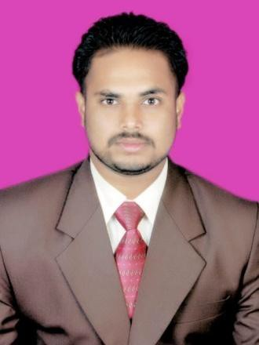

**Lalitranjanojha**

Diploma ,civil Engineering Contact No. : - +91-8763376197

E-mail [:-lalitranjanojha@gmail.com](mailto:-lalitranjanojha@gmail.com)

[:-lalitranjanojha@yahoomail.com](mailto:-lalitranjanojha@yahoomail.com)

**Present Address:**

Goutamnager, 2ndline Koraput

Dist. - Koraput, Odisha Pin code-764020

# CAREER OBJECTIVE

To work in a firm with a professional work driven environment where I can utilize and apply my Technical knowledge, skills which would enable me to grow while fulfilling organizational goals.

# BASIC ACADEMIC CREDENTIALS

|  |  |  |
| --- | --- | --- |
| **Qualification** | **Board/University Year** | **Year** |
| **Diploma (Civil)** | SIET ,Koraput (73.32%) | 2016 |
| **Intermediate** | National Institute Of Opening  Schooling,Noida,New Delhi | 2013 |
| **High School** | Saraswati Sishu Vidya Mandir  Koraput,Odisha | 2011 |

**WORK EXPERIENCE**

* Civil Junior Engineer Rural Development still continued
* Junior Engineer Civil

- Drawing Study (Building, putting section of building, Plan, Iligation)

-Soil Testing, Concrete Consistence Test, Initial & Final Testing, Time Testing Workability Test, Sand Test, Metal Test, Brick Test, Road Levelling etc.

# PROJECT REPORT

Title: - Building & Road modelling & finite Quantity analysis Duration: - 2 Year & Still continued

ROLE- Designing and Modelling Building & Road

Description: -The basic aim of the project is Building Modelling and finite Quantity analysis of Estimating and Cost Evaluation against work of building, road & Construction.

# IT PROFICIENCY

* Operating System Known - Windows 10, XP, 7
* Microsoft Office Word, Microsoft Office Excel, Microsoft Office Power Point
* Internet Browsing
* Language= C

# DESIGNING SOFTWARE SKILL

* AUTO CAD
* CATIA
* PRO ENGINEER
* C POGRAMING

# INTERPERSONAL SKILL

* Ability to rapidly build relationship and set up trust.
* Confident and Determined
* Ability to cope up with different situations.
* Hard Working & Team player

# PERSONAL DETAILS

* Father’s Name :-Nagendra Ojha
* Permanent Address :-Goutam Nager 2nd line, Koraput

Dist:-Koraput,Odisha

* Date of Birth :- 23th May 1996
* Language Known :- English , Hindi ,Oriya & Sanskrit
* Marital Status :- Single
* Nationality/Religion :- Indian / Hindu
* Interest & Hobbies :- Internet browsing , travelling ,Listening music
* Contact No. :- +91-8763376197
* Passport No. :- L8337450

# DECLARATION

I do hereby declare that the above information is true to the best of my knowledge.

**Place-Koraput Lalit Ranjan Ojha**