**Curriculum vitae**

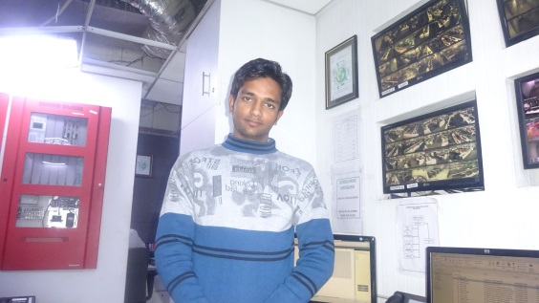

**Farman Ali**

* Surajpur Greater Noida
* DISTT-GB NAGAR (UP)
* MOB< 8506048793-8447563449
* Email <[farmanalimetlife@gmail.com](mailto:farmanalimetlife@gmail.com)

**Title**

BMS Operator

Department /Project

**FM Operations**

Reports to

**Electrical Engineer**

**Facility Manager**

**CAREER OBJECTIVE:**

To obtain a Challenging in the Fielding of Computer engineering learn new Skills utilize maximum personal capabilities to reach the Peak.

**WORKING EXPERINCE:**

* One year worked in ST Microelectronic Greater Noida Honeywell third party roll as a BMS operator
* Presently working in CBRE through Strabag as a BMS Operator and posted at a site MetLife global operation support Sec. 135 Noida. From 01stjanuary 2016 to till date.

**ACADEMIC QUALIFICATION:**

* 10th Passed From UP Board.
* 10+2 Passed From UP Board.
* Graduate Passed from Kanpur University.
* Diploma in Computer certificate application.
* Pursuing Diploma in Electrical & Communication.

**SAFETY AND QUALITY RESPONSIBILITIES**

Maintain standards of safety and comply with Company’s Health, Safety & Environment Management System requirements. Take reasonable care of own health and safety and that of others in the workplace, especially the client personnel. Follow and maintain Company standards of Quality in accordance with Company Quality System requirements

**JOB PROFILE**

* FireAlarmSystem & P.A. System,
* Access Control System. Honeywell system EBI. > R410
* CCTV Camera DVM System, DVR System with installation
* Water Sprinkler System WLD system & VESDA system
* Monitor the operation of the HVAC control systems using the BMS to monitor performance.
* Knowledge of Microsoft office, suite MS Words, MS Excel MS Power point
* Working with Honeywell system

**JOB OBJECTIVES**

* Maintain and repair the control systems of the BMS controlled HVAC systems throughout the site as determined by the manufacturers recommended system as detailed by the site management
* Carry out routine checks for correct operation of all control equipment as directed by site management and Daily/Weekly Servicing Plan.
* Renovate and replace equipment as required by fault finding to maintain equipment in optimal performance condition.
* Attend Safety Meetings and Toolbox talks to increase safety awareness

**STRENGTH:**

* Sincerity, Punctuality, Confident, Co-operative & hard work

**HOBBIS**

* Surfing Internet browsing
* Listening Music and Game of software
* Playing Cricket & volleyball

**DECLARATION:**

* I hereby declare that above written particular are true to the best of my Knowledge and belief.

**PERSONAL DETAILS**:

* Father’s Name : Ali Adil
* Date of Birth : 1st July 1996
* Marital Status : Unmarried
* Languages Known : Hindi & English
* Nationality : Indian
* Gender : Male

**PERMANENT ADDRESS** Vill. Kabirpur post.Saurikh

Dist. Kannauj (UP)

DATE: …………………………..

**SIGNATURE**

PLACE: …Gr Noida……………………….