From,

### RAJESH R

#13/A, GOWRISHANKARA NAGAR, OOTY ROAD

MYSORE-570025, KARNATAKA INDIA.

**Sub:** Application for the suitable post.

#### Respected Sir,

With high hopes and aspiration I submit myself for a suitable job in your esteemed organization. I have completed **Diploma in Electrical and Electronics Engg and ITI in Electrician Trade.**

#### I feel that your concern will give scope for better growth of my ability. I will take the assignment with a great sense of responsibility and enjoy the challenges of the situation and make a positive contribution.

As I am young, energetic and talented and full of zeal, I am sure you will top my inherent talent to the best advantage of the organization, simultaneously shaping my future with bright, promising career.

Looking forward for your favorable reply at the earliest to present myself for an interview in your Organization.

Thanking you in anticipation, I remain for your positive response.

Yours Sincerely,

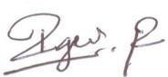

**RAJESH R**

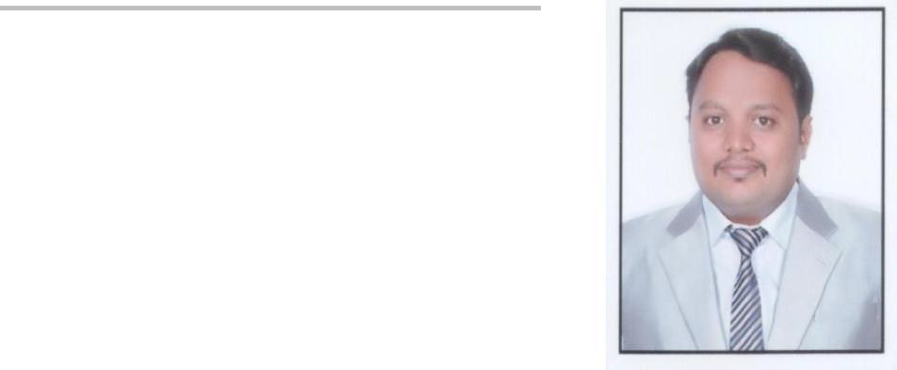**CURRICULUM VITAE**

### RAJESH.R

#13/A, GOWRISHANKARA NAGARA, OOTY ROAD,

MYSORE-570025, KARNATAKA INDIA.

##### PHONE: +91 9916549697 / +91 7353595989

EMAIL: [**rajeshee2014@gmail.com**](mailto:rajeshee2014@gmail.com)

### Objective

Seeking a challenging position which will permit me to use and enhance my skills in the field of Electrical Engineering in a progressive and dynamic organization. To be a part of organization that undertakes innovate projects and I am ambitions, workaholic.

### WORK EXPERIENCE:

|  |  |  |  |  |
| --- | --- | --- | --- | --- |
| **SERIAL** | **NAME OF** | **DESIGNATION** | **AREA OF** | **YEAR OF** |
| **NO** | **WORKING** | **EXPERIENCE** |
| **ORGANIZATION** |
| **1** | GSSS Institute of | Junior |  |  |
| Maintenance |  | May 2011 to till |
| Engineering and | Electrical |
|  | date |
| Technology for | Engineer | Maintenance |
| (5.8 Years) |
| Women, Mysore | (Electrical) |  |
| **2** | VANRAJ Power | Junior Engineer | Electrical | May 2009 to Apr |
| Installation/ |
| Associates , Mysore | 2011 ( 2 Years) |
| Maintenance |
| **3** | Kirloskar Electric | Diploma Engineer | Transformer | AUG 2008 to |
| Company Limited. |
|  | Production | may 2009 |
| Transformer | Trainee. |
| Supervisor | (10 Months) |
| Div.Mysore. |  |

**Total Experience (Till Date): 8.6 Years**

**Key Knowledge:-**

Electrical Wiring work of Buildings. Maintenance of electrical equipment. Troubleshooting of Electrical Installation. Faults Detection and restore the supply.

### EXPERIENCE DETAILS:

1. **NAME OF ORGANIZATION**: GSSS Institute of Engineering and Technology for Women, Mysore

**Period** : May 2011 to till date (5.8 Years) **Designation**

: Junior Maintenance Engineer (Electrical)

##### ROLES & RESPONSIBLE:

* 1. Electrical Equipments Maintenance.
  2. 11Kv/440V HT Yard Maintenance
  3. DG Set Maintenance.
  4. Switch Gears Maintenance.
  5. Lifts Maintenance.
  6. Sewage water treatment Plant Maintenance.
  7. Lighting system maintenance
  8. Maintenance of Split and Centralized AC system.

##### Additional experience:

1. Working in Multi Storage building electrical wiring project work
2. CCTV Security System.
3. CCTV Camera Installation work.
4. Telephone Cabling work.
5. **NAME OF ORGANIZATION**: VANRAJ Power Associates, Mysore

|  |  |  |  |
| --- | --- | --- | --- |
| **Period** | : | May 2009 to Apr 2011 (2 Years) | |
| **Designation** | : | Junior Engineer | . |

##### ROLES & RESPONSIBLE:

* 1. Residential Building Wiring Installation
  2. Commercial Building Wiring Work Installation.
  3. Maintenance of HT Yard.
  4. Electrical System Maintenance.
  5. Corrspandance with Designing people

1. **Company Name**: Kirloskar Electric Company Limited. Transformer Div.Mysore.

|  |  |  |
| --- | --- | --- |
| **Period** | : | May 2008 to AUG 2009 (10 months) |
| **Designation** | : | Diploma Engineer Trainee. (Production In charge) |

##### ROLES & RESPONSIBLE:

* 1. Supervising the Transformer Manufacture line
  2. Maintain the Quality in Transformer Production.
  3. Involved in Stage by Stage Testing of Transformer in production
  4. Attending the machine and Lighting System Breakdown

### Educational Qualification:-

|  |  |  |  |  |
| --- | --- | --- | --- | --- |
| **Course** | **Branch** | **Institution** | **University /** | **Percentage** |
| **And Year of** |
| **Board** |
| **Completion** |
| **Diploma** | Electrical & | J.S.S Polytechnic, | DTE | 61% |
| Electronics |
| Mysore. | (2008) |
| Engg. |
| **ITI** | Electrician | V.V. ITC Mysore | NCVT | 67% |
| (2006) |
|  |  |
| **10th** | ----- | J.S.S High School, | KSEEB | 48.53% |
| **Standard** | Mysore. | (2003) |

**Skills/Strengths:** Strong Leadership qualities, Creative thinking, Passionate in learning new technologies, Flexible to any Environment.

### Personal Profile:-

|  |  |
| --- | --- |
| **Date Of Birth** | 08 May,1988 |
| **Marital Status** | Married |
| **Spouse Name** | APOORVA HS |
| **Permanent Address** | **RAJESH.R** |
| #13/A, GOWRISHANKARA NAGARA, |
| OOTY ROAD, |
| MYSORE-570025, KARNATAKA |
| INDIA. |
| PHONE: +91 **9916549697 / +91 7353595989** |
| EMAIL: [**rajeshee2014@gmail.com**](mailto:rajeshee2014@gmail.com) |
| **PASSPORT DETAILS** | **P0447694** |
| Valid Till 04/05/2026 |
| **Hobbies** | Listening Music and Bike riding. |
| **Nationality** | Indian |

**Declaration:** The above statements are true to the best of my knowledge and belief.

**Place: Mysore** YOURS SINCERELY



**Date:** (RAJESH R)

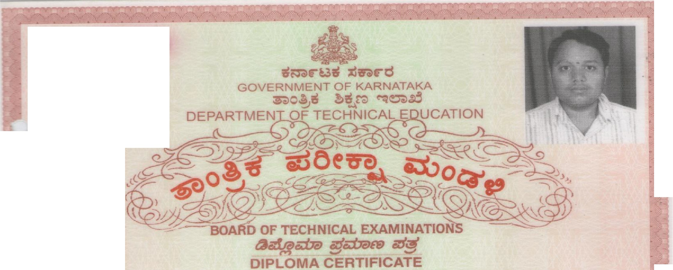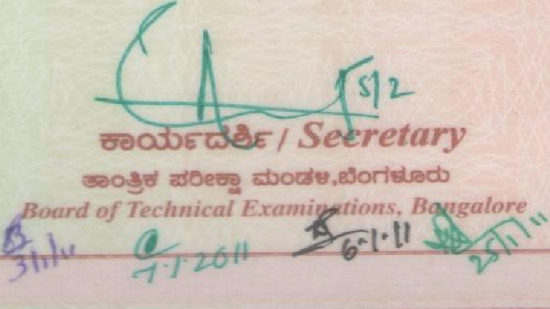

SI. No. **012985**

*'Ifiis is to Certify tfzat****!l{ajesfi !I{***

*Son./'Daugliter of* ***!l(fiju p***

## *having uncfergone the prescribecl three years course of stuclies in*

***'Ekctrical & 'Electronics 'E11tJB***

*fias been cfecfared to liave passed in* ***!First Class***

## *in tfze final e;r_amination lie.[cf in the nwntli of* ***Mag***

*in tlie year* ***2lXJ8*** *Ulitli !R.g.gister g,..,[um6er* ***418'EW5025***

## *In testi'flon3 whereof tli.Ll rfipComa in*

***'Ekctrica{ & 'Electronics 'E11tJB***

*is awarcfecf Wlth tlie. pnviCege to •J..)c tlie titfe* ***'lJ*** *'£&£,****'E*** *ancf compCetecf :DipComa on* ***18th ,June 2009*** --

.

***'510 woatl***

***.or.1reehlm.*** • .. ***wONJ, a1orlr&«b***

*Board of Technical E.rami11ations and*

*Director, n partmc11t of 'J'edwkal Educatim1, IJangalore*

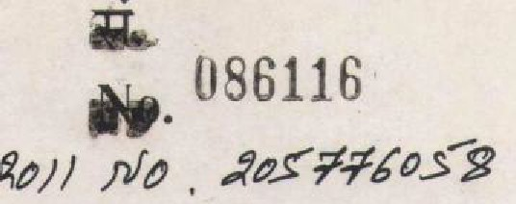7.li. 1:i. < Tl:f.tt .m. )2006( s *1* >

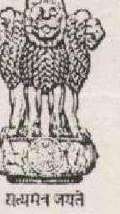SI. No. (N.T.C.) 2006(5 -7)

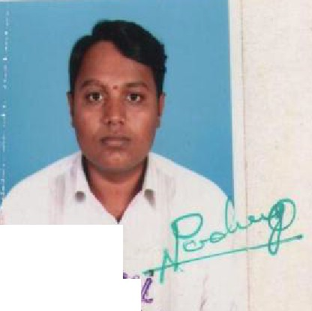-..n«Jmcrn­

GOVERNMENT OF INDIA

# Wlf 'ITT:11'ITT

MINISTRY OF LABOUR AND EMPLOYMENT

lclfliftl&i

L : : ;; ;; 1t:•a.

NATIONAL COUNCIL FOR VOCATIONAL TRAINING

"' _. ......_. ....... ----- *l'irlp1111r; ;t'?r1rc111,*

**NA,---- ,N-1**:...

w 1 s,ftlttfr .........................................................................................................................................................

# WP m..······,······················ eir

·············.·.·····....···............................................................................................................,..•.. . .··•···············...· *ij*

,;rma_nrr aITTlTT!\ ...................................:......····•············· ll, ir ................................................. ...

*ii* 3 ············.·.·· cfi1' f.t.;rifr,:f

-qft ii Ttftut -q.- i;mJUl- lR:R f.:f;'m ,t

*S fu /S l"J::*.............*.JJlr:.:;r:.![£ff:,,....:: .*.f(....................................

*Srm l o/ Shu* ............. rt..;r.. .:...1?.............................................

*fdeted,tk e ot at .......v. .,d'Jf#ld.../4.t/4.... T.. ....*.........

............. .$. .:-:./? *a«d jza44ed tk*

*puwrded (luu{c tea "" tk t1iade ot,..*..........*£. .'.0.'f!.11.. ..................... .*...........

*kid ut tk 1tt<Udh. ol .*.......;( .................. *7wo 7 4.o«aa«d* ......-2.(&....................

*i4 M.Jaul.cd t/4.,,7 w de {5e1t,ti£i.cate.*

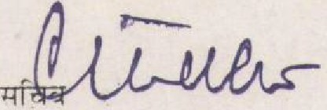

Secre tar y

-,,.f I -1r:11f•H-, imT%-iUT

Na tiona l Counc il for Vocational Train in g

Secretary

'lp:T .m:; *m rm*

Sta te Counc il for Voca ti onal Training

### PASSPORT FRONT SHEET

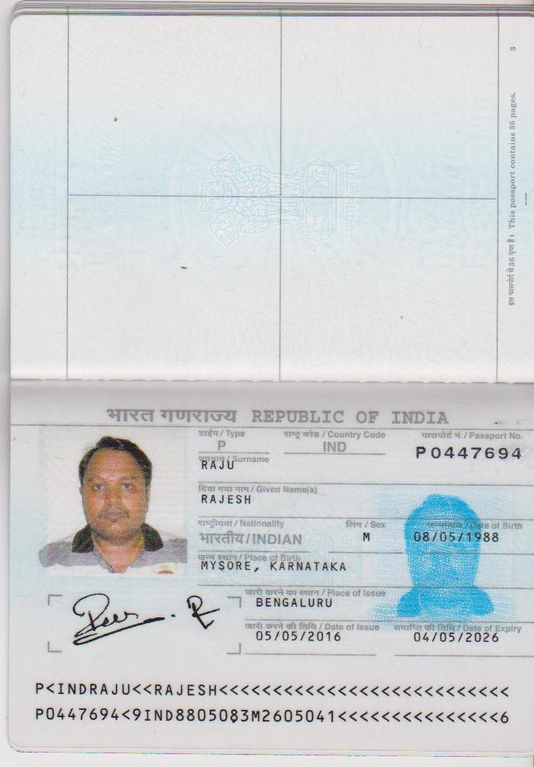

**PASSPORT END SHEET**

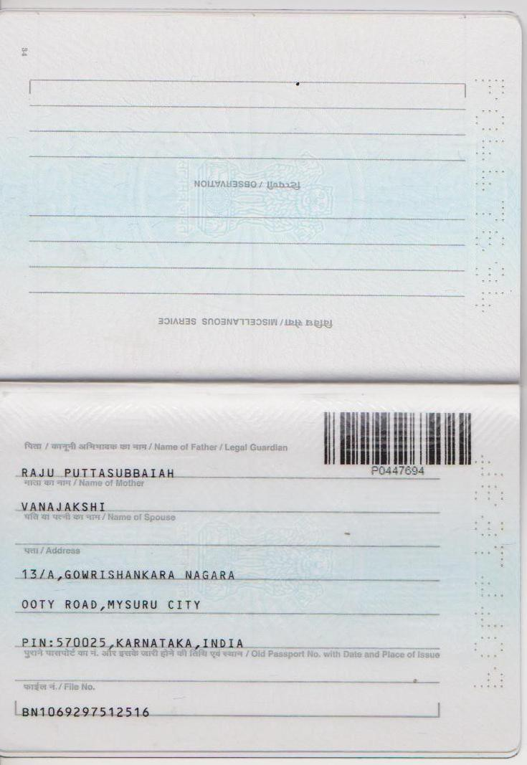

**PRESENT WORKING ID CARD**

