**COVER LETTER**

Respected Sir,

It is with great interest that I am forwarding my CV for your consideration. My record of academic achievements and professional career history, demonstrates attributes that make me a valuable employee.

My CV is enclosed to provide you with details of my skills and accomplishment, but I am certain that a personal interview would more fully reveal my desire and ability to contribute to your organization.

Thank you for your time and consideration.

Regards,

Sachin K

+91 7848951805

+91 9902356485

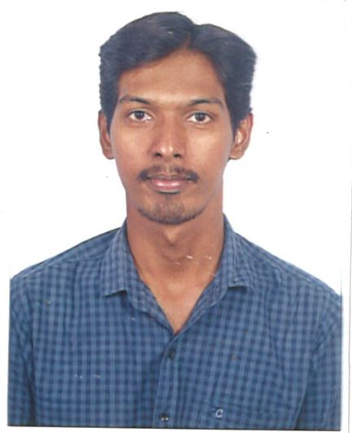**CURRICULUM VITAE**

**Sachin K**

#113,Patel Siddappa house,

Gadikoppa,Shivamoga-**577205**.

Mobile:+917848951805,

+91 9902356485

Email: **sachin1gowda@gmail.com**

**Career Objective:**

* Looking for an opportunity in a company where I could learn under working

Professionals to gain knowledge and improvement of my skills by giving inputs to

The company.

* To work for an organization which provides me the opportunity to improve my skills

And knowledge to grow along with the organization’s objective.

**Work Experience:**

* Worked As a **Site Engineer**(Internship) in Coastal Projects LTD.From Nov 2013 To jan 2013 (3 Months).
* Worked As a **Design engineer cum Quantity surveyor**(Internship) in Manasa consultants.From Jan 2014 To jun 2014 (6 Months).
* Worked As a **Site Engineer** in BEARDSELL PVT.LTD**.** From July 2014 To Dec 2014 (6 Months).
* Working as a **Quantity Surveyor cum Civil Draftsman**  in PIXEL SOFTEK PVT. LTD**.** From 19th Jan 2015 to till date.

**Technical Knowledge:**

* Knowledge of basics of Auto CAD, Auto Cad Land Development, E Tab, MX Road, Google Earth, E-survey Solutions, GPS Track maker. MS Excel, Power Point. Open Office.
* Working knowledge of codes, construction sequencing and safety regulations.
* Working knowledge of prepare Daily Progress Report and safety regulations in site.

**Educational Qualification:**

|  |  |  |  |  |
| --- | --- | --- | --- | --- |
| **Sl. No.** | **COURSE** | **NAME OF INSTITUTION** | **YEAR OF PASSING** | **PERCENTAGE SCORED** |
| 1 | **B.E** | Jain University | 2014 | 82.10 |
| 2 | **II PUC** | Department of Pre -University | 2010 | 66.16 |
| 3 | **S.S.L.C** | KSEEB | 2008 | 74.08 |

**Interests:**

* Making designs of multi-storied buildings, Canals, highways using software.
* Designing of foundations, RCC structures and Road alignment using software .

Quantity estimation for High Rise Buildings and Roads.

**Strength:**

* An enthusiast with highly motivated and leadership skills.
* Eager to learn new technologies and methodologies.
* Always willing to innovate the new things which can improve the existing technology.
* Seeking for a challenging position as a Civil Engineer, where I can use my planning,

designing and overseeing skills in construction and help grow the company to achieve its goal.

**Projects Undertaken:**

**Project 1:** STATE HIGHWAY Projects of PWD department in Bengaluru & Hassan

**Description:** prepare the Road Alignment & cut fill Quantities using **MX ROADS** software. junction Design, Area encroachment Details using Auto cad Software, Providing Templates of formation to the road, Preparation of Reports by using CBR and Finalizing

**Project 2 :** KRRDA, PRED, PMGSY, SH, NABARD and JAIKA Roads.

**Description:** Preparation of DPR for roads using excel and Auto Cad, Providing Proper Road Alignment, Curve Details, Existing Structural Statement, Area encroachment Details, Providing Templates of formation to the road, Preparation of Reports by using CBR and Finalizing.

**Project 3** **:** HASSAN And SALIGRAMA Tanks

**Description:** Generating the contours and spot levels by using Existing data available With the help of terrain module of Auto Cad Land development for hilly region and giving capacity of tank. Estimating the Cutting and Filling Quantities.

**Project 4 :** HANAGUDU, HEMAVATHI, HARANGI LEFT BANK CANALS.

**Description:** Removing the old available waste materials from the canals like Revetment, CC Lining etc and Replacing the canal, Giving Regular intervals of Cross- sections by using spot levels which have taken from site and giving cutting and filling quantities by using E-Survey solution software. Estimating the cost of the projects.

**Achievements:**.

* Worked as a Team Lead in KRRDA Projects and Appreciated by the department.
* Have been a part of design of various Canal Projects and State Highway and Road projects.
* Participated in **IIT Bombay** Tech fest win the 5th Place in the competition (certified)
* Participated  **NIT Warangal** Tech fest (certified).

**Personal Details:**

Date of Birth : 23-03-1992

Languages known : English, Kannada, Hindi, Telugu

Gender : Male

Marital Status : Single

Passport No : P4286411

Validity : 23-08-2016 To 22-08-2026

Address :S/o Kumar S,Patel Siddappa house

Gadikoppa, Shimoga-577205.

**Place**: Shivamoga (Sachin K)