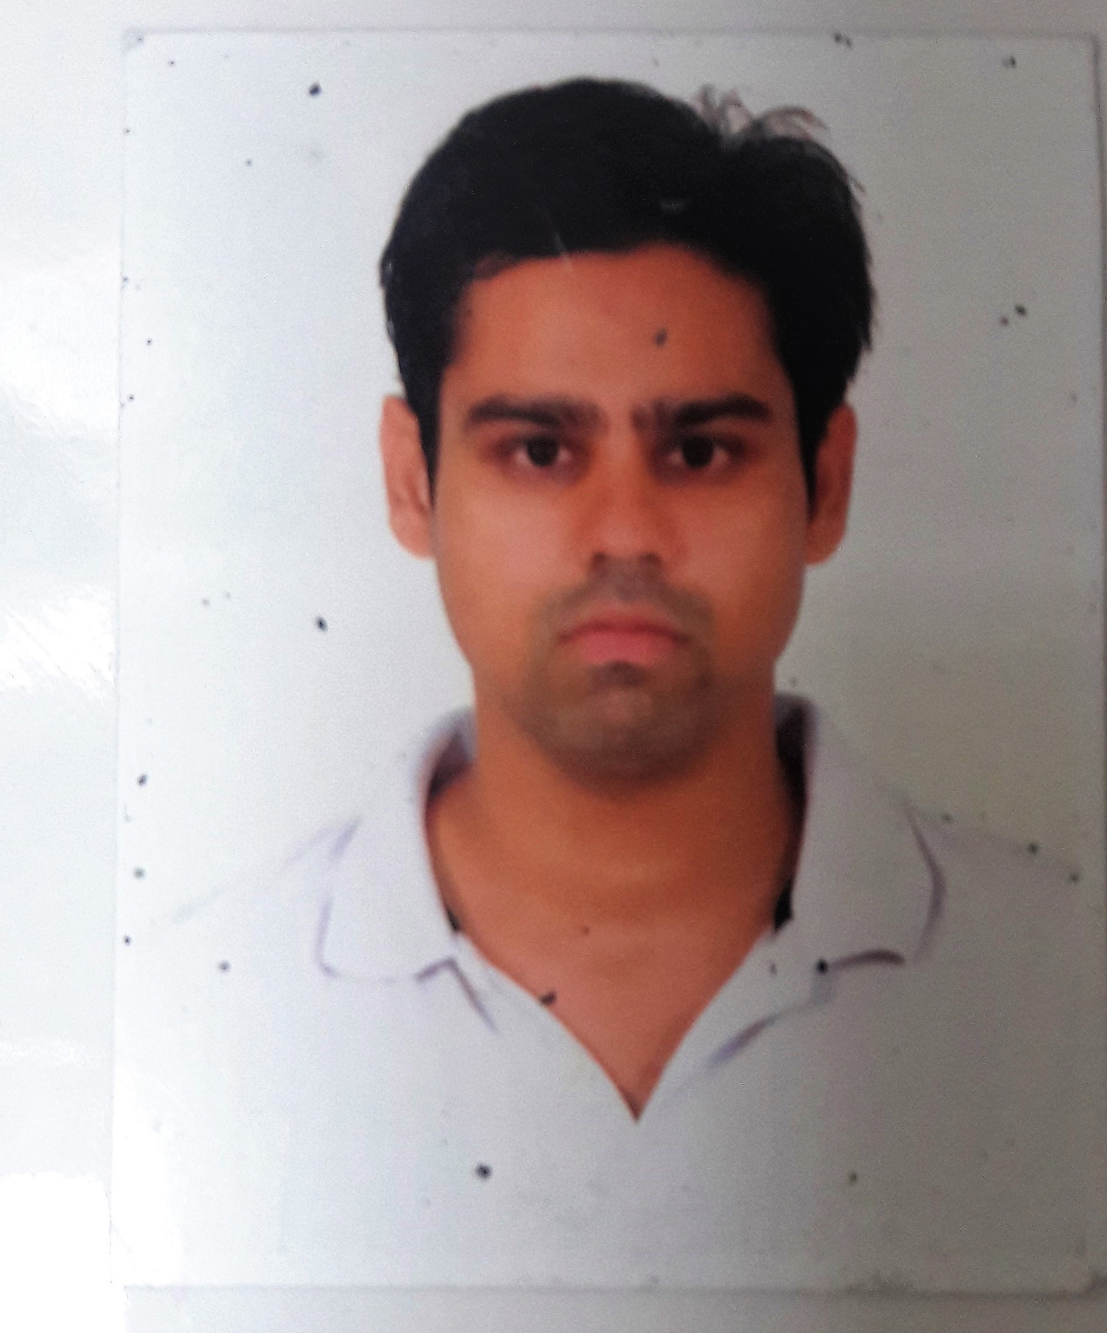

Respected Sir/Madam,

With profound hope I wish to offer my candidature for a suitable post in your esteemed organization. I believe that my qualification will interest you.

If given chance in your esteemed organization I assure that I will do my duties to the best of my abilities with your valuable guidance. A positive response would give me an opportunity to exhibit my abilities to the fullest.

Enclosed here with a copy of my resume for your kind perusal and consideration.

Thanking You,

Siddique Mohd. Abdus Samad

Mohd. Abdus Samad

+919137164414

[aatifsaamad@gmail.com](mailto:aatifsaamad@gmail.com)

**OBJECTIVE**

To be a part of an organization where I can grow in terms of knowledge, skills and attitude and put to an effective use my analytical abilities, professional competence and previous experience to align self development with organizational development.

**PROFILE SUMMARY**

* A dedicated and organization oriented professional ,where I may enhance my skills and strength in conjunction with the company’s goals and objectives.

**KEY SKILLS**

* Maintaining effective client’s coordination.
* Good communication skills.
* Maintaining & updating records.
* Team Handling.
* Having the ability to prioritize task as well as multitasking.
* Being Organized.
* Excellent problem- solving and Strong analytical skills.
* Exercise sound, independent judgement within established guidelines

**EMPLOYERS & EXPERIENCE**

* Worked as a Sales Executive From 1 June 2011 till December 2012 in Inway- Mas Enterprises (Car Polishing products).
* Worked as a Sales Executive From January 2013 till February 2015 in T.S. Traders(Supplier of Construction Materials).
* Worked as a Business Development Executive From April 2015 to September 2017 in Vippro Enterprises(Contractor of Civil ,Electrical and Supplier of Electrical Products).

**COMPUTER KNOWLEDGE**

* Proficient in use of MS Office (MS Word, MS Excel, Power Point).
* Proficient in use of Internet.

**PERSONALITY TRAITS**

* Good communication skills in written and verbal both.
* Excellent presentation and interpersonal skills.
* Strong motivational and leadership skills.
* Ability in working with team as well as individually.
* Ability to produce quality result in pressure situation.
* Strong numerical acumen and having remarkable logical and analytical skills.
* Uses initiatives to develop effective solution to problems.

**KEY RESPONSIBILITIES HANDLED**

* Keeping Healthy Relationship with Clients ,Attending Conference , Meetings and Industry Events.
* Present promote and Sell Products to Existing customers and Perform Cost Benefit and needs Analysis of Existing ,Potential Customers to meet their needs.
* Preparing Power point Presentations and Sales Display. Contacting Clients to Inform them about new developments in the Company Products.
* Ensuring to Deliver High sales Volume and Contacting and Meeting the Government Civil Departments Officials and Private Firms to Develop Business Consistently.
* Bringing new line of business and networking and sales collaborations in alien with the existing portfolio.
* Closing deals follow up Deliveries by providing supporting Information , Guidance and Follow up the Existing Customers and search for new contacts.
* Networking among the Real Estate Development Construction Companies and Coordinating Sales Effort with Team Members and others Department.
* Deliver Samples to Construction Sites if Needed and follow up with Clients Design Requirements.
* Maintaining Quality Service by Establishing and Enforcing Organization Standard.
* Preparing Adequate and Complete Supporting Documentation for Submission in Tenders, Quotations and Proposals.
* Work closely with the other members of the team to help develop a coherent sales strategy and Monitoring , analyzing market trends and keep up to date market information.

**EDUCATION**

* **B.B.A.** from **IISE COLLEGE-Dr.B.R. Ambedkar University,Agra** in 2011.
* **Senior Secondary** from **Maharashtra Board** 2007.
* **Higher Secondary** from **Maharashtra Board** 2004.
* **Pursuing MBA from Heriot Watt University(Online) Student.**

**PERSONAL DETAILS**

* Name : Siddique Mohd. Abdus Samad
* Father’s Name : Mohd. Idris Javed
* Date of Birth : 25th March , 1988
* Address BaBu Bhai Apartment,5flr,Flat no.15,khar 5 Road,Mumbai-52
* Nationality : Indian
* Gender : Male
* Marital Status : Unmarried
* Language Known : English, Hindi

**DECLARETION**

I declare that all the information given in this resume as for my knowledge and belief are correct.

Siddique Mohd. Abdus Samad