**CURRICULAM VITAE**

**NAME :** - DEEPK CHANDRA

**MOB.NO :-** 09997616317

**Address : -**VILL.GADHI THANI POST NAGLA SINGHI TUNDLA DIST.FIROZABAD (U.P)283204

**E-Mail :**- [deepakchandra84@gmail.com](mailto:deepakchandra84@gmail.com)

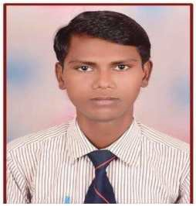

# OBJECTIVE:-

To sincerely put forward my best efforts and hard work in technical development Activities of the organizations, which provide me an opportunity to show my knowledge And offer challenges as well as career growth.

# EDUCATION QUALIFICATION:-

|  |  |  |  |  |
| --- | --- | --- | --- | --- |
| QUALIFICATION | SPECIALIZATION | BOARD/ UNIVERSITY | MARKS | YEAR |
| 10th | SCIENCE | UP BOARD | 49.50% | 2009 |
| 12th | PCM | UP BOARD | 54.80% | 2011 |
| B. Tech | MECHANICAL ENGINEERING | UTTAR PRADESH  TECHANICAL UNIVERSITY LUCKNOW | 65.00% | 2015 |

**PROJECT: -**CAR POWERD BY SOLAR AND WIND ENERGY

**SUMMER TRAINNING:-** REGIONAL WORKSHOP UPSRTC EDGAH AGRA

# OTHER SKILLS:-

Certified in AUTO CAD Software from (RGCSM, AGRA)

**Hobbies:-** Browsing Internet, Cricket.

# PERSONAL PROFILE:-

|  |  |
| --- | --- |
| Father’s Name | Tota ram |
| Date of Birthday | 15-06-1993 |
| Marital Status | Unmarried |
| Gender | Male |
| Language known | English , Hindi |
| Nationality | INDIAN |

**PERSONAL ATTRIBUTES:-**

A sincere, punctual and industrious person with the skill of creativity and faced various seminar during my study period.

# DECLARITION:-

I do here by declare that the above information furnished by me true to the best of my Knowledge

**PLACE: -** …………...

DATE:-……………… **(**DEEPK CHANDRA**)**