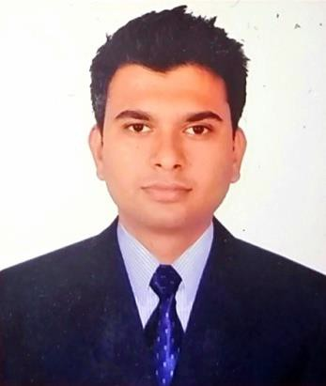**Anil Paudel**

**Electrical Engineer with 4years Experience**

D.O.B.: 23-Nov-1989

Nationality: Nepal Location: Dang, Nepal Mobile: +977 9851172992

Email: [anilpo@gmail.com](mailto:anilpo@gmail.com) Nepal Passport no: 07057162

# PROFILE

I am an accomplished Electrical engineer with 4 years of experience as a Project Engineer (Electrical operation and maintenance Project). I have proven success in organizing; planning and executing electrical maintenance task in given time frame. I am searching for an opportunity where my experience and skills would be put in use.

# OBJECTIVE

Applying 4 years of Electrical operation and maintenance experience in a reputed organization where a culture of freedom and working for initiatives is ensured, facilitating my contribution and skills through thoughts and action to the company's target and fulfillment of the organization's goal, as well as self development by playing a significant role in building the organization's vision.

# EDUCATION

Khwopa College of Engineering (Tribhuvan University), Bhaktapur, Nepal Bachelor in Electrical Engineering May 2013

# LANGUAGES

**English –** Excellent reading, writing and speaking (IELTS Overall score: 7)

**Hindi –** Excellent reading, writing and speaking

# COMPUTER SKILLS

* Microsoft office package
* Auto Cad Draft (2D)

# PROFESSIONAL EXPERIENCE

**Electrical Maintenance Engineer (Electrical O&M Project)**

**Cosmic Electrical Engineering Associates Pvt. Ltd (2014- Present)**

Cosmic Electrical Engineering Associates Pvt. Ltd. (CEEA), Kathmandu (Nepal), a renowned Electrical Contractor.

I am working as Project Engineer for Electrical operation and maintenance Project representing CEEA at B.P. Koirala institute of health Science, Ghopa , Dharan.

# Responsibilities and Role details:

* Conduct Operation and maintenance of all generators, Auto Mains Failure (AMF) panels, Electrical Panels, Sub Panels, Underground (XLPE, PILC) and overhead cables and so on.
* Maintaining periodical maintenance schedules of Electrical equipment’s like a circuit breaker, transformer, generators, motors etc. and executing them.
* Conduct and maintain safe work place to minimize accidents and avoid surprises.
* Preparation of the monthly work progress report, salary sheet for the entire team and maintain logbook of the work process.

# Electrical Engineer, Rolpa Cement Pvt. Ltd (2013-2014)

Rolpa Cement Pvt. Ltd is the 500 TPD Cement plant located in Rolpa, Nepal

# Responsibilities and Role details:

* Installation & maintenance of Electrical equipment's (Circuit Breakers, OLR, Contractors, 3 phase Induction motors).
* Design of Electrical panel board for Distribution system medium voltage (400V) and low voltage (220V), and also lightening design.
* Motor control circuit design for 3 phase Induction motor.
* Operation and maintenance of DIESEL GENERATOR of 1700*2 KVA
* Record keeping and managing MIS report.

# REFERENCE

Mr. Netra B. Khada

(Chief Engineer of Electrical Engineering Department)

BP. KOIRALA INSTITUTE OF HEALTH SCIENCE Dharan, Nepal

[netra_70@yahoo.com](mailto:netra_70@yahoo.com)

+9779842038951

Mr. Bindu Sagar Shakya General Manager

Rolpa Cement Pvt Ltd Rolpa, Nepal [bshakya@rolpacement.com](mailto:bshakya@rolpacement.com)

+9779803481329

# OTHER INTERESTS

Watching Movies, Playing Football, Travelling, Trekking.