**RESUME**

**ANUJ BHANOT**

64-C, L.I.G Flats, Prasad Nagar,

Rajendra Place, New Delhi

Email: anujbhanot39@gmail.com

**Mobile: +91-8860875860**

**CAREER OBJECTIVE**

To have a growth oriented and challenging career, where I can contribute my knowledge and skills to the organization and enhance my experience through continuous learning and teamwork.

**QUALIFICATIONS**

|  |  |  |  |  |
| --- | --- | --- | --- | --- |
| **Degree/Certificate** | **Institution** | **Year** | **State** | **Percentage** |
| B.TECH (M.E) | BCET (PTU) | 2011-2015 | PUNJAB | 73.17% |
| SSC | CBSE | 2011 | PUNJAB | 77.8% |
| HSC | CBSE | 2009 | PUNJAB | 81.8% |

**TRAINING**

* I have done software training in solid works from C-DAC (MOHALI)
* I have done industrial training in rear axle production in ESCORTS AGRI-MACHINERY (Faridabad)

**PROJECTS**

|  |
| --- |
| **MINI PROJECT** |

|  |  |
| --- | --- |
| Project Area | Automobile Technology |
| Project Title | Design and fabrication of hovercraft |
| Project role | Team Leader |

|  |
| --- |
| **MAJOR PROJECT** |

|  |  |
| --- | --- |
| Project Area | Automobile Technology |
| Project Title | Methods involved in the process of production of rear axle |
| Project role | Done the analysis and helped in production |

**PERSONALITY TRAITS**

* Strong motivational and leadership skills.
* Exceptional presentation and interpersonal skills.
* Unmatchable communication skills in written and verbal both
* Ability to work in team as well as individual

**LANGUAGES KNOWN**

* English
* Hindi
* Punjabi

**CERTIFICATIONS**

* Programming in C++
* Designing through Catia
* Designing through Solid Works

**COMPUTER PROFICIENCY**

Operating system : Windows XP/vista/seven/eight

Ms Office : MS Excel, MS Power Point, MS Word, MS Outlook.

I solemnly declare that the statements made by me in the above form are correct to the best of my knowledge and belief. I understand that if any information given above is found false /incorrect my candidature is liable to be rejected.

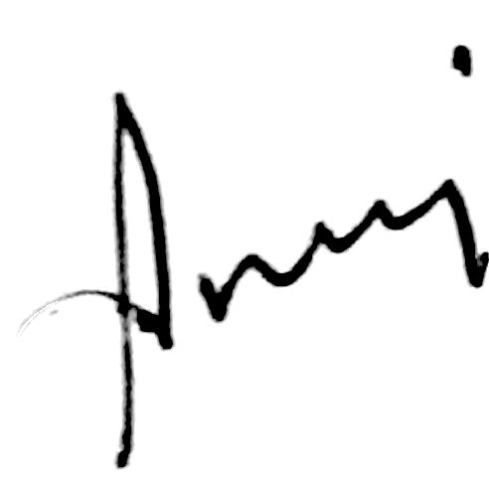

ANUJ BHANOT

**-----------------------------------------------------------------------------------**