*CURRICULUM –VITAE*

**Jitender Singh**

CONTACT NO. - +919917293135, E-Mail : Jitender_16@ymail.com.

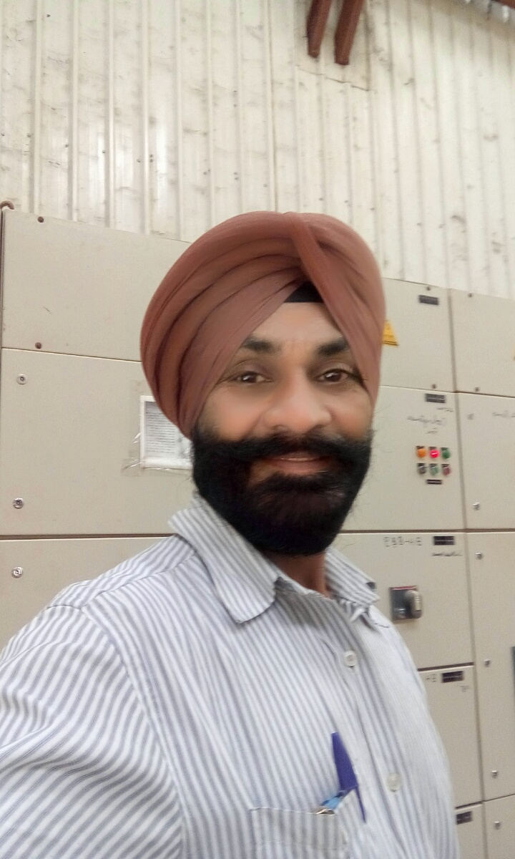**JOB OBJECTIVES**: Passport no. : Z2526688

A Challenging position in a professional organization, where I can enhance my skill& abilities to fulfill the objectives of the company by hard work &constant of my knowledge.

**Professional qualifications: Current Designation – FORMAN ELECTRICAL**

* I.T.I Electrician 1991 to 1993

**Experience:**

* 19 years experience with Simbhaoli Sugars Ltd. & Simbhaoli Power Private Ltd. ( 1997 to Sept.2016 )
* Present working with Raj Agro Industries PLC, Wama Sugar Factory, Sibu Siree, East Wolega Zone, Ethiopia as Electrical Forman from Sept. 2016 to till date.

**Electrical (work experience in operation & maintenance ):**

1. Sound knowledge of HT & LT distribution and switchgears.
2. Operation & maintenance of LT&HT Motors (1675 HP/6.6 KV).
3. Operation & maintenance of AC&DC Drives of make ABB/690volt/conv.duty and , Danfoss.
4. Operation & maintenance of soft starter of ABB ,DOL Starter, star delta starter ,PCC Cabling, MCC Cabling and wiring,Interlocking,
5. Operation & maintenance of all panels including VCB’s (Siemens & Alstom),ACB’s (L&T, Siemens, ABB) Etc
6. **Operation & maintenance of ESP ,AVR, Synchronizing, Exitation**
7. Motor Re-Winding – All types of squirrel cage motors up to 90 KW.
8. Erection work experience of 22 MW & 12 MW back pressure turbines Alternators of AEG Germany and Thermodyne France respectively.
9. Erection work experience of 28 MW Alternator of back pressure turbine and 125 TPH Boiler with fully DCS for CO-GEN PLANT,

**Organization and development activities:**

* Participating in QUALITY CIRCLE of power house.
* Safety committee.

**Academic qualifications:**

* Intermediate from UP Board in 1985.

**Personal details:**

Name : Jitender Singh

Date Of Birth : 14 NOV 1967

Nationality : Indian, Sikh

Marital Status : Married

Language known : Hindi ,English,Punjabi

Correspondence Address : Jitender Singh Simbhaoli Sugars Canal Colony Simbhaoli , Hapur 245207 U.P.

**Declaration:**

I hereby declare that the above-mentioned information is up to my knpwledge and I bear the responsibility for the correctness of the above –mentioned particulars.