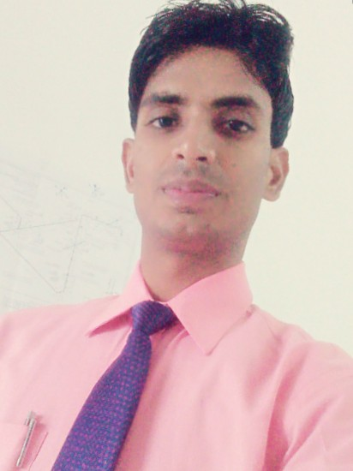

**RESUME**

**RAJU KUMAR**

**(Mechanical Engineering)**

H/No. 715

C/O-Shankar prasad

AT-Laxmipur naya Tola siwan ,Bihar

Pin: 841226

E-mail : rajuk638@gmail.com

Cell: +917389803352

**Objective:** To work with an organization where I can demonstrate my skills in Mechanical Engineering to improve the overall profitability of the organization.

**Professional Profile:**

**DATT ENGINEERING & FABRICATION**

**C/O LARSEN & TOUBRO LIMITED , HAZIRA, SURAT (GUJARAT)**

**Designation :** Production Trainee

**Time Period : June** 2015 - Present

**Skills :** Production and welding supervisor

**Company Details : LARSEN & TOUBRO LIMITED**

* A Heavy Engineering manufacturer and supplier of customized equipment to critical process industries such as fertilizer, refinery, petro-chemical, oil & gas , as well as to sectors as nuclear, power,aerospace and defence.

**Area of Working**  **:** My area of working is PRESSURE VESSELS. Till now I have worked on projects name, K-cot converter (Disenger & Regenerator),for Lotto chemical company LLC ,KBR Malesiya and High Pressure Feed Water Heater for Rajasthan Rajya Vidyut Utpadan Nifam Limited (RRVUNL), Rajasthan , India.

**Summer Training:**

* **Major Training:** I have completed my major training form **Bharat Heavy Electrical Limited (BHEL)** ,Bhopal. M.P.There I learnt about Manufacturing of Turbine ,and repair of Turbines blades.
* **Workshops:** I have also attended the workshop on **AUTOMOBILE** named Maintanainace of Maruti Vichels organized by **Maruti Suzuki India limited, ( JEEWAN motor's Bhopa**

**Qualification:**

* Completed **B.E,Hon's Mechanical Engineering,** in the year 2015 from Bhopal institute of Technology ,Bhopal (M.P), Affiliated to **Rajiv Gandhi Technical University, Bhopal (M.P)** with **aggregate percentage 75.1%**
* Completed 12th from BSEB Board (Patna) in the year 2011 with **aggregate 63.8%**.
* Completed 10th from BSEB Board (Patna) in the year 2009 with **aggregate 69%**.

**Working Projects**

* + - * Project Title : K-COT converter, Disengager & Regenerator
      * Project Duration : July 2015 – Present
      * Project Details : For Lotto Chemical company Malesiya .

**Core Subjects:**

* Thermodynamic
* Production Process.

**Educational Activities:**

* Achived certification in Mechanical **AUTO CAD & CATIA.**
* Make a major project On **Eco -friendly Refrigeration system without using any Refregrent (2015).**
* Make a minor project on **simulation method Development of Ultra-thick Laminate for Aerodynamic components (2014).**
* Industrial visit at BHARAT HEAVY ELECTRICAL LIMITED **,Bhopal (M.P),**

# **Strength & Hobbies**:-

Quick Learner

Self Motivated

Adoptable in adverse conditions

Reading books

Keen to learn new things

Outing

Cooking.

**Personal Details:**

* D.O.B : 24 - June - 1993
* Gender : Male
* Home Town : siwan (Bihar)
* Passport No. : N0163051
* Languages : Hindi and English
* Father’s Name : Mr. Shankar Prasad

**DECLARATION**

I hereby declare that the above information is true to best of my knowledge.

**Date: (signature)**

Place: Surat Raju Kumar