**CURRICULUM -VITAE**

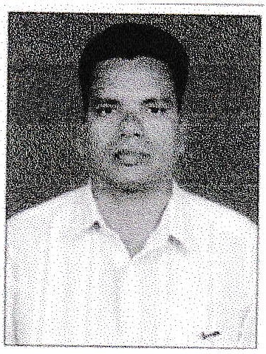APPLICANT :- **KISMAT MOHAMMAD MALPEKAR**

CONTACT NO : +918793812191/+919284786480

[kismat1973@gmail.com](mailto:kismat1973@gmail.com) DATE OF BIRTH : 17/03/1973

MARITAL STATUS : M arr ied NATIONALITY : Indian

RELIGION : Islam

LANGUAGE KNOWN : English,Hindi,Urdu,& Marathi.

**OBJECTIVE** : Seriously looking for an opportunity to join hands with best bunch of professional experience to enhance my set and knowledge for the betterment of the company & self.

**WORK EXPERIENCE** : from 1993 to 2018 = **25** yrs.

* worked as trainee Engineer in ECC Construction Group (L & T Limited) from 1993 to 1994 for the project of construction of cement plant.

* worked as an Engineer in Building Construction company from 1994 to1996 for building projects.
* worked as a site Engineer in Konkan Railway project on contract basis from 1996 to 1998 for the prject of trough wall and tunnel.
* working as a Registered civil Government contractor and Municipal registered Engineer for undertaking various types of jobs like construction of buildings,bridges,culverts,drains,retaining wall,water supply, sanitary works,tendering,contracting,etc.till date.

**EDUCATIONAL QUALIFICATION** :

|  |  |  |  |  |
| --- | --- | --- | --- | --- |
| Examination | Board of Examination | Year of passing | Certificate | %  Obtained |
| Secondary school | Maharashtra state | 1990 | s. s. C. | 80.28 |
| Three yearsDiploma in  Engineering | Maharashtra state | 1993 | Diploma in Civil Engineering | 67.72 |

**PERMANENT/CORRESPONDENCE ADDRESS:** Flat No.08, AL-AMEEN TOWER,M ir karw ada,

Ratnagiri - 415612 Maharashtra state,lndia.

**PASSPORT DETAILS** : Passport No. : S2762037

Place of Issue : Mumbai, Maharasht ra.

Date of Issue : 25/04/2018 Date of Expiry : 24/04/2028

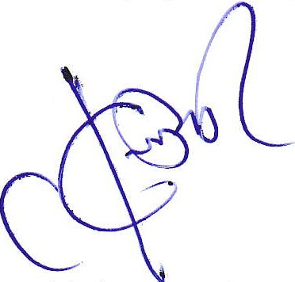Mr. Kismat Mohammad Malpekar