***DEAR SIR,***

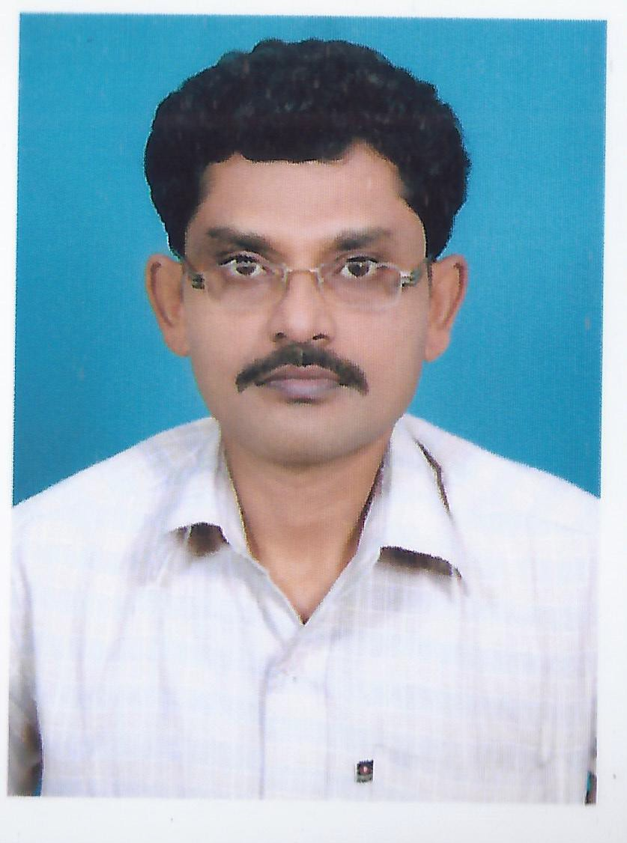***I WANT TO A SUITABLE JOB ACCORDING TO MY PROFILE. MY PROFILE AS A HVAC ENGINEER / SECTION INCHARGE. EXPERIENCE MORE THAN 16 YEARS.***

***MY RESUME ATTACHMENT BELOW HERE. THANK YOU,***

***REGARDS... H.N.MANNA MOB:+919827477776***

***INDIA.***

***C.G. 496001***

**********************************************************************************

***My Education Details is given below.***

**\*\*\*\*\*R*ESUME* \*\***\*\*\*\*\*\*

*************

# HARA NATH MANNA

JlNDAL STEEL AND POWER LIMITED .quarter no JV-11 ,Near-2 no gate, kharsia road,Raigarh-CG-496001 Contact: +91-9827477776; Email: [hnmanna@gmail.com](mailto:hnmanna@gmail.com)

# HEATING VENTILATION AND AIR CONDITION MECHANICAL STEEL AND POWER INDUSTRY

Offering 16 years of experience in Maintenance of MECHANICAL AND AIR CONDITION equipment within allocated budget and stipulated schedules while accomplishing personal as well as organizational

goals.

# PROFILE

**Competent & diligent foreman and departmental in -charge with 15 years of career success** across HVAC Maintenance ,Mechanical and Air-condition equipment . Currently associated with **JINDAL STEEL AND POWER LTD, Raigarh**, as a **Department In-charge.**

**JINDAL STEEL AND POWER LIMITED** being such a pioneer company in steel and power sector has

entire range of products to offer to customers and being associated to them I have gained good knowledge on the same. I am personally **working on Screw/Scroll/Reciprocating Type Package/Ductable, Split Units, VRFs, AHUs of HVAC etc**.

Proven, **People management skills**. exceptionally well organized with a track record that demonstrates self-motivation, creativity and initiative to achieve both personal and corporate goals.

***Also,Awarded of 2016: INOVATION OF IN HOUSE DEVELOPMENT & MODIFICATION OF* "Process Chiller Unit and Industrial Crane AC."**

# Core Competencies

**HVAC:-**

* Heat load calculation
* Material Handling
* Equipment selection
* HVAC Commissioning
* Quality control & ISO process maintaining for department

# Technical Skills

* SAP Operations
* Microsoft word/ excel/Power-point

# RESPONSIBILITIES:

* Annual maintenance of HVAC system at one of biggest steel and power plant of the country.
* Handling the contractors/ sub- contractors and provide technical support.
* Leading team, arrange training session on chillers/DX system / Package ac / VRF of HVAC
* Monitoring the performance of team members to ensure efficiency in testing and tools.
* Efficiently coordinating meeting with the team members for execution of project.
* Achieve financial target of every month.

# PROFESSIONAL EXPERIENCE

**JINDAL STEEL AND POWER LTD.-CG Since-JUN 1998**

as a DEPARTMENT INCHARGE-AC SECTION

# ACADEMIC CREDENTIALS

**DIPLOMA in Mechanical Engineering**; In 2012 IME -DISTANCE EDUCATION

**ITI-AIR CONDITION AND REFRIGERATION** IN 1996 HOWRAH ,WEST BENGAL

**Class 12TH**-1994 HOWRAH ,WEST BENGAL

# COURSE

**ADVANCE TRAINING ON HEAT LOAD CALCULATION**

ADVANCE TRAINING INSTITUTE ,HYDERABAD

# ANOTHER EXPERIENCE:-

**COURSE**

**OP JINDAL INSTITUTE OF TECHNOLOGY.**

Renewable Energy Of Solar Power System Maintenance,

# PERSONAL DOSSIER

Date of Birth: 29-FEB-1972

Languages Known: Hindi ,Bengali ,English Permanent Address: S/0 PRAFULLA MANNA.

VILLAGE- BARBANGALPUR , POST-JOARGORI , DISTT- HOWRAH , WEST BENGAL,PIN NO:- 711303.INDIA.