CURRICULUM VITAE

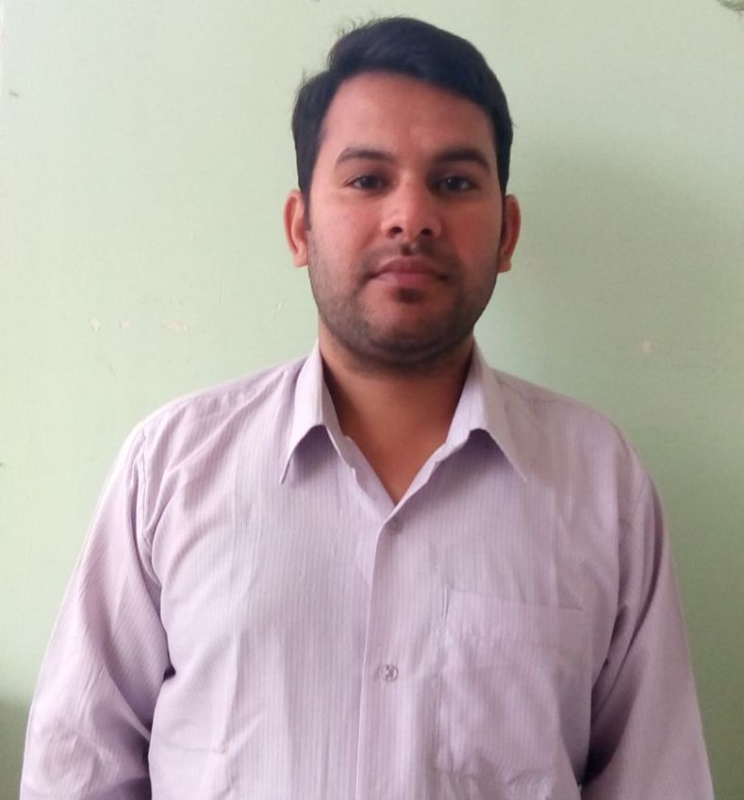

|  |
| --- |
| **Sunil Kumar**  176045 Hamirpur Himachal Pradesh  Contact No: +91 70180 49349, 88942 54304  Email address: [sunilsartaj@gmail.com](mailto:sunilsartaj@gmail.com) |

**OBJECTIVE:**

Seeking a position to utilize my skills and abilities in the Information Technology Industry that offers professional growth while being resourceful innovative and flexible.

Ability to work independently with high motivation toward new knowledge and a good team worker with evidence by my excellent performance during internship and the university.

**WORK EXPERIENCE:**

**5Years 6Month of Professional Experience**

**Electrical And Solar Technician**:

* Two Years Experience in Electric Work (Single Phase & Three Phase) from Dhiman Electrical Nalagarh, as Electrical technician.
* Three years experience in Exide Industries Ltd. as a service engineer (Deals with all type of battery, Inverter850VA TO 12 KVA, Solar inverter, solar panels etc& half year also working in Micromax Energy Ltd.
* Six month working experience in Al Reyami Group UAE, deals with welding machine or generator, Tower light, Maintenance.

**Duties & Responsibilities**

* Deals with all type of Domestic, and industrial wiring and MEP work.
* Single phase and three phase electrical work and maintenance of domestic appliances
* In Exide batteries services center deals with all type of batteries, inverter, solar panel and all type of inverters.
* Charging and discharging of industrial and solar batteries
* Installationof solar panel and maintenance of the solar inverter
* In Al Reyami rental maintenance of generator, tower light, welding machine, and solar tower light

**Relevant Skills:**

ElectronicData ProcessingKnowledge:

Excellent in Microsoft OfficeProgram:

* MS Word: Excellent skills in editing typing and maintaining documents.
* PowerPoint presentations: Basic skills in creating power point presentations.
* Excel Spreadsheets: Basic skills to create and maintain Excel sheets on daily basis.

**EDUCATIONAL BACKGROUND:**

**Diploma in Electrical Enginering**  
Punjab state technical Board ChandigarhJune 2009-July 2012

**Secondary Education**

Passed 12th from H P Board of School Education

Dharamshala 2008

**Relevant Qualifications:  
Languages:**

* English: Fluent in speaking and writing
* Hindi: Mother language

**HOBBIES**

As per my hobbies I love cooking delicious food and visiting new places.

**PERSONAL INFORMATION:**

Full Name: Sunil Kumar  
Nationality: Indian  
Marital Status: Single  
Date of Birth: May 3, 1990  
Place of Birth: Himachal Pradesh

Indian Passport no: L8477602

**Thanks**

**Sunil Kumar**

**Place:**

**Date:**