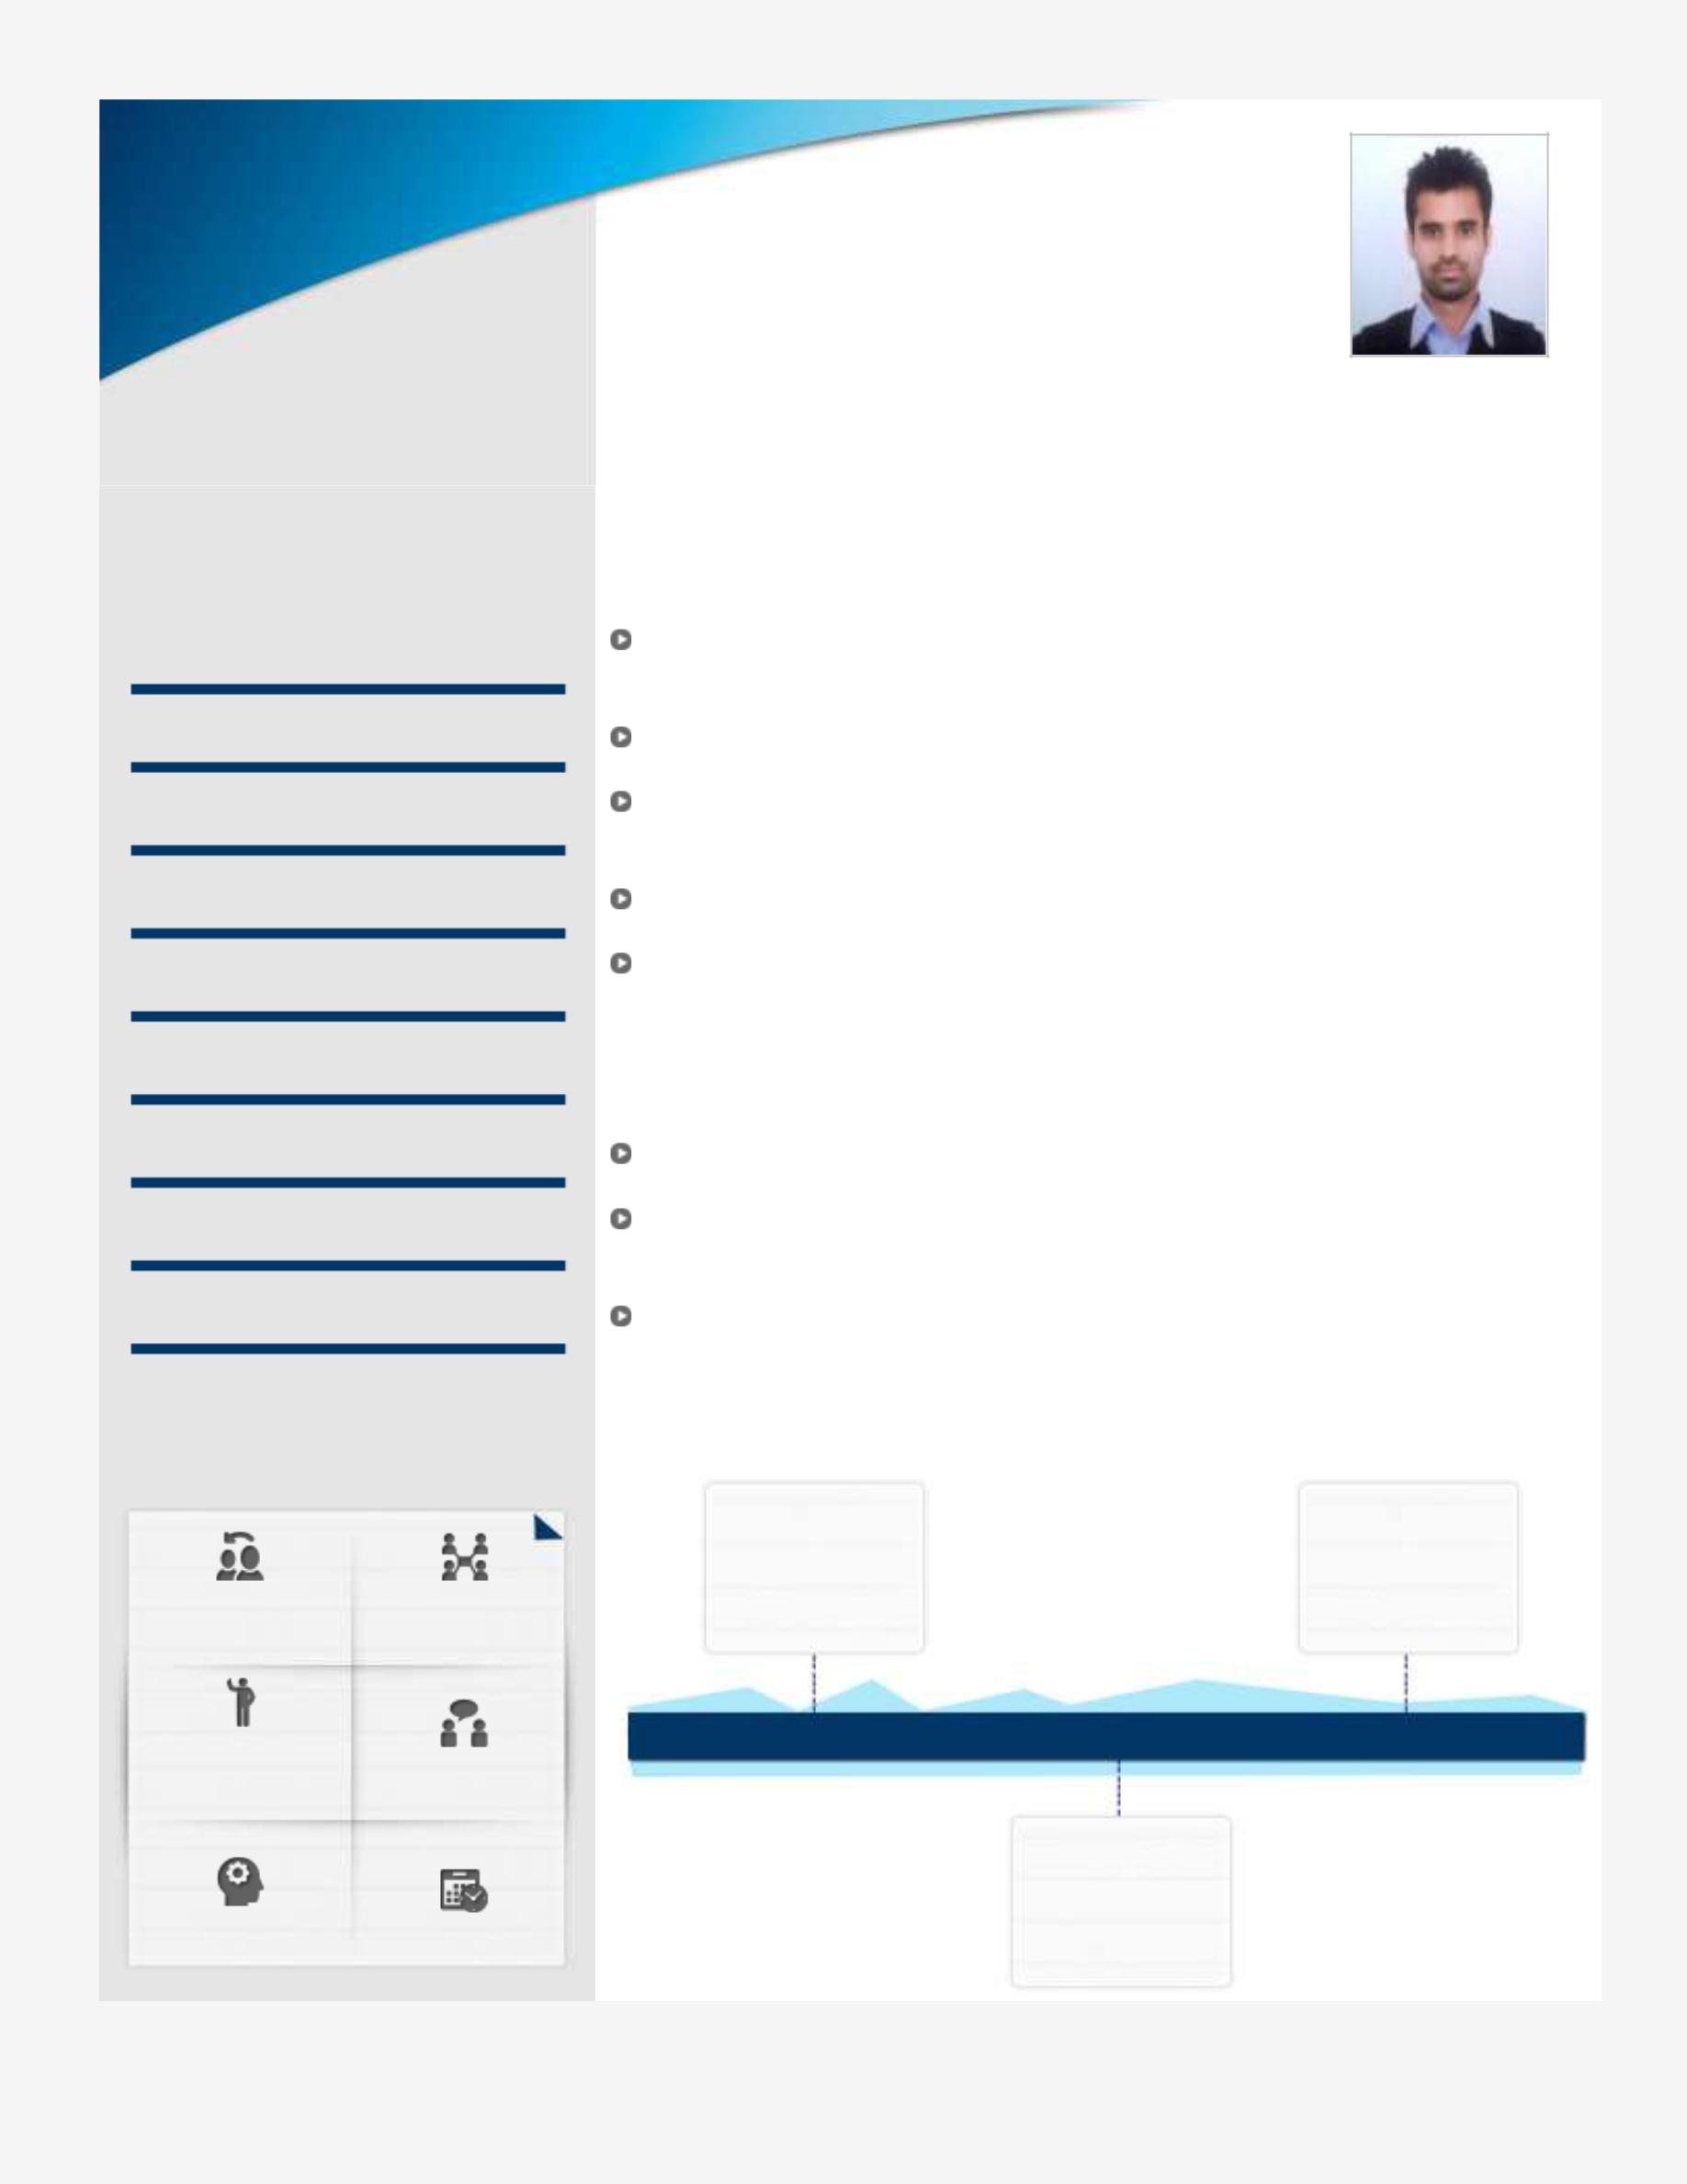

 Core Competencies

Maintenance

Operations

Management

Reporting & Documentation

Quality Check

Product Development

Kaizen Approach

Dimensioning

 Soft Skills

Coperative  Team Player

Self

Motivated Travelling

Observer Planner

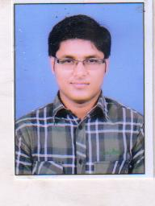**UDIT GUPTA**

 uditgupta29@gmail.com

 +91 9599512413/ +91 8909176841

***Result-oriented Professional****, targeting challenging assignments in* ***Product Designing/ Warranty Management with*** *a growth-oriented organization of repute*

Industry Preference: Manufacturing/production

Location Preference: Delhi/ NCR

 Profile Summary

Proficiency in troubleshooting technical issues; conducting inspections to ensure that products developed are in compliance with pre-set quality specifications

Possess skills at managing dimensioning of the parts

Capabilities to work in product development projects in accordance to the

customer’s requirements

Reporting the details at all aspects so no communication biasing between management and employees.

Supervising the labour in segments of working area

 Education

B.Tech. (Mechanical Engineering) from Anand Engineering College – Agra (Dr A.P.J Abdul Kalam Technical University,Lucknow) with 70% in 2016

12th from Jhon Miltan Public School With 74.4 %

10th from Bhartiya Vidhya peeth School With 70%

 Career Timeline

|  |  |
| --- | --- |
| **BANARA** | **VIPAR** |
| **UDHYOG** | **AUTO** |
| **LTD** | **PVT LTD** |
| **ENGINEER** |
| **Training** |
| **TRAINEE** |
|  |

|  |  |  |
| --- | --- | --- |
| **15 DAYS Training** | **45 DAYS Training** | **7 MONTHS Job** |
|  | **INDIAN RAILWAYS** |  |
|  | **LKO** |  |
|  | **DEMU WORKSHOP** |  |
|  | **DEMU POWER** |  |
|  | **PACK Training** |  |

* TRAINING & PROJECTS UNDERTAKEN/ INTERNSHIP
* Undertaken a Project on **“ (Pneumatic based road security system)”.**
* Winter training of **15 days** *in* **2014** from ***Banara*** **Udyog Limited (Technical Collaboration With NTE Korea),** Manufacture of **bearings ,pistons** etc**.**
* Industrial training for **28 days** in **2015** from **Indian** **Railway,** Lucknow on **“Diesel Electrical Motor Unit (DEMU)”.**
* **Certification** course on **Leadership** From **(psychologyworld.org).**
* EXTRA CURRICULAR ACTIVITIES/ACHIEVEMENTS
* Participated in **10th National Science Olympiad** by **Science Olympiad Foundation,**
* Partcipated in **The AerotriX Super challenge** organized by **AerotriX** , in association with **Concientia’14,IIST Trivandrum,**
* Student Membershipof **Indian Society For Technical Education,**
* **Participated** in **Technical events of Mechanical Department** of **AEC**,
* **Coordinator of technical event in** the annual college festival **Cerebrum, 2014**.
* **Presented** project of Hydraulic jack on **INOVATION DAY 2015 IN AEC,AGRA**
* Participated in various sports events
* PERSONAL DETAILS
* Date of birth: 14-FEB-1994
* Mother’s name: Mrs. SADHNA GUPTA
* Father’s name: Mr. ATUL KUMAR GUPTA **BANK MANAGER (P.N.B)**
* Brother’s name: Mr. VIDIT GUPTA **ANALYST (R.B.S)**
* Permanent address : 6,NEETI BAGH SHAMSHABAD ROAD,AGRA (282005)

**(UDIT GUPTA)**

**DATE:**

**PLACE:**