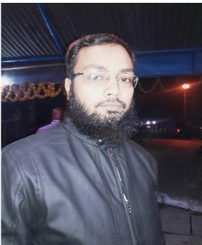**MOHD Mahtab Khan**

# (DMRT) Ph.+919598464725

[**Email:-mohdmahtabkhan950@gmail.com**](mailto:-mohdmahtabkhan950@gmail.com)

|  |  |  |
| --- | --- | --- |
|  |  | **Carrer Objective** |
| **MOHD.MAHTAB** | Seeking a position that offers professional growth and learning which will help me to grow with the company, learn new technologies and work in an innovative and challenging environment.  **Professional Qualification** |
| **KHAN** |
| ***Address:*** |
| Ward-Rafi Ahmad Kidwai |
| Nagar |
| Chhawani,Post-Padraun |
| a, DISTT-Kushinagar |
| Diploma 1n Radiology Technology (D.M.R.T.) From Indian Institute of Health Education & Resea rch Patna, Bihar in 2001-2003. (2 year course )  **Educational Qualification** | |
| ,U.P.- 274304 |
| ***Contacts:*** |
| *Mobile* ***:+97*** |
| ***9598464725*** |
| ***E-Mail*** |  | **1**Qth fro m UP 1st Division 12th from UP 2nd Division  B.Sc.(Bio)from Udit Narayan PGCollage Recognized From DOU 2nd Division  **Key Skill in Computer** |
| mohdmahtabkhan950@g |
| mail.com |
| ***PersonalData:*** |
| *Father's Name:* | * MS Office ( Word, Excel & Pow erPoint ) |
| *Or. Mohd Maroof Khan* |  |
| *Date of Birth :* | **_.W:....:.o...:.:r...k..:.:i:.n:....:g., Exp...:e......r:...i_e_n_ce _**  **2** |

12 year of experience above over all jobs

12 Years experience in Selling allopathic

medicine in Shifa Hospital & Pharmacy

•

•

•

•

•

Work ing as X-Ray technician in a Shifa

Hospit al Padrauna from 2004 to 2016..

•

*7. English*

1. *Hindi*
2. *Urdu*

***Languages known:***

***Passport No..***

***N6796823***

***Date of Exp.27/ 12/ 25***

*77 -Jul - 1979*

*Sex*

*: Male Nationality Indian*

*Marital Status Married*

## Strength

* Fast Learner
* Self Confident
* Motivation
* Team Leadership

## Declaration

I hereby declare that the above written particulars are true to the best of my knowledge & belief.

## Date :

**Place:** Padrauna

## (MOHD.MAHTAB KHAN)