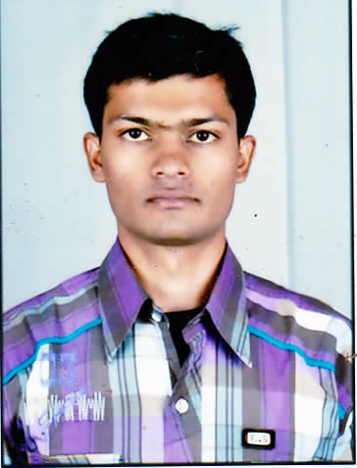

**Ram Krishna Shukla**

H.no17 Lakshmipuri Hinotiya

Chadbad Bhopal (M.P)INDIA

Email:[ram21.sistec@gmail.com](mailto:ram21.sistec@gmail.com)

Contact: +917747086881

#### Career Objective:

My immediate aim is to work in an organization where I can utilize my knowledge, technical skills, analytical skills, hard work & consistency towards organizations technological endeavors.

#### Academic Profile:

,

|  |  |  |  |
| --- | --- | --- | --- |
| **EXAMI EXE EXAMINATION** | UNIVERSITY | YEAR OF PASSING | AGGREGATE |
| M.Tech[Machine Design] | RGPV | 2017 | 63.5% |
| BE[ME] | RGPV | 2015 | 83.9% |
| 12th | CBSE | 2011 | 79.8% |
| 10th | CBSE | 2009 | 85.2% |

**Professional skill:**

* MS Office.
* AUTO CAD(basic)
* Pro-e(basic)
* CNC programming (basic)
* Basics of C++ and JAVA(basic)
* ERP(Safal)

**TRAINING:**

* Completed Two week Expert training at IGTR (Indo German Tool room) Indore.
* Learned programming & operation of machine on CNC Machine

**Projects Undertaken:**

* Title: Fabrication of powered Exo-Skeleton Arm
* Description: It is based on four bar mechanism and developed to support the paralyzed body part. It can also be used in industries like medical, defence etc as a robot where human presence is not possible due to harmful chemical testing. These robotic parts will be more efficient and precise in comparison to human when talking about industrial use. It can give chance to working population to start earning again to support themselves and come up to their family expectation.

**Co-curricular activities:**

* Presented paper on the topic “Renewable Energy” in SRIJAN state level Technical Event, Bhopal, M.P.
* Participated in model competition in Srijan Technical Event Bhopal,M.P.
* Participated in model competition Nirman held at SISTec Bhopal.
* Participated in essay competition on the topic Renewable Sources of Energy at SISTec, Bhopal.

**Extra Curricular Activities:**

* Participated in District level National Science Congress held at Shahdol(M.P)
* Won several medals in athletics (long jump, high jump, javelin, shot put, throwball).
* Captain of cricket team at school level & won Annual sports tournament.

**Achievements:**

* Best student award for the discipline & 100% attendance in the class during semester and school.
* Won several medals at school athletic meet.

**Personal Profile:**

Name : Ram Krishna Shukla

Fathers Name : Rajendra Prasad Shukla

Date of Birth : 01/04/1994

Marital status : Unmarried

Language Known : Hindi & English

**Experience:**

Company: Par Techno Heat Pvt Ltd Ahmadabad.

Experience**:** 6 months

Job Field: Boiler Fabrication

Job Profile**:** Production Engineer

**Strength:**

Interpersonal skills, self discipline, understanding with good convincing etiquettes, dedication towards my work and blessings of my Parents & the Almighty.

Focus on work completion before time, able to work under pressure.

**Interests:**

Listening to music, Playing Cricket, Cooking, & Gardening.

**(Ram Krishna Shukla)**