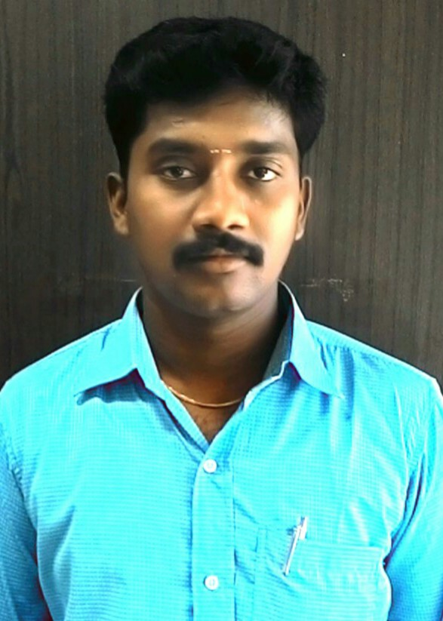

**SURESH KUMAR. B**

# 8/3,6th Cross Street,

TNEB Colony, Menamedu,

Ambattur, Chennai-53

CELL: 9940446240

E-mail: [sureshkumarsrc78@gmail.com](mailto:sureshkumarsrc78@gmail.com)

**OBJECTIVE:**

I consider myself to be a diligent team player who is always open to suggestions on how quality and efficiency can be improved. My work ethic is second to none and I thrive on new challenges always maintaining safety to be of the highest priority. I believe that with my extensive experience that I am a prolific asset in my chosen field of work.

**WORK EXPERIENCE:**

**1. RPK GREEN TRADING, Chennai (1st April 2015 to Till Date)**

Working as PROJECT ENGINEER **(Electrical).**

**Responsibilities:**

1. Responsible for factory Electrical machineries and maintain to the all maintenance documents.
2. Handling to the 100kva Diesel Generator and maintain to the supporting Documents.
3. Responsible for site solar erections and commissioning works and also handling to all solar maintenance report and site reports.
4. To prepare design as per client requirement.
5. Work with a team of engineers in designing, developing, and homologating solar photovoltaic and solar systems support Structures, solar panels, modules, batteries and electric power generation.
6. Prepare all pertinent documentation for each manufactured product like user’s manual, installation manual, operations manual and technical reference manuals.
7. Prepare, inspect and assemble solar structures, modules, panels as prescribed in the assembly instruction.
8. Conduct site inspections to check on work progress and compliance to work specifications.
9. Handling to vendors details and maintaining to the vendors documents.
10. Established detailed construction& solar structure drawings and schematic drawing sets.
11. Preparation of solar KWP projects BOM, BOQ.
12. Coordinated with customer site visits.

**Project Details:**

1. I have completed 210 KW Roof top solar project erection and commissioning in KSRM Engineering Collage –kadapa.

2. I have completed 550kw Roof Top solar erection with civil work in Infosys-Hyderabad.

3. I have completed 250 KW Ground mounted solar project erection and commissioning in HPCL-Chennai.

4. I have done in 250kw Roof top solar projects in world Trade centre –Mumbai.

5. We are completed currently 200kw roof top solar project in National Small Industrial Corporation (NSIC) – secunderabad.

**2. SRC GREEN POWER PVT LTD, Chennai (10th July 2012 to 28th Feb 2015)**

Working as TECHNICAL ENGINEER **(Electrical).**

**Responsibilities:**

1. Responsible for site wind turbines erections and commissioning for Electrical, Mechanical and Civil works and also handling to all WTGs maintenance report and site reports.
2. Erection and commissioning to the 113KVA Transformer with CTPT unit in WTG site.
3. Work with a team of engineers in designing, developing, testing and homologating solar photovoltaic and wind systems support Structures, solar panels, modules, batteries and electric power generation units supply to EB.
4. Prepare all pertinent documentation for each manufactured product like user’s manual, installation manual, operations manual and technical reference manuals.
5. Prepare, inspect and assemble solar panels, modules, panels and wind turbine power and control panels as prescribed in the assembly instruction.
6. Conduct site inspections to check on work progress and compliance to work specifications.
7. Handling to vendors details and maintaining to the vendors documents.
8. Established detailed construction& solar structure drawings and schematic drawing sets.
9. Preparation of solar KWP projects BOM, BOQ.
10. Coordinated customer site visits.
11. Wind turbine panel architecture design for250/225/200/55 KW Machines.
12. Contacting routine test for generator 250/225/200/55 KWP witnessing as per 1231.
13. Wind turbine for250/225/200/55 KWP Machines drawings preparations.
14. Maintaining to all factory and site electrical documents.

**3. GKAR ENGINEERING INDIA PVT LTD, CHENNAI. (4th Sep 2011 to 30th June 2012)**

Working as ELECTRICAL SUPERVISOR,

**Responsibilities:**

1. Responsible for Department staffs attendance.
2. Responsible to work allocation for Deportment Staffs
3. Preparing schedule for weekly work allocation.
4. Ensure working conditions and safety at work as per standard.
5. Reporting daily progress to client and our Site engineer.
6. I have taking care of Lighting and earthing department in the thermal power plant.

**Project:**

2x135 MW POWER PLANT GUDUR Andhra Pradesh.

**4. G4S FACILITY SERVICE (P) LTD, CHENNAI. (24th Aug 2009 to 31st Aug 2011)**

Working as **MULTI TECHNICIAN**

**FACILITY LOCATION-** MASTER SYS TECHNOLOGY IN CHENNAI (DLF), INDIA.

**Responsibilities:**

**Operations & Maintenance**

1. To maintain the 100x2 Kva diesel generator.
2. Preparation and maintaining for all Electrical documents.

3. Preparing schedule for preventive maintenance and man power supply.

4. Ensure working conditions and safety at work as per standard.

5. Responsible for all start up and shut down of electrical activities related jobs.

6. Maintenance of 100 kva UPS 2No’s, and one no 10kva Ups.

7. Responsible and maintenance for all type of Air conditioners (Such as split AC, cassette ac..)

8. Responsible for all UPS rooms, Server Rooms and Battery Rooms,

9. Maintained all floor equipment in good, safe working order.

**FACILITY LOCATION-** BARCLAYS BANK CHENNAI (DLF), INDIA. Working as SENIOR TECHNICIAN

**Responsibilities:**

**Operations & Maintenance**

1. Preparation and maintaining for all Electrical documents.
2. Preparing schedule for preventive maintenance and man power supply.
3. Preparing to shift schedule for shift technician.
4. Ensure working conditions and safety at work as per standard.
5. Responsible for all start up and shut down of electrical activities related jobs.
6. Responsible for the operation and Maintenance of all floor equipment’s.
7. Maintenance of 160kva UPS 4No’s, 100kva UPS 2 no’s, 20kva Ups 1no’s and10kva UPS.
8. Responsible for water heater coil replacement for all type of Greaser.
9. Responsible and maintenance for all type of Air conditioners (Such as split AC, cassette ac...)
10. Responsible for all UPS rooms, Server Rooms and Battery Rooms,
11. Maintained all floor equipment in good, safe working order.

**5. ACE TECH POWER SOLUTION LTD, CHENNAI INDIA. (10th Feb 2008 to 6th Dec 2008)**

Working as JUNIOR ENGINEER

**Responsibilities:**

1. Responsible for all UPS power wiring.
2. Responsible for all service and installation ups and inverters.
3. Planed to the dispatched UPS and Inverters.
4. Maintained to the all documents and Reports.
5. Reporting to Director for progress day by day.
6. Received materials from Deportment Store.
7. Ups and Inverters Servicing to customer site.
8. Maintaining to install UPS and Inverters.

**6. NUMERIC POWER SYSTEM LTD, PONDY (2nd Feb 2007 to 31st Jan 2008)**

Working asAPPERANTICE,

**Responsibilities:**

1. Received from stores required materials.
2. Making to the Sub assembly for Ups required no’s.
3. Issued to the sub assembly materials to Assembly section.
4. Responsible to required numbers Ups laying power and control wirings.
5. Maintained to the deportment documents.
6. Ups Testing also done.

**EDUCATION:**

**1.** **Bachelor of Engineering: 2013-2017 in Electrical and Electronics Engineering.**

I have completed in Degree program in Electrical & Electronics Engineering from

Sathyabama University, Chennai.

**2. Diploma in Electrical and Electronic engineering (2003-2006)**

Accomplish from DOTE Chennai through PV polytechnic Collage, Tindivanam.

**COMPUTER SKILLS:**

MS-Office : MS-Word, Ms-Excel, Ms- Power point.

DCA : C Language, C+ +, HTML, Front Page

Auto CAD : Electrical CAD

**PERSONAL:**

Name : B.Suresh Kumar

Father’s Name : S.Bala Krishnan

Date of Birth : 04/05/1986

Marital Status : Married

Nationality : Indian

Religion : Hindu

Interests : Listening to music and Browsing,

Languages Known : English, Kannada, and Tamil &Hindi

Permanent Address : Sathaputhur village

Mariamman Koil Street, Eyyakonam post,

Gingee Taluk, Villupuram Dist-604204

**DECLARATION:**

I would be glad to provide any other information required by you. I hereby declare that the above-mentioned particulars are true to the best of my knowledge and belief.

**Yours Faithfully,**

(Suresh Kumar.B)