**CURRICULUM  VITAE**

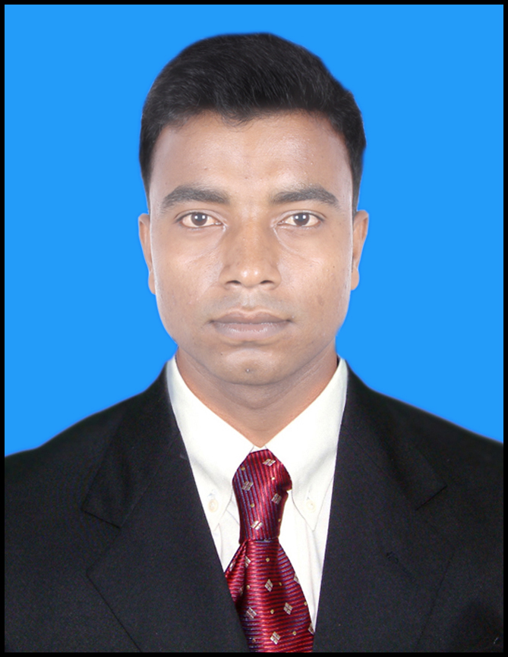

**SONU KUMAR SINGH**

Vill-Bishunpur Po-Sarsar

Ps-Muffasil , Siwan

Pin-841226, Bihar (India)

**Contact No. +91-9555454434**

**Email Id:-sonudilli156@gmail.com**

**POST APPLIED FOR: “HVAC TECHNICIAN”**

**CAREER OBJECTIVE:**

* To utilize my skills, abilities and knowledge in a positive and beneficial manner in an Industry that offers professional growth. And to do some thing extra ordinary for the Industry especially in my field of knowledge and related to it.

**ACADEMIC QUALIFICATION:**

* Passed **MATRICULATION** from **CBSE, Delhi** in the year of 2009.
* Passed **INTERMEDIATE** from **BSEB,Patna** in the year of 2012.

**TECHNICAL KNOWLEDGE**

* Completed two year of **DIPLOMA IN MACHANICAL** from **MONAD UNIVERSITY** in the year of 2014.

**WORKING EXPERIENCE:**

* Working In **TARAPORE & CO.** in Jamshedpur as a **“HVAC TECHNICIAN** period from 12th May 2015 to till continues in service.

**PERSONAL INFORMATION**

* Name : **SONU KUMAR SINGH**
* Fathers Name : SURENDRA SINGH
* Date of Birth : 05th September 1994
* Religion : Hindu
* Nationality : Indian
* Marital Status : Married
* Languages Known : English & Hindi.

**PASSPORT DETAILS**

* **Passport No : P-5646638**
* Date of Issue : 24/01/2017
* Date of Expiry : 23/01/2027
* Place Of Issue : **PATNA**

**NATURE OF JOBS**

* Overhauling of Reciprocating Compressor.
* Day to day operating of centralized air conditioning system.
* Breakdown rectification of air conditioning system. Alignment of equipment with their drive. All type of Air conditioning (Erection and commissioning).
* Knowledge of Chiller pump, Condenser Pump, Cooling tower, Chiller desk clean, Condenser desk clean.
* Preventive (routine) maintenance & alignment of Auxiliary equipment viz; centrifugal pumps A.H.U., F.C.U., Blower, Cooling tower etc.
* Operations of reciprocating screw type and centrifugal compressor. All micro processor based system, water cooled and air cooled.
* Pressure testing, Evacuating and refrigerant to up and charging package chiller.
* Maintenance and servicing of Domestic units.

**ABILITIES**

* Accept additional hours & responsibilities as needed by our senior.
* Able o develop quality maintenance and operation.
* Extensive experience and skill, which can be applied for betterment of the organization.
* Adaptable according to new situation.

**SAFETY AWARENESS**

* Maintaining Power safety and environment at the work place.
* Understand safe working procedure and ensure safety of self and people working under him.
* Should know understand the quality policy environment policy, safety policy & the department of the company.

**DECLARATION**

­­­­­­­­­I do hereby declare that all the statement as mentioned above are true & correct to the best of my knowledge and belie.

Date: ----------------- Yours faithfully

Place: Delhi **(SONU KUMAR SINGH)**