CURRICULUM--VITAE 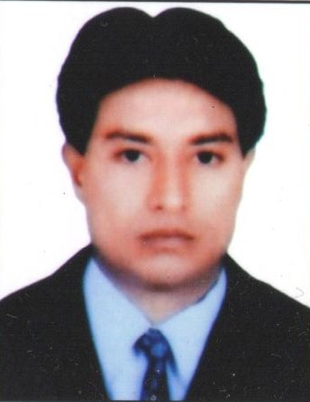

S. Naqui Abbas

Qtr No.-54/C 3rd Floor

Street-5 , J- Extension, Laxmi Nagar

New Delhi --110092. (INDIA)

Tel-9873538782, 9953492854, 09504742835, 061542-78014

Email : Naqui_Abbas@rediffmail.com

[Syed_Abbas1982@yahoo.com](mailto:Syed_Abbas1982@yahoo.com)

SyedAbbas2554@gmail.com

Carrier Objective To make a career with a leading organization contribution towards exodus of

the organisation and personal gain of knowledge to develop, mature creative

myself as an able IT Professional in today’s IT industry.

Academic Qualification: Graduation (Hons) in 1996

Professional Qualification: Completed Master Degree in Computer Applications

from NIIT New Delhi –110001 (INDIA)

Pursuing M. B. A. (IT) from Pondicherry University.

Technical Skills:

Languages:

C++, Visual C++, Visual Basics(6.0) , HTML, Sybase

Operating Systems:

Windows 95,Windows 98, Windows-NT, MS-Dos, Unix

Front End Tools:

Visual Basics, SQL

Networking:

Windows-NT, TCP/IP, LAN, INTERNET

Packages:

MS-Office

# My Job Role JOB PROFILE AT CUSTOMER LOCATION

Key Responsibilities 1.American Express

**The job involved looking after their mainframe jobs, mainly submission and processing and other production related activities using IBM AS/400. I was looking after their daily upload and download s of files from the mainframe database and running query on mainframe application. I was also looking different processes and smooth functioning of their different package, which are related to production such as Reward Trackers, Xcom, FTP, etc.**

American Express (TRS): working with American Express Travel Related Service in Technologies (Production Control) as a representative of PSPL.

Job Role: The organization has fully automated operation based on highly advanced information technology system IBM-AS/400, Mini system. My Job role is to manage the administrator of As/400 operation as per the allocated schedule. This requires in depth knowledge of SQL and CL (Control language As/400).

Responsibilities included:- Ensure connectivity to the mainframe System in Phoenix USA. The connectivity of American Express System globally is through CISCO routers support the launch of new product by analysing the system requirement .

Managing User Profile As/400:- Looking after mainframe data administration and different production related activities using IBM As/400.IBM AS/400 is being used as interface between and the local system. I also Monitors LAN and Lotus Notes.

## **Networking / Telecom Support**

* Support of Standard Packages and all kind of Remote Access Packages like Database Related, Image Bases, Mailing etc.
* Installation, configuration, troubleshooting, Maintaining and Documentation of WIN NT / WIN95 / 98 Server and Workstation, Lotus Notes Server / Workstation, CITRIX Server.
* Workstation, NS Elite Workstation Mainframe Application and Banking Application etc.
* Installation, Monitoring and maintaining of Network and communication equipment’s like – Token Ring, Ethernet, Router 7200/ 3600, series, IGX ,WAN ,Switch, Token Ring, Switch ,Hubs & four wires leased line.
* Monitoring and Maintaining of ATM’s for whole India.

Projects done: 1.Sales Order & Processing System using Ms-- Access.

2.Video Library Application System using Sybase & C++.

3.Video Library Application System using Visual C++ &Access.

4.Video Library Application System using Visual Basic & SQL.

Experiences: 1. Worked as a MIS Executive with Shilpi Modes Pvt Ltd,

East of Kailash, New Delhi from March 1997 to Sept 2000.

2. Worked as a Customer Support Engineer in American Express

Connaught Place New Delhi, from November 2000 to June 2004.

3. Worked as a Data Center Officer in Tata Aig Insurance Co. Ltd. from

August, 2004 to Oct 2005.

4. Worked as a Technical Support Engineer in Al-Jeraisy Computers &

Comm. Services Ltd. Jeddah (KSA) From October 2005 to Nov 2006.

1. 5. Worked as Technical Support Engineer with Stracon Solutions
2. Ltd, New Delhi from December 2006 to January 2008.

6. Worked as IT Administrator with Oger AbuDhabi LLC, UAE, from

March 2008 to January 2014.

7.Working as a Admin.Manager with Harveera Bharat Services New Delhi

from March 2014 to till date.

Personal Details:

Father’s Name: Mr. S. Nazim Hussain (APP Advocate)

Date of Birth: 5th December 1975

Sex: Male

Nationality: Indian

Marital Status: Married

Languages Known: English , Hindi, Urdu & Bengali

Date:

Place: New Delhi

Signature