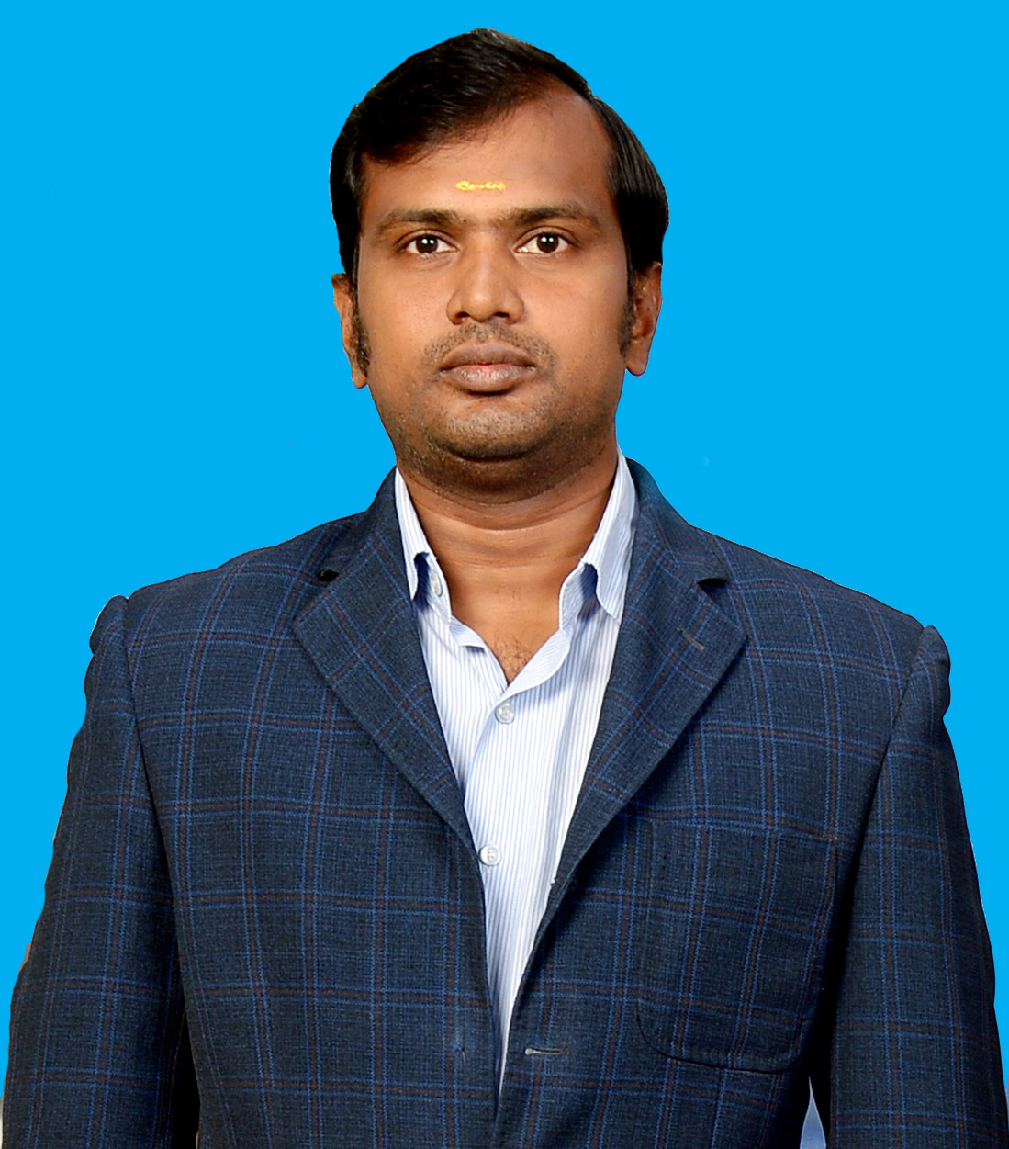

**RESUME**

**I am looking for job @ Electrical Maintenance Supervisor.**

NAME : V. RAJAMANICKAM

**Email id (vrajamanickam79@gmail.com)**

FATHER’S NAME : M. VENKATACHALAPATHY

SEX : MALE

DATE OF BIRTH : 17.11.1979

NATIONALITY : INDIAN

PERMANENT ADDRESS : V.RAJAMANICKAM,

WEST STREET,

SRIMUSHNAM – VIA,

RAJENDRAPATTINAM. PT.

VRIDDHACHALAM. TK.

CUDDALORE – DIST- 608703

PHOTNE NO :

Cell: +65 85897585

+65 82470695

+91 9976992205 (India)

EDUCATIONAL QUALIFICATION : S.S.L.C. MARTH’ 95

GOVT.HSS.VRIDDHACHALAM

TECHNICAL QUALIFICATION : DIPLOMA ELECTRICAL &

ELECTRONICS ENGG.

YEAR OF PASSING : April ‘ 99

NAME OF THE INSTITUTION : MUTHAYAMMAL POLYTECHNIC

KAKKAVERI – POST

RASIPURAM – TALUK

NAMAKKAL – DIST

ELECTIVE SUBJECT : INDUSTRIAL ELECTRONICS

ADDITIONAL QUALIFICATION : AUTO CAD IN RELEASE 14

KNOWLEDGE IN R.2000

LANGUAGE KNOWN : ENGLISH, TAMIL

**DETAILS OF EXPERIENCE:**

1. March 2006 – Until : Miyoshi Precision Limited.

Singapore.

Have 2006 to Until working experience in MIYOSHI PRECISION LIMITED Singapore.

**Designation: Electrical Maintenance Supervisor (EXON MOBILE**

**OIL & GAS)**

**Nature of Job:**

* Controlling of all Electrical systems and Power Panels.
* Electrical Drawing preparation & analysis.
* Maintaining DG Set Capacity of 225KVa
* Maintaining & Controlling of Power Capacitors.
* Installing & Maintaining of mechanical equipment’s like Gear Boxes, Hydraulic & Pneumatic
* Power cabling work up to 400 Sq. mm
* Service and Maintenance of all kind of Industrial electrical equipment’s.
* Service and Maintenance of Single Phase & 3 Phase Electrical Induction motors up to 125 HP
* Maintenance of Electrical Contractors.
* Service and Maintenance of Submersible pumps, Centrifugal Pumps, Valves and Aerators.
* Transformer Maintenance up to 950Kva
* Water treatment plant maintenance.

1. March 2003 – April 2005: : Avasarala Automation Limited

Bangalore

Working in Madras Automic Power Station (MAPS) Kalpakkam

* Maintenance for crane, Hoist, SE Platform & P.T. Removal
* Troubleshooting of electrical control system & Motor
* Laying of power cables
* Generator maintenance
* Preventive maintenance of electrical motors (single phase & 3 phase Induction motors.
* Service and Maintenance of pumps and coupled gear boxes.

2. 10TH JAN’ 2001 – 17TH DEC” 2002 : M/s. Shinei international Pvt Ltd.

No: 31, Jookoon Circle

Singapore.

Have Two Years of Working Experience in SHINEI INTERNATIONAL PVT. LTD

Singapore as a “ SENIOR TECHNICIAN SHIFT INCHARGE “ from

10th Jan 2000 to 17th Dec 2002.

**JOB DESCRIPTION:**

My Job Responsibilities includes the following:

* Troubleshooting of electrical control systems.
* Servicing and maintenance of all kind of domestic electrical equipment.
* Electrical Drawing preparation & analysis.
* Control panel assembling and installation.
* Service and Maintenance of all kind of water pumps, Submersible pumps, Centrifugal Pumbs, Valves and Aerators.
* Laying of Power Cables.
* Defining new electrical control function system.
* Electrical related devices servicing.
* Controlling of all Electrical systems and Power Panels.
* Power cabling work up to 400 Sq. mm.
* Maintenance of Electrical Contractors.

3. 1998 – 2000

Hi-tech engineering India Pvt Ltd.,

53, (NP) developed Plots, Industrial Estate.

Ekkattuthangal, Madras – 600 097

* Worked as a lathe Operator in Conventional Machines Like Lathe (NH- 22) Raial Drilling Machine (RM-61 RM-62)
* Have Knowledge to operate special process like cylindrical Grinding and Centerlines Grinding.
* Have Knowledge in assembling Hydraulic pumps, Control Valves and Trouble shooting.

**PASSPORT DETAILS:**

* Passport No : J1301127
* Date of issue : 10.03.2010
* Date of Expiry : 09.03.2020
* Place of issue : Singapore

I Declare that the above information are true and correct to the best of my knowledge and belief.

Date :

Place: **V. RAJAMANICKAM**