# CURRICULUM VITAE ABDUL RAZACK @ ARSHAD

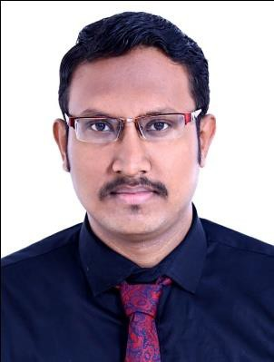

Hor Al Anz Deira, Dubai.

[Email : arshad21294@gmail.com](mailto:arshad21294@gmail.com) Mobile : +971 589379868

Mobile : +91 8098778672

----------------------------------------------------------------------------------------------------------

# CAREER OBJECTIVE:

To take up a challenging job that would help me to upgrade my knowledge and to contribute the organization goals by effectively using conceptual skills and knowledge gained through education and experience

# ACADEMIC PROFILE:

|  |  |  |  |
| --- | --- | --- | --- |
| **Course** | **Name of the school** | **Percentage(%)** | **Year passing** |
| B.TECH  (Mechanical) | Bharathiyar college of engineering and technology, karaikal. | 78% | 2016 |
| HSC | St.Mary’s hr.sec.school,  Karaikal. | 70.1 | 2012 |
| SSLC | St.Mary’s hr.sec.school,  Karaikal. | 77.4 | 2010 |

**WORKING EXPERIENCE:**

**COMPANY :** “GESTAMP AUTOMOTIVE INDIA PRIVATE LIMITED ” , CHENNAI.

**DESIGNATION :** Quality Inspector

**DURATION :** One year ( July 2016 to July 2017 )

# ROLE AND RESPONSIBILITEIS:

* All types of instruments are used(vernier, depth vernier, micro meter, bore gauge).
* Conducting programs for Housekeeping and 3C,5S.
* Analyzing the rejection component & daily discussing with operators.
* In-house inspection for the first sample (both visual & dimensional).
* Customer end & internal rejection analysis, planning & monitoring corrective action.

# AREA OF INTEREST:

* QUALITY CONTROL
* MANUFACTURING
* MAINTENANCE
* ASNT NDT LEVEL II ( UT,RT,MT,PT,VT,RTFI )

# SKILLSET:

* Operating system : Windows, MS-office.
* Languages : C, C++.

# TECHNICAL QUALIFICATION:

* + American Society for **NON DESTRUCTIVE TESTING** [**ASNT] Level II** as per SNT- TC-1A in NIILE SOLUTION, CHENNAI.
    - Penetrant testing
    - Magnetic particle testing
    - Ultrasonic testing
    - Radiography testing
    - Visual Inspection testing
    - Radiography test film interpretation
* Tmc on heat treatment, material testing, welding in advanced training institute ( ISO 29990-2010 certified), guindy, chennai.

# IN-PLANT TRAINING:

* Summer project training at **Supreme Industries Ltd.,** Sanyasikuppam Village, Thirubuvanal Port, Puducherry.
* Attended inplant training for one week at **Ambal auto ,** A unit of Sree Saradhambal Automobiles (P) Ltd., Singanallur, Coimbatore.

# INDUSTRIAL EXPOSURE:

* Lakshmi Machine Works at Coimbatore.
* ELTEX at Coimbatore.

# PROJECT UNDERTAKEN:

* **PROJECT AREA :** Thermal Engineering

# PROJECT TITLE : “ Performance test and reducing emission by electrolytic generation of hydrogen & oxygen in diesel engine ”

**STRENGTHS:**

* Creative and logical, Willingness to learn, Problem solving ability, Time Management

# PERSONAL PROFILE:

**Father’s Name** : Haja Nizamudeen. A

**Passport Number** : N3747956

**D.O.B** : 02-12-1994

**Sex** : Male

**Nationality** : Indian

**Marital Status** : Single

**Language known** : English,Tamil, French.