*I*

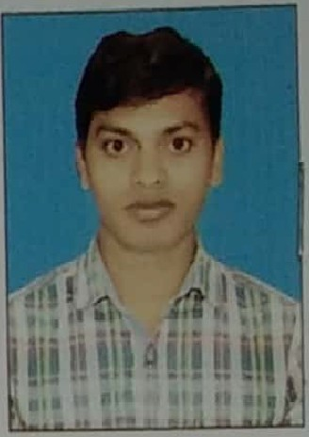

**Brief CV**

Name:

Address:

SUMAN KUMAR

**S/0-HARI PRASAD MAHTO, VIUAGE-OANDU BHANGATH**

P. O • DUMDUM!, P.S- TOPCHANCHI,DISTRICT-DHANBAD,STATE-JHARKHAND PIN CODE-828402

E-mail:SUMAN [4264@GMAIL.COM](mailto:4264@GMAIL.COM)

Phone:09955027721

Education

|  |  |  |  |  |
| --- | --- | --- | --- | --- |
| Degree | Olscipline | School/Institute/Unlv rslty | Year | **MARKS/** CGPA |
| B. Tech . | ELECTRICAL ENGG. | K.K.C.E.M GOVINDPUR DHANBAD (V.B.U  HAZARIBAGH,JHARKHA ND} | 2017 | 70.60*'¼* / 7.06 |
| Dfploma | ELECTRICAL ENGG. | **K.K.** POLYTECHNIC DHANBAD (STATE BOARD OF TECHNICAL  EDUCATIONJHARKHAND) | 2013 | 74.87 o/o |
| 101h/ MATRIC | MATRICULATION | KARITAND HIGH SCHOOL MANJH ALADIH,DHAN BAD  (J.A.C BOARD RANCHI) | 200B | 78.0C,% |
|  |  |  |  |  |

•

Technical **Skills**

1. MS WORD (iii) POWERPOINT
2. EXCEL (iv) C++,MATlAB

Training and Pro)ects

* 1. FOR DIPLOMA-JHARKHAND ELECRICITY BOARD DHANBAD

(ii) FOR B.TECH-TRAINING ON 33KV/11-6.6KV MADHUBAND D.G.SUS STATION IN GUID ENCEPOF BCCL

Career/ Int erest : ELECTRICAL & ELECTRONICS

**rersonal Detal)s**

DOB

## Sex

M arital Status Father's Name Languages Known

Hobb ies Strength

25-12 -1993

MALE UNMARRIED

HARi PRASAD MAHTO

HINDI, ENGLISH

PLAYING CRICKET

EASILYLEARN, TEAM M ANAGEMENT ,LEAOERSHIP QUALITY

# Declaration

I hereby declare that the lnformatl on furnished by me is correct to the best of my knowledge.

## *=* 17.08.2017

**Place: DHANBAD**

fW'>'Jll'JJ

I(*Um*

# Candidate's Slgnaturi:

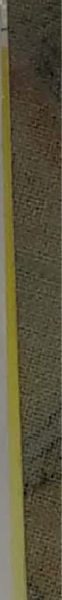

Scanned by CamScanner