

***CURRICULAM VITAE***

# MD. AASIF AJAZ

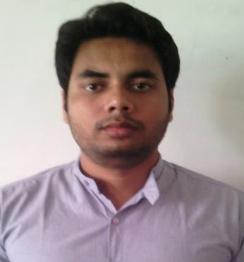

1. 5Ansari Apartment, Abulfazal Enclave, Jamia nagar, New Delhi, India

Mob no: +919911885168

[ajaz.aasif@gmail.com](mailto:ajaz.aasif@gmail.com)

**CAREER OBJECTIVE**

*To associate with an organization which progresses dynamically and gives me a chance to update my knowledge and enhance my skills, in the state of art technologies and be a part of the team that excels in work to words, the growth of organization and my satisfaction thereof.*

**WORK EXPERIENCE**

**ORGANISATION:** Welspun Energy Private Limited, Noida

**DURATION:** Jan 2015 to May 2015

* + Estimate the performance of solar power plants at different locations in the country.
  + Estimate the total power generation of solar power plants.
  + Review existing radiation data sources and softwares.
  + Review design criteria for better performance of power plants.
  + Review Rainfall Data at different locations in country.



**ACADEMIC PROJECTS**

## *During M.Tech*



I worked as a trainee with **Welspun Energy Private Limited, Delhi**. Design and investigate the power of solar power plant for welspun energy pvt ltd, Delhi during Jan to May 2015.

* **ORGANISATION : *Welspun Energy Private Limited, Delhi***
* **DESIGNATION :** Trainee (Solar Energy)
* **DURATION :** Jan to May 2015
* **PROFILE :** Investigate the performance of solar power plants. Provide correct investment decisions, a better regulatory framework. Examine the various factors contributing to the performance of solar power plants, such as radiation, temperature and other climatic conditions, design, inverter efficiency and degradation due to aging.
  + Estimate the performance of solar power plants at different locations in the country.
  + Review existing radiation data sources and softwares.
  + Review design criteria for better performance of power plants.



## *During B.Tech*



* + PIC Based Energy Conservation in hotel room appliances.

**ACADEMIC**

|  |  |  |  |  |
| --- | --- | --- | --- | --- |
| **Qualification** | **School/College** | **Board** | **percentage** | **Year of passing** |
| M.tech (Energy and  Environment) | BBAU, Lucknow | Central University | 71% | 2015 |
| B.tech(Electrical&  Electronics) | SIET Gr.Noida | UPTU,  Lucknow | 67.74% | 2013 |
| 12th | Muslim Inter College,  Mau | UP Board | 56% | 2006 |
| 10th | Adarsh Inter college,  Ghazipur | UP Board | 53% | 2004 |

**TRAININGS**

* **ORGANISATION:** NATIONAL INSTITUTE OF SOLAR ENERGY, GURGAON **DESIGNATION :** Trainee **Duration:** June- July 2014 **TRAINING OBJECTIVES:**
  + Study about outdoor testing of PV module.
  + Performance evaluation of three thin film technologies (CdTe, Micromorph & CIGS).
  + STC estimation of the performance of these technologies & comparison of it.
* **ORGANISATION:** UPNEDA, LUCKNOW & MULLAHI KHERA BIOGAS PLANT

**TRAINING OBJECTIVES:** Learnt about different renewable energy usage

**HOBBIES**

* Playing Cricket

• Listening music

**EXTRA CURRICULAR ACTIVITIES**

* Coordinator of E-SPARK competition.
* Coordinator of Electro hunk Quiz competition in College.
* Got silver medal as a participant in basket-ball team in annual sports of university.

**TECHNICAL AREAS OF INTRESTS**

* **SUBJECTS-** Solar Energy, Electrical Machine, Power Electronics, NCER**.**
* **SOFTWARES-** AutoCAD, PVsyst, SAM, Metenorm, Solar GIS.

**STRENGTHS**

* Adaptable
* Leadership Qualities
* Diligent
* punctuality

**PERSONAL DETAILS**

**Date of birth** : 1st April, 1990

**Father’s Name** : Ajaz Ahmad Khan

**Languages Known** : English, Hindi, & Urdu

# Date: (MD. AASIF AJAZ)

**Place:**